Reviewing for the AP Bio Exam:
College Board Site: Has practice MC and FRQ questions to try. Those start on p. 121 of the file.
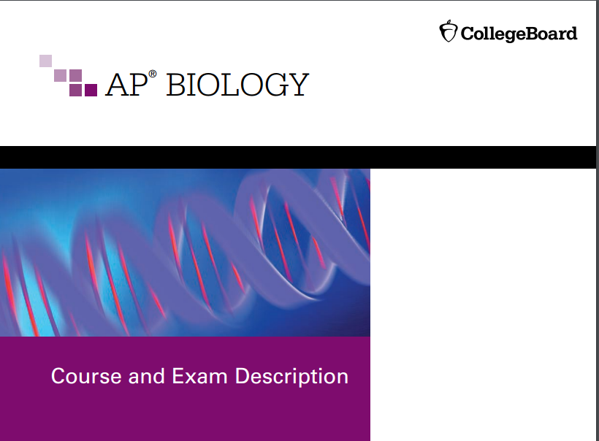
https://secure-media.collegeboard.org/digitalServices/pdf/ap/ap-biology-course-and-exam-description.pdf

Bozeman: Exam Review (51 min): answers student questions
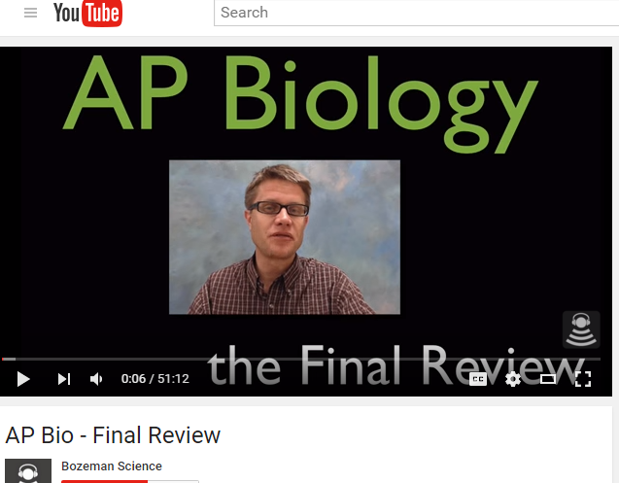
https://www.youtube.com/watch?v=BpaqvCrNAgI
Bozeman: Exam Review (33 min)
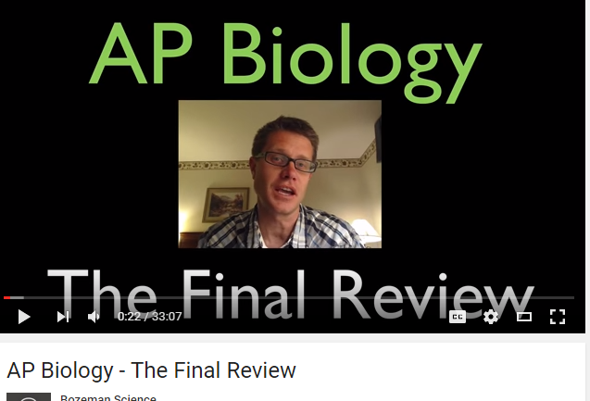
https://www.youtube.com/watch?v=6IDLSvCNPTs
Equations Review:
http://teachersites.schoolworld.com/webpages/AKeiper-Wilson/files/equations__formulas_practice_packet.pdf
Answer key: for some of the questions
http://ehardmanapbio.weebly.com/uploads/5/2/0/5/5205206/jenniferkloocksquantitativeguidekey2.pdf

