Geometry **5.5 *INDIRECT* Proofs** Name_____________________per_____

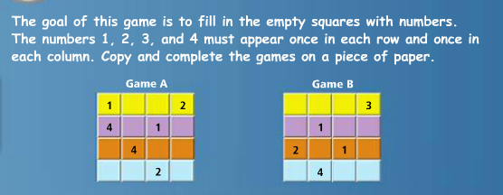**Objective: To use indirect reasoning to write proofs.** *(proofs by contradiction)*

You use ***Indirect Reasoning*** in order to complete the above puzzle. INDIRECT REASONING is when you eliminate possibilities because you know they cannot be true, then choose the one option as the true statement or answer because it is the only one left that you could not prove to be false.

*this works because there is NO overlap in the possible answers. In other words, for each box, for example, it is either ‘4’ or ‘not 4’ …there is no way for it to be BOTH ‘4’ and ‘not 4’. Therefore, once you eliminate all of the numbers that are ‘not 4’, then you can be sure that the answer for that box must be ‘4’.

Practice finding the ‘negation’ of a statement..

|  |  |
| --- | --- |
| **Statement** | **Negation**  (the opposite of the statement) |
| 4 | Not 4 |
| Congruent | Not congruent |
| x > 7 | x 7 |
| <ABC is acute | (HINT: don’t say ‘not acute’) |
| y is negative |  |
| ab |  |
| <C is not obtuse or acute |  |

**In all of these examples, is it possible for the ‘STATEMENT’ and its ‘NEGATION’ to BOTH be TRUE??? NO**

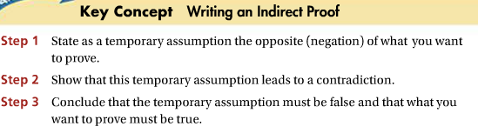We can use INDIRECT Reasoning to write a new type of proof… **Indirect Proofs** are written in paragraph form.

🡪 assume the negation is true

* Eliminate your assumption as a possibility because it contradicts a true known fact
* Therefore since the negation is FALSE, the original statement must be TRUE!

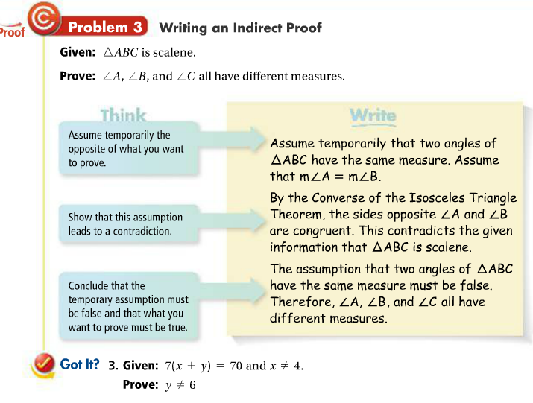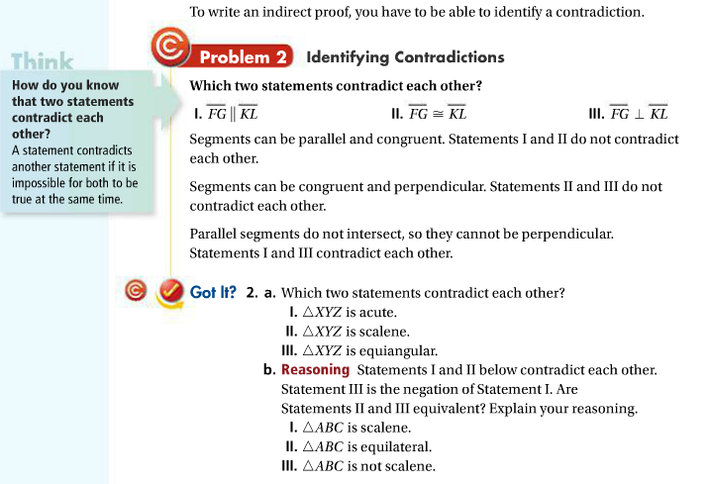

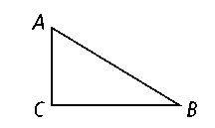

Example#2:

**Given: ∠***A* and ∠*B* are not complementary.

**Prove: ∠***C* is not a right angle.

**Step 1:** Assume that∠*C* is a right angle.

**Step 2:** If ∠*C* is a right angle, then by the Triangle Angle-Sum Theorem, *m*∠*A +* *m*∠*B +* 90 = 180. So *m*∠*A +* *m*∠*B =* 90. Therefore, ∠*A* and ∠*B* are complementary. But ∠*A* and ∠*B* are not complementary.

**Step 3:** Therefore, ∠*C* is not a right angle.



HW pg 319-322 # 1-13, 19, 22, 23, 29, 30