Geometry 5.5 INDIRECT Proofs Name_____________________per_____
Objective: To use indirect reasoning to write proofs. (proofs by contradiction)
Indirect Proofs basically prove a statement is TRUE, by eliminating the negation of that statement. In other words, we prove that the statement can’t be FALSE, which means it has to be true!
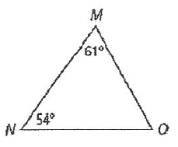
Just as a quick example…If I asked you to use the triangle below and prove that it is NOT equilateral…

You might start by saying …“If it WAS equilateral, then all of the angles would be 60º, and since neither of the given angles are 60º, then it can’t be equilateral.

STEPS for INDIRECT PROOF: **Usually written as paragraph proofs
- Assume the negation of the “PROVE” is TRUE. (like above when we said ‘if it WAS equilateral’)
- Use some of the “GIVENS” and other geometry truths to show your assumption from step 1 can’t be true, either because it CONTRADICTS one of these facts, or it leads to a statement that is ABSURD!
(like above when we used the “GIVEN” angle measures to CONTRADICT the equilateral triangle theorem that states all angles of an equilateral triangle are congruent.)
- Write a ‘therefore’ statement as a conclusion that the PROVE must be TRUE. For example, “Therefore , since our assumption lead to a CONTRADICTION (or absurd statement) , then our assumption must be FALSE, and ____________(the prove) must be true.
The logic of these indirect proofs are based on the basic fact that…
****A statement and its negation CANNOT BOTH be TRUE! In other words if ‘p’ is true, then ‘not p’ must be false and vice versa!
Practice finding the ‘negation’ of a statement..
Statement | Negation  (the opposite of the statement)
4 | Not 4
Congruent | Not congruent
x > 7 | x 7
<ABC is acute | (HINT: don’t say ‘not acute’)
y is negative
ab
<C is not obtuse or acute

In all of these examples, is it possible for the ‘STATEMENT’ and its ‘NEGATION’ to BOTH be TRUE??? NO

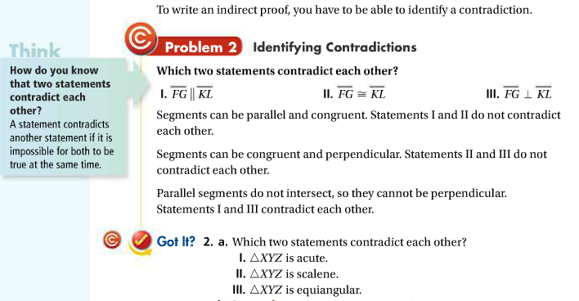
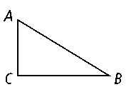
Let’s write an indirect proof;
Example#1:
Given: ∠A and ∠B are not complementary.
Prove: ∠C is not a right angle.
Step 1: Assume that∠C is a right angle.
Step 2: If ∠C is a right angle, then by the Triangle Angle-Sum Theorem, m∠A + m∠B + 90 = 180. So m∠A + m∠B = 90. Therefore, ∠A and ∠B are complementary. But ∠A and ∠B are not complementary.
Step 3: Therefore, ∠C is not a right angle.
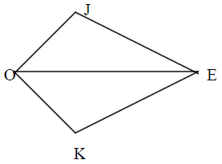
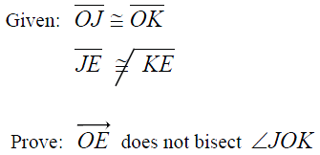
Let’s try another one on our own…
2.

HW pg 319-322 # 1-13, 19, 22, 23, 29, 30

