Dear Parents and Guardians,
Welcome to Geometry!
I am looking forward to a great year with your students! This year I will be using four main forms of technology to improve the students’ access to information which will lead to greater success in Geometry!
- Google Classroom – the students have all received access codes and will use this site to see upcoming assignments and test dates as well as occasionally posted answer keys and notes or worksheets.

- Remind app – this is a way for the students to receive timely messages from me regarding homework, tests, or anything else that I may need to communicate with them about outside of class time.

- Email – please see directions to make sure you are signed up for receiving my emails

- Video lessons – sometimes I will be assigning the students to watch an instructional video for homework. This time spent learning at home will give us more time during school for applying our knowledge and clarifying concepts. Please see video on the ‘flipped classroom’ on my FLHS website.
All students have received a course syllabus with information regarding course objectives, expectations, and other important procedures. Unfortunately, parents don’t have access to the students’ Google account, however, you can access all of the important information and links through my webpage.
Mrs. Meyers Geometry Webpage
STEPS:
- Go to http://fairfieldschools.org/schools/flhs/

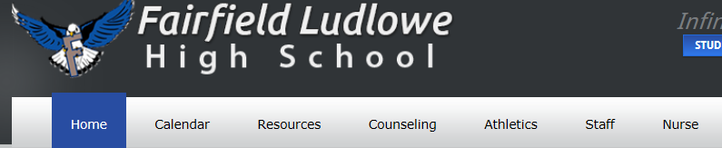
- Click on ‘Staff’

- Click on “Mathematics”

- Click on website next to the name “Sharon Meyers’

This should take you to my webpage. Here you will find helpful links to…

This should take you to my webpage. Here you will find helpful links to…
- Course Handouts – syllabus etc.
- Homework Calendar (updated regularly)
- Link to online textbook
- Link to Quizlet study tool for Geometry vocabulary
- Remind app and Google classroom (directions and class codes)
- Link to this letter
- Video about the ‘flipped classroom’ approach
- OPEN HOUSE 2016 video
- Video titled “how to make sure to get emails from teachers in IC” (also see written directions below)

Email at smeyers@fairfieldschools.org

Another form of communication that is also helpful throughout the year is through email. You can feel free to email me at any time with questions or concerns. The students should also feel free to email me as well. Often students email me when they are absent and I am able to email them the class notes and homework for the day(s) they missed so that they can stay caught up. However, sometimes I like to be able to send an email message to the entire class. In order for you to receive these messages I would like you and your student to sign up to receive emails from me. Here are the steps;
- Login to Infinite Campus portal.
- Click “contact preferences” toward the bottom of the left hand column and enter any and all email addresses that you would like to use.
- Be sure to click “SAVE”
- Once you have ‘saved’ you will see a table at the bottom of the page with different communication options…please check the boxes for Email notification under the “Teacher” column.
- Then click “SAVE” again.
Online Textbook at www.pearsonsuccessnet.com
I wanted to also take the time to introduce you to our textbook.
This year, we will be using Pearson Common Core Geometry. Each student has received a copy of the textbook, as well as access to the textbook and other content online. I would like highlight some of the online content I believe will be useful to you and your student.
The students have been given personal usernames and passwords and instructions for logging on.
Follow the steps below to explore what it has to offer!
- Click Explore
  - Choose Chapter Number
  - Choose Lesson Number (such as 1-3)
    - At the top of the window that opens, click “Instruction”
      - This will show worked out solutions to key problems that may have been demonstrated in class
    - “Practice” will display problems from the book, many of which may be assigned for homework
    - “Self Assessment” is a very brief check of major lesson targets
      - Answers are provided, but not worked out solutions
Go back to the home page Student Resources
  - Click on Chapter Number
  - Click on “Homework Video Tutors” (Spanish videos also available)
*great for when a student misses class or needs reinforcement of the lesson.
  - Click on Section Number
  - This is a narrated homework tutorial, which thoroughly explains how to do one of the problems from the lesson. It can also be printed.
Go back to the home page
- Clicking on the “Open Book” icon next to the image of the textbook will open a digital copy of the textbook
There are other resources available through Pearson’s online content, so feel free to explore and take advantage of what is available

Looking forward to a great year,

Mrs. Meyers
smeyers@fairfieldschools.org
room 328 FLHS

