Name: ____________________________________________________ Date: ___________________________ Period: _______

**Geometry**

**Summer Packet Review**

This review is to help you practice the types of problems that will be on your assessment this week. Please be sure to get help (math center or after school with me) on concepts that you are unsure about .

1) Solve the equation for *x*. 2) Solve for *m*. (isolate m)

3) Solve the following compound inequality for *x*. 4) Given two points, find the slope and

state the slope of a perpendicular line.

$-2≤4x+6≤22$ M(2, 1) and N(-4, 3) slope = 

Slope of  = _________  Perp. Slope =_________

5) Graph the following equation. 6) Graph the following equation.



7) Solve the following equation for x and y. 8) Factor completely.

9) Solve the following by using the zero product property.

10) Solve using the quadratic formula. $x=\frac{-b±\sqrt{b^{2}-4ac}}{2a}$

$$3x^{2}+2x-5$$

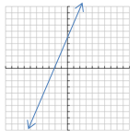ANSWERS:

1. x = -3 2) x =  3)  4) slope =  , perp = 3 5)

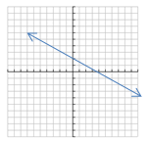6) 7) x = -4 8) (x+8)(x-5) 9) (2x-3)(x-4)

10)  , so x = 1, x = 