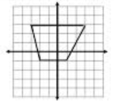Coordinate Geometry **3.8 Parallel and Perpendicular Lines** Name _______________________



***Objective:*** *The students will be able to relate slope to parallel and perpendicular lines.*

* **If 2 lines are PARALLEL, then they have *equal slopes*.** The converse is also true…
* **If 2 lines have *equal slopes*, then they are PARALLEL.**
* **Any 2 vertical lines are PARALLEL.** (both have a slope of _______)
* **Any 2 horizontal lines are PARALLEL**. (both have a slope of _______)

Examples:

1. Given 2 lines where one line passes through the points (1, 3) and (-3, -5). The other passes through the points (5, 4) and (2, -2). Determine if the 2 lines are parallel. How do you know?
2. Write the equation in slope-intercept form of a line that is parallel to the line y = 4x – 2 that contains the

point (-2, -2).



* **If 2 lines are PERPENDICULAR, then they have *opposite reciprocal slopes***(product = -1) The converse is also true…
* **If 2 lines have *opposite reciprocal slopes*, then they are PERPENDICULAR.**
* **Every vertical line is PERPENDICULAR to every horizontal line.**

Examples;

1. Given a line that has a slope of **6**, what is the slope of a line perpendicular to it? m = _______________
2. Given a line that has a slope of **-2/3**, what is the slope of a line perpendicular to it? m = _______________
3. Write the equation in slope-intercept form of a line that is perpendicular to **y = 3x + 2** that contains the point (6,2).

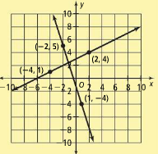

1. 

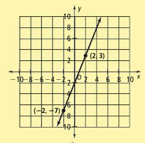



(use point-slope form)

Slope of line shown? _______________

Slope of perpendicular line? ___________

Equation ______________________________________

1. 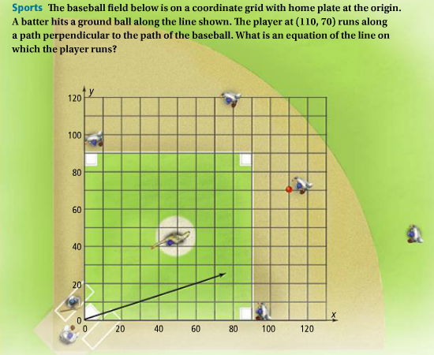

**Slope of baseball’s path? ________**

**Slope of path? ___________**

**Equation of line on which player runs** (hint: use his current location as a point ON the line, then point-slope form)

**HW pg. 201-203 #5 – 23 odd and # 31 Equation ________________________**