Geometry 21 6.9 More Practice with Coordinate Proofs Name _______________________________

For each proof, please include a diagram labeled on a coordinate plane.

STEPS:
- draw and label the graph
- state all formulas you plan to use
- show all work
- have a concluding sentence

Formulas you will most often use in coordinate proofs are:

MIDPOINT FORMULA -

DISTANCE FORMULA -

SLOPE FORMULA -

- Prove: The diagonals of a parallelogram bisect each other. (Hint: Show that the midpoint of each diagonal is at the same point!)

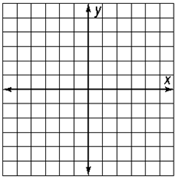

- Prove: The diagonals of a rhombus are perpendicular.

- Prove: The segments joining the midpoints of the sides of a rectangle form a rhombus.

- Prove: The segments joining the midpoints of the sides of an isosceles triangle form another isosceles triangle.

