Name: ____________________________________ Period: _____ Date: ________

**Geometry 21: Coordinate Geometry Practice for Test (1.7, 3.7, 3.8, 6.7, 6.8, 6.9)**

**1. Find the coordinates of the midpoint of given** *A*(-3, 14) and *B*(10, −4).

2. **The coordinates of point *Y* are** (-2, -7)**. The midpoint of  is (6, −10). Find the coordinates of point *X.***

3. **Find the distance between points C and D. Leave answer as a simplified radical.** *C*(-3, −5), *D*(-9, 4)

**4. Find the slope of the line passing through the given points:** (2, 3), (-1, -6)

**Graph the line. Use the given information to write an equation for the line**

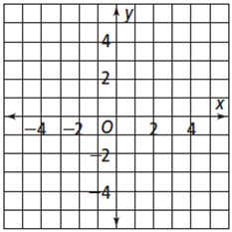**5.  6.** **through (10, 2) and (2, -2)**

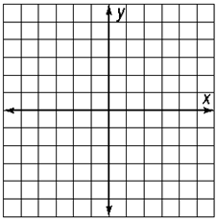

**7. Graph the pair of lines. Then find their intersection point. *y = -5, x = -2***

**Are the following lines parallel, perpendicular or neither? Explain.**

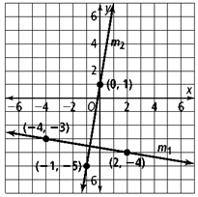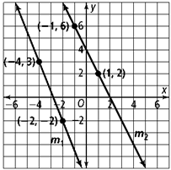

**8. 9.** 10. 

**11. Write an equation of the line perpendicular to that contains point *C*.**

**;** *C (-6, 5)*

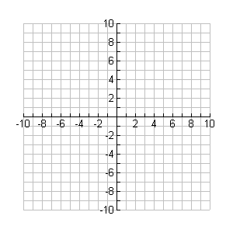

12. The vertices of a triangle are given. Plot the points on a coordinate plane and determine whether the triangle is a right triangle. Show your work to justify your answer.

*T(-2, 4), R(-1, 0), I(2, 5)*

13. Is  scalene, isosceles, or equilateral? The vertices are .



14. A quadrilateral has vertices **S (5, 3) N (5, -1) O (-1, -1) W (-1, 3).** Show that the quadrilateral that is formed by connecting the midpoints of the sides is a rhombus? (HINT: Show that it is a parallelogram with perpendicular diagonals.)



15. Determine the most precise name for the quadrilateral with the given vertices. Use the appropriate formula(s) to “prove” your answer. Write a summary statement explaining your conclusion.

*A*(–5, 0), *B*(2, –6), *C*(8, 1), and *D*(1, 7).

16. Find the missing coordinates in terms of the given variables.

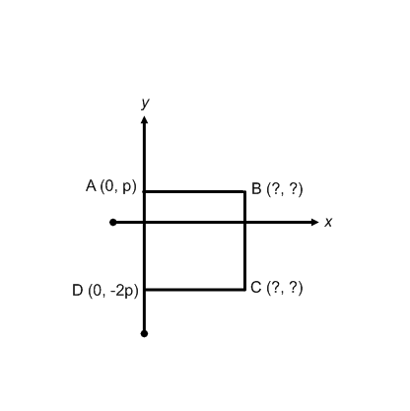a. Δ*ABC* is a right isosceles triangle b.  c. 



# 

# 17.

.

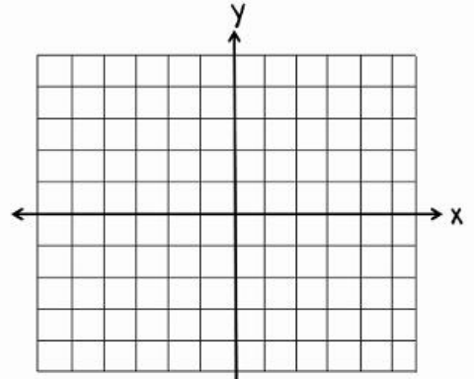18. The fact that the diagonals of a kite are perpendicular suggests a way to place a kite in the coordinate plane. Show this placement. Include labels for the kite vertices.

19. In the coordinate plane, draw a square with sides 4*q* units long. Give coordinates for each vertex, and the coordinates of the point of intersection of the diagonals.

20. If you want to prove that the diagonals of a parallelogram bisect each other using coordinate geometry, how would you place the parallelogram on the coordinate plane? Give the coordinates of the vertices for the placement you choose.

21. Prove using a coordinate proof.



22. Write a coordinate proof of the following theorem:

If a quadrilateral is a kite, then its diagonals are perpendicular.

23. Prove that the midpoints of the sides of a rectangle form a rhombus.