**Geometry 22 Midterm Exam Review 2015-16 Answer Key** (V20160110EZ1)

Answers may vary for #1-6: 1. $\overset{⃡}{AB}$ 2. $\vec{HB}$ 3. plane *ACG* 4. $\overline{AH}$ 5. point *G* 6. $\overset{⃡}{AB}$ 7. point *B* 8. point *H* 9. line 10. 19 units 11. $9$ 12. $x=9, m∠DYN=83˚$ 13. 2 $5$ 14. 33 15. 32 units 16.

17. x=7, 18. a. 12 b. 21 units c. 53 units 19. a. 74˚ (or ̴̴ 75˚) b. 39˚ (or ̴̴ 40˚) 20. 137˚ 21. a. 6 b. 39˚ 22. a. 11 b. 49˚

23. a. 143˚ b. c. $x=15$ 24. a. If the segment is an altitude, then it forms a right angle. b. Hyp: The segment is an altitude. Concl: It forms a right angle. c. *[See figure at right.]* d. If the segment forms a right angle, then it is an altitude. e. False. It could be a perpendicular bisector.

altitudess

segments that form right angles

25. a. If the figure is a polygon with exactly three sides, then it is called a triangle. b. Converse: If a figure is called a triangle, then it is a polygon with exactly three sides. c. A figure is a polygon with exactly three sides if and only if it is called a triangle. d. Yes because the statement is reversible; the original conditional and its converse are both true.

26. If you are on the tennis team, then you are on a sports team.

27. Similarity: Both supplementary angles and a linear pair have an angle measure sum equal to 180˚. Difference: Linear pair angles need to be adjacent and sharing a side while supplementary angles can be separate. Example: supplementary linear pair

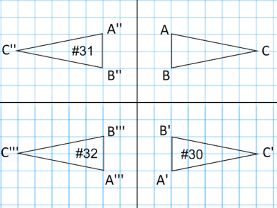28. Similarity: Skew and parallel lines never intersect. Difference: Skew lines are not coplanar (occur in 3D) while parallel lines are coplanar (occur in 2D).

29. a. reflection b. translation 30-32. *[See figure at right.]*

33. a. reduction, $\frac{1}{2}$ b. enlargement, 2 c. enlargement, 2

34. a. enlargement b. reduction c. reduction d. isometric e. enlargement f. reduction

35. a. 60˚ b. 80˚ c. 40˚ d. 80˚ e. 100˚ f. 80˚ g. 60˚ h. 120˚ i. 60˚ j. 120˚ k. 100˚ l. 80˚

36. a. 110˚ b. 70˚ c. 70˚ d. 70˚ 37. a. 7 b. 53˚ c. 53˚ d. 37˚ 38. 13. 39. 45˚ 40. 15 41. a. 900˚ b. 1800˚ c. 180,000˚ 42. a. 60˚ b. x=31, angles: 56˚, 69˚, 117˚, 142˚, 156˚ 43. a. 108˚ b. 135˚ 44. a. 45˚ b. 51.4˚ 45. a. 6 b. 15 46. 3- triangle 4- quadrilateral 5- pentagon 6- hexagon 7- heptagon (septagon) 8- octagon 9- nonagon 10- decagon 11-gon 12-dodecagon 13-gon 14-gon

47. 54 units, $FE=$ 27.5 units, perimeter = 149 units 48. $x=$ 27, $m∠N=$ 49˚ 49. y = 48, 60˚

50. a. no, sum of the shorter sides is not greater than the third side (5+10 = 15) b. yes, 3 + 20 >21 c. no, sum of the shorter sides is not greater than the third side (4+7<15)

51. is the shortest side because it is opposite ∠S, the smallest angle.

52. 23˚, 157˚, 67˚

53. Conv: If an angle is acute, then it measures 32˚. False- an acute angle could be 40˚

54. a. *x* = 97, *y*=96 b. *x* = 73, *y* = 41 c. *x* = 24.5 d. *x* = 65, *y* = 108

55. a. *x* = 23, 49˚, 100˚ b. *x* = 22, 44˚, 81˚, 125˚ c. *x*= 51, 51˚, 131˚ d. 78˚ e. *x* = 13, 39˚, 51˚ f. *x* = 45, 125˚, 55˚, 55˚

56. a. isosceles b. equilateral c. 108˚

57. *∠H, ∠HGI, , ∠GIH,*

58. a. AAS, HL b. SSS c. AAS

59. a. ∠*DUT*≅∠*SUT* ∆*DUT*≅∆*SUT* b. ∠*L≅∠T* ∆LMK≅∆TSU c. $\overline{WV}≅\overline{VM}$ ∆*UWV*≅∆*KMV* d. $\overline{RS}≅\overline{QD}$ ∆*RQS*≅∆*DSQ* e. $\overline{JI}≅\overline{TS}$ ∆*JIH*≅∆*TSR* f. $\overline{BC}≅\overline{KL}$ ∆*BAC*≅∆*KJL*

60. x = 2, 5 b. x=4 c. x=12 61. angle bisector

62. perpendicular bisector 63. parallel lines 64. a. median b. $\overline{AD}$ 65. 24 66. a. 7 b. 8 c. 9 67. 42˚

68. a. 13 b. 5 69. 24

70. a. 10 units b. $\overline{PR}$ is the angle bisector of ∠SPQ c. 10 d. *m∠SPR*=30˚, *m∠QPR*=30˚

71. a. y=9 b. x=3 72. 0 < XY < 12 b. 4 < XY < 14 c. 5 < XY < 17

73.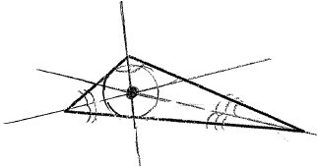74.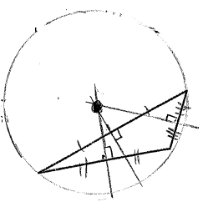75.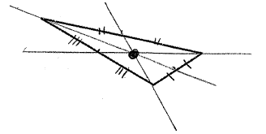76.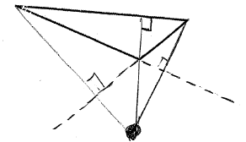 77. 13 units 78. 8 units 79. ¼

|  |  |
| --- | --- |
| 1. | 1. Given |
| 2. | 2. **Definition of Vertical Angles** |
| **3. ∠PRQ≅∠SRT** | 3. Vertical Angle Theorem |
| 4. | 4**. Definition of angle congruence** |
| 5. | 5. **Substitution POE (or Transitive POE)** |
| 6. | 6. **Triangle Sum Theorem** |
| 7. | 7. **Substitution POE** |
| **8. *m∠P* + 137˚=180˚** | 8. Combine Like Terms |
| **9. *m∠P* =43˚** | 9. Subtraction Property of Equality |

80.

|  |  |
| --- | --- |
| **1.** | **1. Given** |
| **2.** | **2. Definition of Midpoint** |
| **3.** | **3. Given** |
| **4.** | **4. Definition of Vertical Angles** |
| **5.** | **5. Vertical Angles Theorem** |
| **6. ∆SQP≅∆TQR** | **6. ASA** |

81.

|  |  |
| --- | --- |
| 1. | **1. Reflexive POC** |
| 2. | **2. Given** |
| **3. $\overline{TS}≅\overline{US}$** | 3. Given |
| 4. | **4. SSS** |

82.

|  |  |
| --- | --- |
| 1. | **1. Given** |
| 2. $m∠1=m∠4$ | **2. Defn. of Angle Congruence** |
| 3. $∠$ 1& $∠$ 2 and $∠$ 3& $∠$ 4 form linear pairs | **3. Defn. of Linear Pair** |
| 4. | **4. Linear Pair Postulate** |
| 5. | **5. Defn. of Supplementary Angles** |
| 6. | **6. Substitution POE (or Transitive POE)** |
| 7. | **7. Substitution POE** |
| 8. | **8. Subtraction POE** |
| 9. | **9. Defn. of Angle Congruence** |
| 10. | **10. Converse Isosc. Triangle Theorem** |
| **11. ∆ABC is isosceles** | **11. Defn. of Isosceles Triangle** |

83.

|  |  |
| --- | --- |
| 1. | **1. Given** |
| 2. | **2. Defn. of Midpoint** |
| **3. $\overline{VY}≅\overline{VY}$** | 3. Reflexive Property |
| **4. ∆VYX≅∆VYW** | 4. SSS |
| **5. ∠VYX≅∠VYW** | **5. Corresp. parts of ≅ ∆s are ≅ (CPCTC)** |

84.

85.

|  |  |
| --- | --- |
| 1. | 1. Given |
| 2. | **2. Isosceles Triangle Theorem** |
| 3. | **3. Defn. of Angle Congruence** |
| 4. | **4. Given** |
| 5. | **5. Substitution POE** |
| 6. | **6. Addition POE** |
| **7. x=27** | **7. Division POE** |

|  |  |
| --- | --- |
| 1. | **1. Given** |
| 2. | **2. Reflexive POE** |
| 3. | **3. Given** |
| 4. | **4. All right angles are congruent (RAT)** |
| 5. | **5. ASA** |
| 6. | **6. Corresp. parts of ≅ ∆s are ≅ (CPCTC)** |

86.

|  |  |
| --- | --- |
| 1) ∠1 and ∠3 are supplementary; transversal p | **1) Given** |
| **2) m∠1+m∠3=180˚** | **2) Defn. of Supplementary Angles** |
| 3) ∠1 and ∠2 are a linear pair | 3) definition of **Linear Pair** |
| 4) ∠1 and ∠2 are supplementary | **4) Linear Pair Postulate** |
| **5) m∠1+m∠2=180˚** | 5) definition of **Supplementary Angles** |
| 6) m∠1 + m∠3 = m∠1 + m∠2 | **6) Substitution POE (or Transitive POE)** |
| 7) m∠3 = m∠2 | **7) Subtraction POE** |
| 8) ∠3≅∠2 | **8) Defn. of Angle Congruence** |
| 9) ∠3 and ∠2 are corresponding angles | **9) Defn. of Corresponding Angles** |
| 10) mn | **10) Converse of Corresp. Angles Theorem** |

87.

88. 1. m║n **1. Given**

2. ∠1 and ∠5 are Corresp. Angles **2. Defn. of Corresponding Angles**

3. ** **3. Correponding Angles Theorem**

4. ** **4. Defn. of Angle Congruence**

5. ∠5 and ∠7 are a Linear Pair **5. Defn. of Linear Pair**

**6. ∠5 and ∠7 are supplementary**  6. Linear Pair Postulate

*7. * **7. Defn. of Supplemenary Angles**

***8.* m∠1+m∠7=180˚8. Substitution POE**