**GEOMETRY 22 MID-TERM EXAM REVIEW**

**Note to student: This packet should be used as practice for the Geometry 22 midterm exam. This should not be the only tool that you use to prepare yourself for the exam. You must go through your notes, re-do homework problems, class work problems, formative assessment problems, and questions from your tests and quizzes throughout the year thus far. The sections from the book that are covered on the midterm exam are:**

|  |  |
| --- | --- |
| **UNIT 1** |  |
| **Chapter 1** |  |
| 1-2 | Points, Lines, and Planes |
| 1-3 | Measuring Segments |
| 1-4 | Measuring Angles |
| 1-5 | Angle Pairs |
| 1-6 | Basic Constructions |
| **UNIT 2** |  |
| **Chapter 9** |  |
| 9-1 | Translations |
| 9-2 | Reflections |
| 9-3 | Rotations |
| 9-6 | Dilations |
| Concept Byte 9-3 | Symmetry |
| **UNIT 3** |  |
| **Chapter 2** |  |
| 2-2 | Conditional Statements |
| 2-3 | Biconditionals & Definitions |
| 2-5 | Proof Intro (Properties of =/ $≅$& Algebraic Proofs) |
| 2-6 | Proving Angles Congruent |
| **Chapter 3** |  |
| 3-1 | Lines & Angles |
| 3-2 | Properties of Parallel Lines |
| 3-3 | Proving Lines Parallel |
| 3-5 | Parallel Lines & Triangles |
| 3-6 | Constructing Parallel & Perpendicular Lines |
| **Chapter 4** |  |
| 4-1 | Define Congruent Figures |
| 4-2 | Triangle Congruence by SSS & SAS |
| 4-3 | Triangle Congruence by ASA & AAS |
| 4-6 | Congruence in Right Triangles |
| 4-4 | Using Corresponding Parts of Congruent Triangles (with proofs) |
| 4-5 | Isosceles & Equilateral Triangles |
| **Chapter 5** |  |
| 5-1 | Midsegments of Triangles |
| 5-2 | Perpendicular & Angle Bisectors |
| 5-3 | Bisectors in Triangles |
| 5-4 | Medians & Altitudes |
| 5-6 | Inequalities in One Triangle |
| **Chapter 6** |  |
| 6-1 | The Polygon-Angle Sum Theorems |

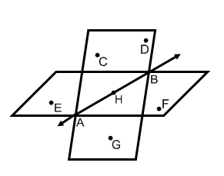Using the diagram to the right, give an example of each of the following:

1. A line: _______
2. A ray: ________
3. A plane: ___________
4. A segment: ________

Using the diagram above, answer questions 5-8.

1. Name a point that is coplanar with points *C, D*, and *H*. _________
2. Name the intersection of plane *CDG* and plane *EHF*. _________
3. Name a point that is collinear with . __________
4. Name the intersection of . __________
5. Through any two points there is exactly one ___________________________.
6. Assume that *B* is between *A* and *C*. If *AB = 6 units* and *BC = 13 units*, what is *AC*? ___________

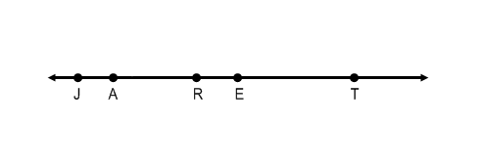

1. Using the diagram below, if *JR = 4x -12, RT = 6x +4* and *JT = 8x + 10*, find *x*. ___________

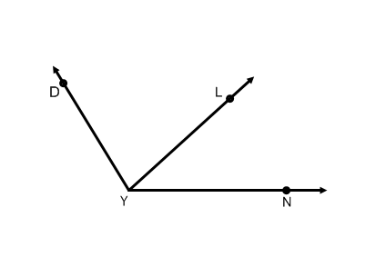

1. In the diagram below, if , solve for *x* and find 

*x* = ___________

=____________

1. If 

1. If 
2. 

*PQ = ___________*

1. 





1. 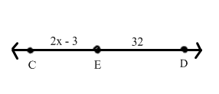If CD = 5x – 7, find the indicated values.

a) x = ____________ b) CE = ______________ c) CD= ________________



**A**

**B**

**C**

**D**

**T**

1. a) What is ? ___________

b) What is ?____________

1. If , what is the measure of its supplement? ___________

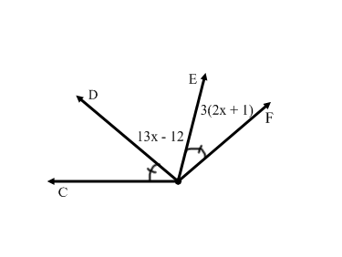

A

1. In the figure below, . Find the indicated measures.

a) x = _______________

b) = ______________

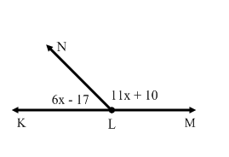

1. In the figure below, find the indicated measures.
2. x = _______________

b) = _______________

1. **Solve for *x* in the following problems.**



a. b. c.

3x - 42

123°

1. Refer to the statement: “*All altitudes form right angles*.”

a) Rewrite the statement as a conditional.

b) Identify the hypothesis and conclusion of the conditional.

Hypothesis:

Conclusion:

c) Draw a Venn to illustrate the statement.

d) Write the converse of the conditional. e) If the converse is false, give a counterexample:

1. Refer to the statement: “*A polygon with exactly three sides is called a triangle*.”

a) Rewrite the statement as a conditional.

b) Write the converse.

c) Write the biconditional.

d) Decide whether the statement is a definition. Explain your reasoning.

1. Given the following Venn diagram, state a conditional using the information.



_______________________________________________________

_______________________________________________________

1. Explain the similarities and differences between supplementary angles and a linear pair.
2. Explain the similarities and differences between skew lines and parallel lines.
3. Determine whether the following is a translation, reflection, or rotation.

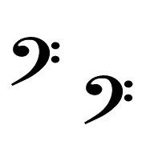

1. 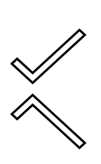_______________________ b) _______________________

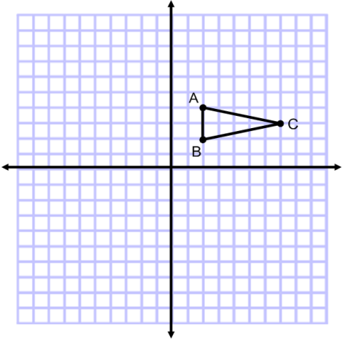

1. Reflect ABC over the x-axis.
2. On the same graph, reflect ABC over the y-axis.
3. On the same graph, rotate ABC 180 $°$ about the origin.
4. The dashed-line figure is a dilation image of the solid-line figure. The labeled point is the center of dilation. Tell whether the dilation is an enlargement or a reduction. Then find the scale factor of the dilation.

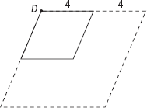

1. 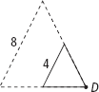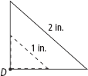 b. c.
2. Determine if the following scale factor would create an enlargement, reduction, or isometric figure.

a. 3.5 b. 2/5 c. 0.6 d. 1 e. 4/3 f. -5/8

1. In the figure at right, lines *r* and *s* are parallel, m∠2 = 40o, and m∠4 = 60o; find:

*r*

13

12

11

7

8

14

6

10

5

4

9

*s*

3

2

1

a) m∠1 ______________ b) m∠3 ______________

c) m∠5 ______________ d) m∠6 ______________

e) m∠7 ______________ f) m∠8 ______________

g) m∠9 ______________ h) m∠10 ______________

i) m∠11 ______________ j) m∠12 ______________

k) m∠13 ______________ l) m∠14 ______________

1. If lines *k* and *l* are parallel, m∠4 = (3x -10)o and m∠5 = (x + 70)o; find:

8

*k*

7

6

5

4

*l*

3

2

1

a) m∠8 ______________

b) m∠6 ______________

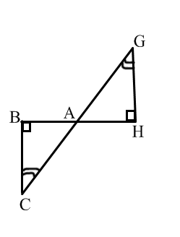 c) m∠3 ______________

d) m∠7 ______________

1. If m $∡$ HAG = (7x + 4)o, and mCAB = (9x – 10)o, find the following:

a) x =______________

b) m $∡$ GAH = ______________

c) m $∡$ CAB =______________d) m $∡$ G = ______________

1. 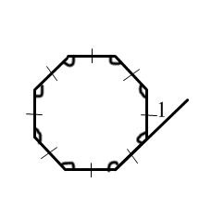The interior angle sum of a regular polygon is 1980o. How many sides does the polygon have?
2. Find m∠1 = ____________
3. An exterior angle of a regular polygon is 24o. Find the number of sides in the polygon.
4. Find the interior angle sum for each polygon:

a. b. dodecagon c. 1002-gon

1. Find the missing measure:

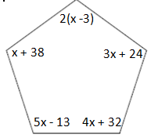a. b.

1. Find the measure of **one interior angle** for the following regular polygons.

a. b.

1. Find the measure of **one exterior angle** for the following regular polygons (round to tenths in necessary):

a. b.

1. Given one **interior angle** measure of a regular polygon, find the number of sides the polygon has:

a. 120˚ b. 156˚

1. List the names of polygons 3 through 14.

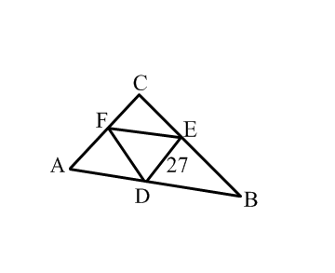

1. In the diagram below F, E, and D are midpoints.

AC = ____________ If AB = 55, then FE = __________

If AB = 55 and FD = 20, find the perimeter of ABC ________

M

N

(3x + 1)o

L

(2x - 5)o

1. x = _________________

m∠N =_________________

1. Solve for *y*, then find the value of the $∠P$ in the figure below.
2. Can the following groups of sides be the sides of a triangle? Explain.
   1. *15, 10, 5*
   2. *20, 21, 3*
   3. *7, 4, 15*
3. In the figure below, $m∠S=24$ and $m∠O=130$. Which side of $⊿SOX$ is the shortest side? Why?

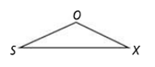

1. Determine *m*∡ *A*, *m*∡ *B*, and *m*∡*C if* *A* is supplementary to *B* and complementary to *C*.



1. Write the conditional and converse of the statement, and determine if the converse is true. If it is not, write a counterexample.

If an angle measure is 32 degrees, then it is an acute angle.

1. **Find the value of *x* and *y*.**

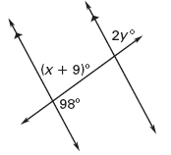

a. b.

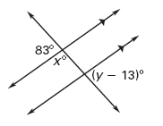

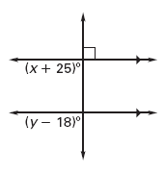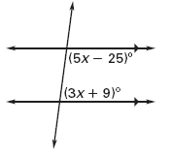

c. d.

1. 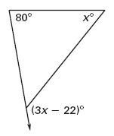**Solve for the given variable and find the angle measures.**

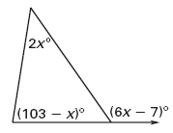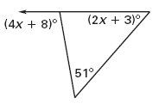

a. b. c.

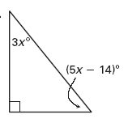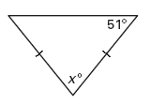

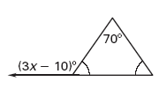d. e. f.

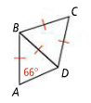

1. Use the diagram to the right.

a. What type of triangle is ? ___________________________

b. What type of triangle is ? ___________________________

c. Find  ___________________________

1. Use the congruency statement to fill in the corresponding congruent parts.

   

  

1. For the following, name which triangle congruence theorem or postulate you would use to prove the triangles congruent.

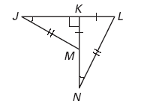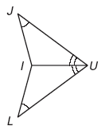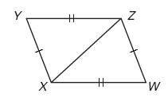

a. b. c.

1. Mark any additional information you can FIRST (ex: vertical angles or reflexive property). Then, label and state what ADDITIONAL information is required in order to know that the triangles are congruent for the reason given.



a. b. c.

extra part: ________≅ ________ extra part: ________≅ ________ extra part: ________≅ ________

ΔDUT ≅ Δ________ ΔLMK ≅ Δ________ ΔUWV ≅ Δ _______

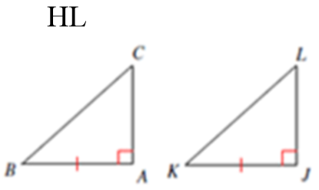d. e. f.

extra part: ________≅ ________ extra part: ________≅ ________ extra part: ________≅ ________

ΔRQS ≅ Δ________ ΔJIH ≅ Δ________ ΔBAC ≅ Δ _______

1. For which value(s) of *x* are the triangles congruent?

a. *x* = ______________ b. *x* = _______________ c. *x* = _______________

4*x* + 8

7*x* - 4

A

B

R

C

A

D

1

m ∠3 = *x*2

m ∠4 = 7*x* - 10

B

E

C

2

3

4

W

S

R

Z

T

*x*2 + 2*x*

*x*2 + 24

1. 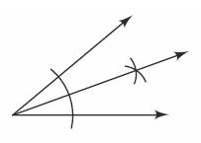Describe what is being constructed in the figure at right.

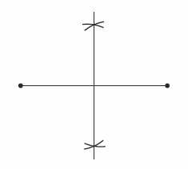

1. Describe what is being constructed in the figure at right.
2.  Describe what is being constructed in the figure at right.
3. 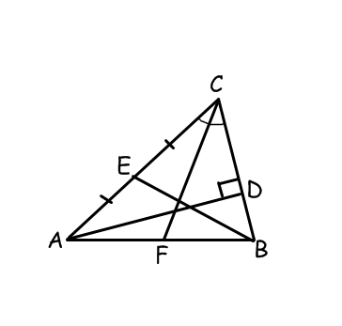Refer to the figure at the right.

a.) $\overline{EB}$ is a ______________________ of ∆ABC

1. _______________ is an altitude of ∆ABC.
2. 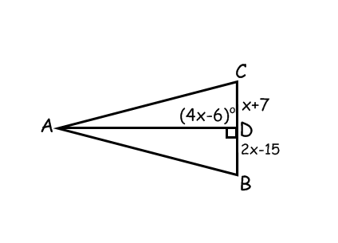Find the value of x if $\overline{AD}$ is an altitude of ∆ABC.
3. 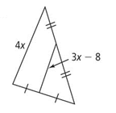**Solve for $x$.**

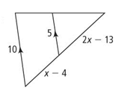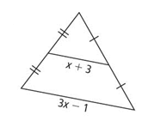a. b. c.

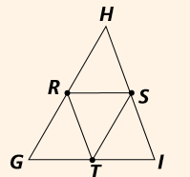

1. In , *R, S,* and *T* are midpoints. If and . Find the.
2. 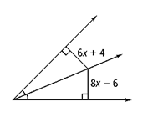*PM* = 4x + 7 and *PN* = 12x – 5 71. Solve for $x$.

Find *PL*.

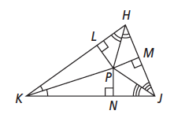

1. Find the value of x if $\overline{AD}$ is an altitude of ∆ABC.
2. 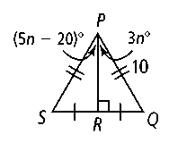a) According to the diagram, what are the lengths of  and *?*

b.) How is related to ∠*SPQ?*

c.) Find the value of *n.*

d.) Find *m*∠*SPR* and *m*∠*QPR.*

1. 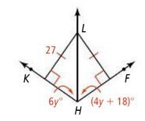Find the value of the missing variables in the problems below.

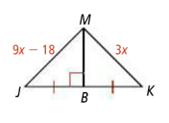a. b.

1. **Find the range of possible measures for $\overline{XY}$ in ΔXYZ.**

a. XZ = 6 and YZ = 6 b. XZ = 9 and YZ = 5 c. XZ = 11 and YZ = 6

1. 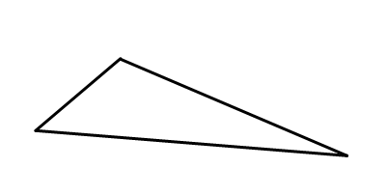Draw the angle bisectors of the triangle at right.
2. Draw the perpendicular bisectors of the triangle at right.
3. Draw the medians of the triangle at right.
4. Draw the altitudes of the triangle at right.

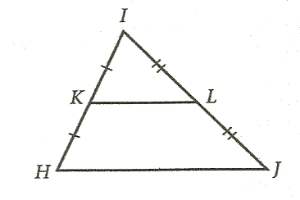

1. If HJ = 26, then KL = ______

1. If HJ = 3x – 1 and KL = x + 1, then HJ = ______

*21*

*84x*

1. Solve for x.



|  |  |
| --- | --- |
| **Statements** | **Reasons** |
| 1. | 1. Given |
| 2. | 2. |
| 3. | 3. Vertical Angle Theorem |
| 4. | 4. |
| 5. | 5. |
| 6. | 6. |
| 7. | 7. |
| 8. | 8. Combine Like Terms |
| 9. | 9. Subtraction Property of Equality |





|  |  |
| --- | --- |
| **Statements** | **Reasons** |
| **1.** | **1.** |
| **2.** | **2.** |
| **3.** | **3.** |
| **4.** | **4.** |
| **5.** | **5.** |
| **6.** | **6.** |

1. 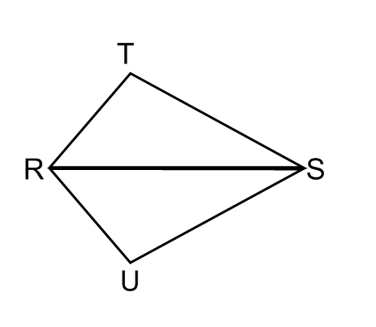*Given:* 

*Prove: *

|  |  |
| --- | --- |
| **Statements** | **Reasons** |
| 1. | 1. |
| 2. | 2. |
| 3. | 3. Given |
| 4. | 4. |

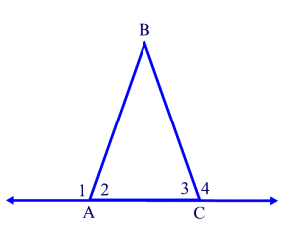

|  |  |
| --- | --- |
| Statements | Reasons |
| 1. | 1. |
| 2. $m∠1=m∠4$ | 2. |
| 3. $∠$ 1 and $∠$ 2 form a linear pair, $∠$ 3 and $∠$ 4 form a linear pair | 3. |
| 4. | 4. |
| 5. | 5. |
| 6. | 6. |
| 7. | 7. |
| 8. | 8. |
| 9. | 9. |
| 10. | 10. |
| 11. | 11. |

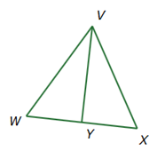**





|  |  |
| --- | --- |
| Statements | Reasons |
| 1. | 1. |
| 2. | 2. |
| 3. | 3. Reflexive Property |
| 4. | 4. SSS |
| 5. | 5. |

1. 

|  |  |
| --- | --- |
| Statements | Reasons |
| 1. | 1. Given |
| 2. | 2. |
| 3. | 3. |
| 4. | 4. |
| 5. | 5. |
| 6. | 6. |
| 7. | 7. |

1. 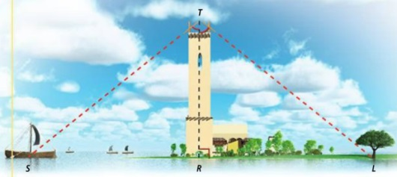

**T**

**S R L**



|  |  |
| --- | --- |
| ***Statements*** | ***Reasons*** |
| 1. | 1. |
| 2. | 2. |
| 3. | 3. |
| 4. | 4. |
| 5. | 5. |
| 6. | 6. |

1. Given:  and  are supplementary

Prove: 

|  |  |
| --- | --- |
| **Statements** | **Reasons** |
| 1) ∠1 and ∠3 are supplementary; transversal p | 1) |
| 2) | 2) |
| 3) ∠1 and ∠2 are a linear pair | 3) definition of ____________________ |
| 4) ∠1 and ∠2 are supplementary | 4) |
| 5) | 5) definition of ________________ |
| 6) m∠1 + m∠3 = m∠1 + m∠2 | 6) |
| 7) m∠3 = m∠2 | 7) |
| 8) ∠3∠2 | 8) |
| 9) ∠3 and ∠2 are corresponding angles | 9) |
| 10) mn | 10) |

1. 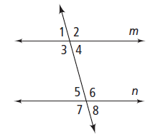

*Statements Reasons _*

1. m║n 1.

2. ∠1 and ∠5 are Corresp. Angles 2.

3. ** 3.

4. ** 4.

5. ∠5 and ∠7 are a Linear Pair 5.

6. 6. Linear Pair Postulate

*7.  7.*

*8. 8.*