**GEOMETRY 22 MID-TERM EXAM REVIEW – PART 2 (JAN 2015)** *Name: _______________________________*

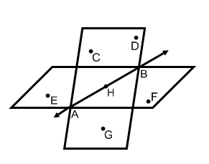

Using the diagram at right, give an example of each of the following:

1. a line ______________
2. a ray ______________
3. a plane ______________
4. a segment ______________

Use the diagram at right for questions 5-8.

1. Name a point that is coplanar with points *C, D*, and *H*. ______________
2. Name the intersection of plane *CDG* and plane *EHF*. ______________
3. Name a point that is collinear with . ______________
4. Name the intersection of . ______________
5. Assume that *B* is between *A* and *C*. If *AB = 6 units* and *BC = 13 units*, what is *AC*? ___________

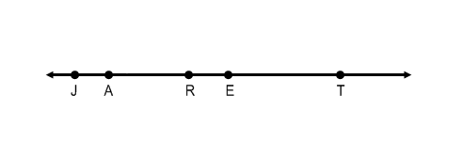

1. Using the diagram below, if *JR = 4x -12, RT = 6x +4* and *JT = 8x + 10*, find *x*. ___________

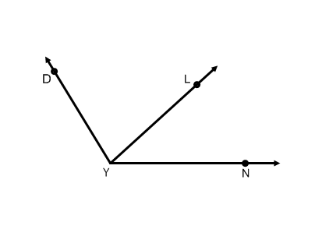

1. In the diagram below, if ,

solve for *x* and find 

*x* = ___________

=____________

1. If 

1. If 
2. In the list below, circle the statements in which the notation is correct.

   

*MO + RG = AN*



*PQ = ___________*











1. **Solve for *x* in the following problems.**

a. b. c.

3x - 42

123°

1. Given the following Venn diagram, state a conditional using the information.



_______________________________________________________

_______________________________________________________

1. Explain the similarities and differences between supplementary angles and a linear pair.
2. Explain the similarities and differences between skew lines and parallel lines.
3. 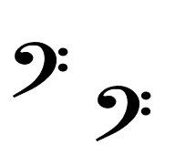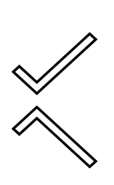Determine whether the following is a translation, reflection, or rotation.

a. b.

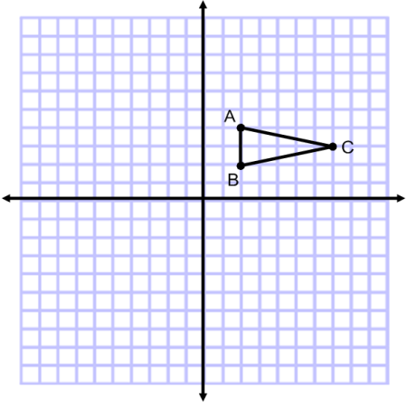

1. Reflect ABC over the x-axis.
2. On the same graph, reflect ABC over the y-axis.
3. 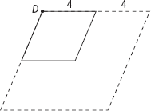The dashed-line figure is a dilation image of the solid-line figure. The labeled point is the center of dilation. Tell whether the dilation is an enlargement or a reduction. Then find the scale factor of the dilation.
4. 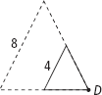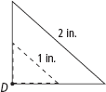 b. c.
5. Determine if the following scale factor would create an enlargement, reduction, or isometric figure.

a. 3.5 b. 2/5 c. 0.6 d. 1 e. 4/3 f. -5/8

1. State whether the following are true or false. If false, give a counterexample.

a. If a figure is a square, then it is a parallelogram.

b. If a figure is a rectangle, then it is a rhombus.

c. If a figure is a rectangle, then the diagonals are perpendicular.

d. If a figure is a trapezoid, then it cannot be a square.

1. *ABCD* is a parallelogram. If , find the measure of the remaining three angles.



P

M

N

O

G

1. *MNOP* is a rhombus. If , find each of the following:
2. 
3. 
4. 

1. Use polygon *GHIJ* to the right to answer the following:

G

H

I

J

1. If *GJ = 3x + 5, GH = 22 – 9x, HI = x + 17,* find *x.*
2. If *GI = 3x – 12, JH = 2x + 10* , find *JH.*
3. List the names of polygons 3 through 14.

1. For which value(s) of *x* are the triangles congruent?

a. *x* = ______________ b. *x* = _______________ c. *x* = _______________

4*x* + 8

7*x* - 4

A

B

R

C

A

D

1

m ∠3 = *x*2

m ∠4 = 7*x* - 10

B

E

C

2

3

4

W

S

R

Z

T

*x*2 + 2*x*

*x*2 + 24

1. 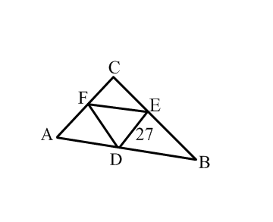In the diagram below F, E, and D are midpoints.

AC = ____________ If AB = 55, then FE = __________

If AB = 55 and FD = 20, find the perimeter of ABC ________

1. Use the congruency statement  to fill in the corresponding congruent parts.

     

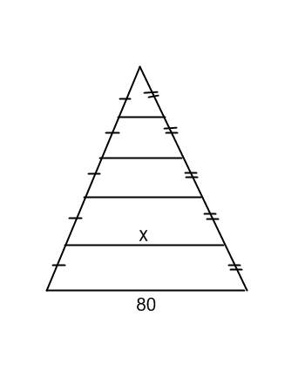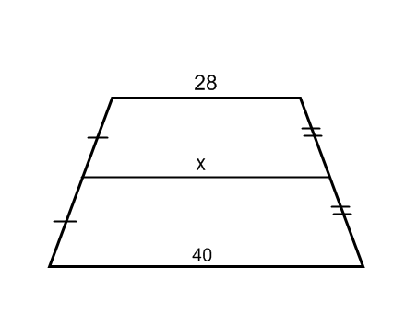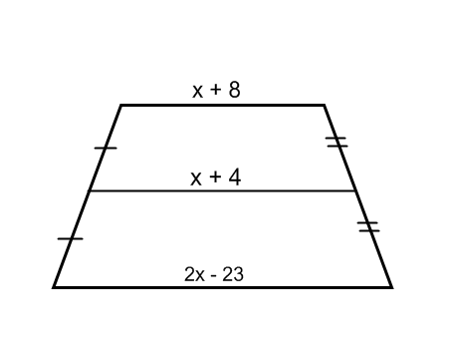

1. **Solve for $x$.**

a. b. c.

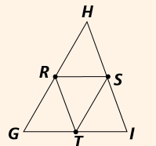

1. In , *R, S,* and *T* are midpoints. If and . Find the.

37. Graph the pre-image AND image using the given information:

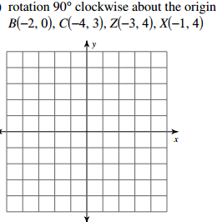

38. *r*(270**°**, *O*)(*QRST*)

(Rotate the figure 270∘ counterclockwise about the origin.)

