**GEOMETRY 21 MID-TERM EXAM REVIEW**

Name: _____________________________________________________ Period: _________

Note to student: This packet should be used as practice for the Geometry 21 midterm exam. This should not be the only tool that you use to prepare yourself for the exam. You must go through your notes, re-do homework problems, class work problems, formative assessment problems, and questions from your tests and quizzes throughout the year thus far. The sections from the book that are covered on the midterm exam are:

|  |  |
| --- | --- |
| **Chapter 1** |  |
| 1-2 | Points, Lines, and Planes |
| 1-3 | Measuring Segments |
| 1-4 | Measuring Angles |
| 1-5 | Angle pairs |
| 1-6 | Basic Constructions |
| **Chapter 9** |  |
| 9-1 | Translations |
| 9-2 | Reflections |
| 9-3 | Rotations |
| 9-6 | Dilations |
| **Chapter 2** |  |
| 2-2 | Conditional Statements |
| 2-3 | Biconditionals and Definitions |
| 2.5 | Reflexive, symmetric, etc |
| 2-6 | Proving Angles Congruent |
| **Chapter 3** |  |
| 3-1 | Lines and Angles |
| 3-2 | Properties of Parallel Lines |
| 3-3 | Proving Lines Parallel |
| 3-4 | Parallel and Perpendicular Lines |
| 3-5 | Parallel Lines and Triangles |
| 3-6 | Constructing Parallel and Perpendicular Lines |
| **Chapter 4** |  |
| 4-1 | Define congruent figures |
| 4-2 | Triangle Congruence by SSS and SAS |
| 4-3 | Triangle Congruence by ASA and AAS |
| 4-4 | Using Corresponding Parts of Congruent Triangles |
| 4-5 | Isosceles and Equilateral Triangles |
| 4-6 | Congruence in Right Triangles |
| 4-7 | Congruence in Overlapping Triangles |
| **Chapter 5** |  |
| 5-1 | Midsegments of Triangles |
| 5-2 | Perpendicular and Angle Bisectors |
| 5-3 | Bisectors in Triangles |
|  |  |
| 5-4 | Medians and Altitudes |
| 5-6 | Inequalities in one triangle |
| **Chapter 6** |  |
| 6-1 | The Polygon-Angle Sum Theorems |
| GOOD LUCK! | |

**Suppose J is between H and K. Use the segment Addition Postulate to solve for the given variable and find the length of each segment.**

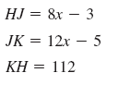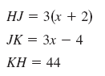

1. 2.

**Let *Q* be in the interior of** ∡**POR. Use the Angle Addition Postulate to solve for $x$*.* Find the measure of each angle.**

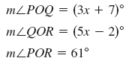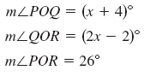

3. 4.

5. bisects ∠LMN. If m∠LMO = ${(x}^{2}+4x-5)°$ and m∠LMN = (9 $x+5)°$, solve for $x$ and find m∠NMO.

6. If two planes intersect, then their intersection is always a ______________________________.

7. Through any three noncollinear points there is exactly one________________________________________.

8. Through any two points there is exactly one ___________________________.

9. Draw a pair of angles that are adjacent but not a linear pair.

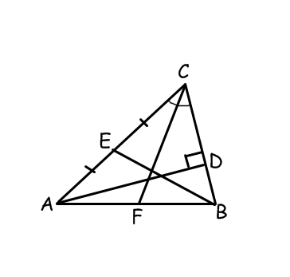**For # 10 & 11, refer to the figure at the right.**

10. is a _________________________ of ∆ABC

11. _____________________ is an altitude of ∆ABC.

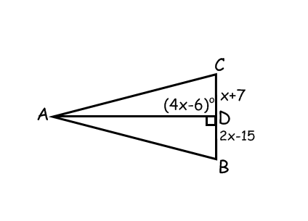12. Find the value of $x$ if $\overline{AD}$ is an altitude of ∆ABC.

13. Draw a Venn Diagram to represent the statement: “A triangle is a polygon.”

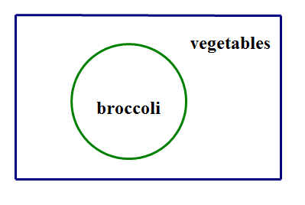14. Write a conditional statement that is represented by the Venn Diagram at right.

__________________________________________________________________________________________

**For #15-18, find the value(s) of the variable(s).**

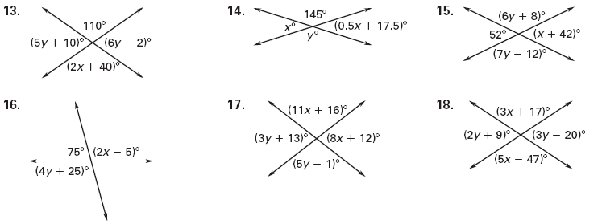

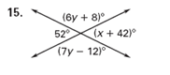



20. In triangle ABC, m∠B is 3 times the m∠A. m∠C is 20 less than 4 times m∠A. Find the measure of each

angle.

19. Assume that *A* is supplementary to *B* and complementary to *C*. Determine *m*∠ *A*, *m*∠ *B*, and

 *m*∠*C* if

**Find the values of the variables.**

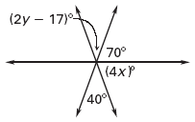 22.

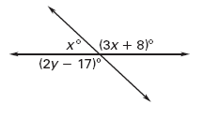21. 22.

**Write the conditional and converse of the statement, and determine if the converse is true. If both statements are true, write a biconditional, if not, give a counterexample.**

23. If an angle measure is 32 degrees, then it is an acute angle.

24. An equilateral triangle is a triangle with 3 congruent angles.

25. When ,

**Find the measure of all labeled angles in the diagram.**

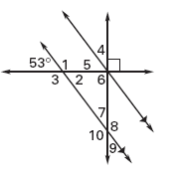

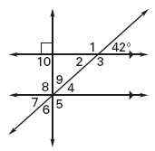

26. 27.

**Find the value of *x* and *y*.**

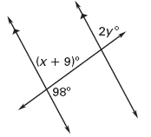

28. 29.

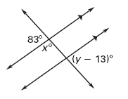

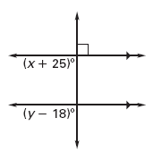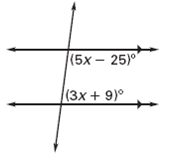

30. 31.

**Solve for the given variable and find the angle measures.**

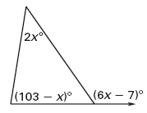32. 33.

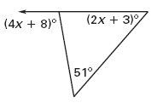

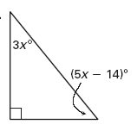34. 35.

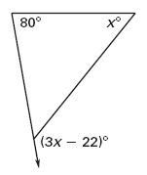

36. 37.

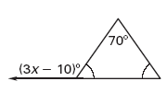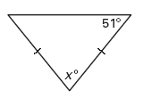

**Name which triangle congruence theorem or postulate you would use to prove the triangles congruent.**

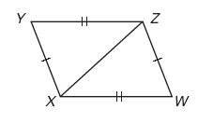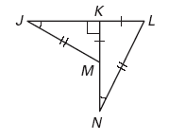

38. 39.

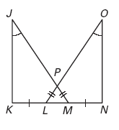

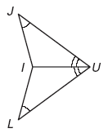40. 41.

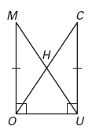

42.

**LABEL AND STATE** the third congruence that is needed to prove the two triangles congruent using the given theorem.

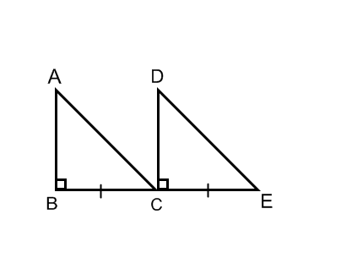

1. **HL $≅$** 44. **SAS $≅$**  45. **ASA**

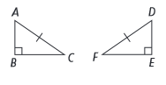

_________________ __________________ __________________

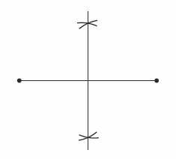46. What is being constructed in the figure to the right?

1. Perpendicular bisector
2. Parallel lines
3. Circle
4. Copy of an angle

47. Perform the following constructions with a compass and straightedge;

1. Construct the perpendicular bisector of the segment LK. Mark it accordingly.

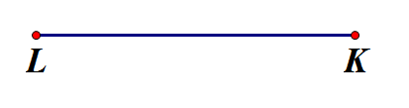

1. 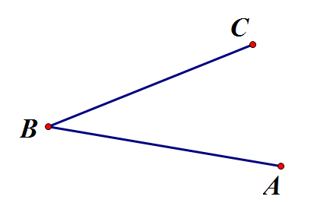Construct the angle bisector of <ABC. Mark it accordingly.
2. Construct an angle congruent to <ABC and call it <DEF.



1. 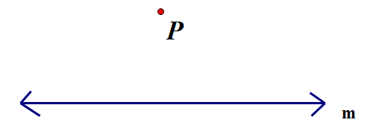Construct the line perpendicular to line m that goes through point P.
2. $\overline{YV }$ is an angle bisector of ∆XYZ. Determine m∡ZYV and m∡XYZ if m∡XYZ = $8x-6$ and

m∡XYV = $2x+7$.

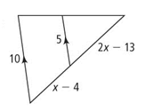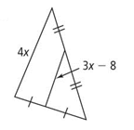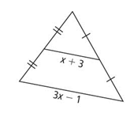**For #49-51, solve for $x$.**

1. 50. 51.

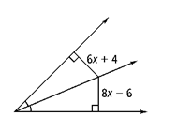52*. PM* = 4 $x$ + 7 and *PN* = 12 $x$– 5 53. Solve for $x$.

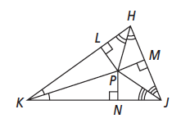 Find *PL*.

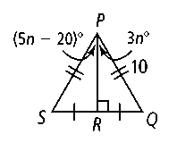54. a. According to the diagram, what are the lengths of  and *?*

b. How is related to ∠*SPQ?*

c. Find the value of *n.*

d. Find *m*∠*SPR* and *m*∠*QPR.*

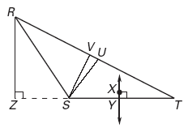55. Use the diagram shown and the given information to name each line or segment as the altitude, median, angle bisector, or perpendicular bisector of a triangle.

m*****RSV* = *m***** *TSV*, *RU* = *UT* and *SY* = *TY*

56. Find the measure of ∡RST given || , m∡SRX = 120°, m∡STY = 160°

57. Find m∡UVW given || . 58. Solve for . || .



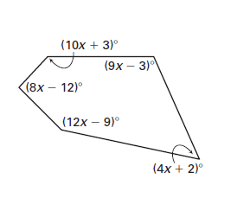

59. Solve for .

60. One exterior angle of a regular polygon is, what is the measure of one interior angle? ___________

1. One exterior angle of a regular polygon is, how many sides does the polygon have? ___________
2. One interior angle of a regular polygon is, how many sides does the polygon have? __________

**Use the figure below for #63-70. , .**

Decide whether the following pairs of angles are congruent. If yes, state the postulate or theorem to support your answer. If no, explain why not.

63.  _________________

________________________________

64.  __________________

________________________________

65.  _________________

________________________________

66.  ________________

________________________________

Given the following relationships and using the figure above, which lines (if any) can be proven parallel? Give the postulate or theorem to support your answer.

67.  68. 

______ ; ________________________ ______ ; ________________________

69. are supplementary 70. 

______ ; ________________________ ______ ; __________________________

71. Find the measures of each of the numbered angles in the figure below.



1 = ______ 2 = ______

3 = ______ 4 = ______

5 = ______ 6 = ______

7 = ______ 8 = _____

Is *a**b*? ________ Why?_______________________

Is *d**e*? _______ Why?_______________________

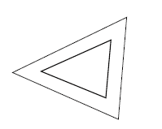72. Tell what type of TRANSFORMATION is shown in each diagram.

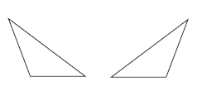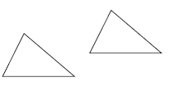

a. b. c.

_______________________ _______________________ _______________________

**For #73 & 74, list the coordinates of the vertices. Perform each transformation. Then list the coordinates of the new vertices. Finally, write the transformation rule.**

73. Rotate about the origin 90 degrees clockwise 74. Translate left 5 and up 3

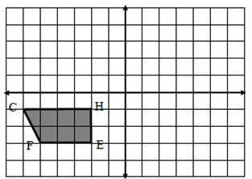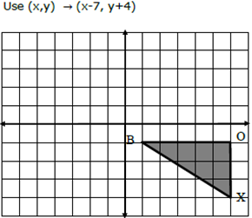

Original coordinates ____________________ Original coordinates ____________________

New coordinates________________________ New coordinates_______________________

Rule_______________________ Rule____________________

75. Given the point and its image, determine the scale factor.

1. $A(3,6) A’(4.5, 9)$ b. $G’(3,6) G(1.5,3)$ c. $B(2,5) B’(1,2.5)$
2. The sides of one right triangle are 6, 8, and 10. The sides of another right triangle are 10, 24, and 26. Determine if the triangles the second one is a dilation of the first. If so, what is the scale factor?

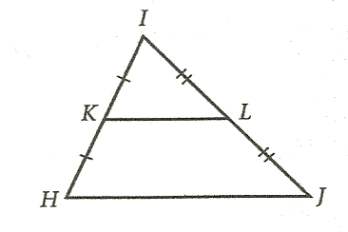**Use the diagram to the right for #77 & 78.**

77. If cm, then _________

78. If and , then

79. Solve for .



80. Find the measure of ∠ABC.

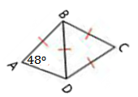

81. Solve for $x$ if $AB=4x+1, BC=2x, and AC=3x+2$. The perimeter of $∆ABC=96$ units.

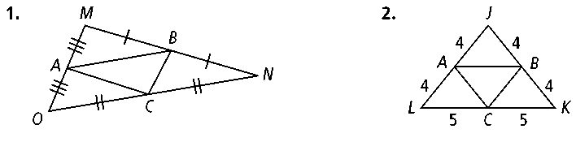

**For #82-84, find the possible measures for $\overline{XY}$ in ΔXYZ.** Write as an inequality or “between __ and __”

82. XZ = 6 and YZ = 6 83. XZ = 9 and YZ = 5 84. XZ = 11 and YZ = 6

85. Can the following be the side lengths of a triangle?

a. 32, 50,  b. 20, 12, 8 c. 122, 106, 100

86. Explain the difference between parallel, intersecting, and skew lines.

87. If line *p* is parallel to line *q*, and line *p* is perpendicular to line *m*, then must line *p* intersect line *q*?

Explain.

88. In a plane, if 2 lines are both perpendicular to the same line then _________________________________.

89. In a plane, if line *p* is perpendicular to line *m*, and line t is also perpendicular to line *m*, then__________.

**Write a proof for each of the following.**

90. **Given**: ≌; ≌

**Prove**: ||

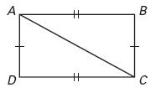

91. **Given**: p || q; ∠1 ≌ ∠2

**Prove**: *l*||*m*



92. **Given**: 

**Prove**: 



93. **Given**: bisects

**Prove**: 



94.  **Given:** is the midpoint of  ;

**Prove:**

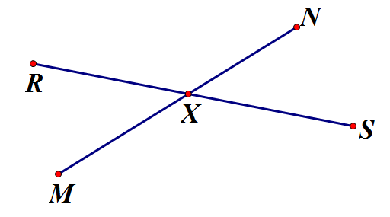

95. **Given:** m∠1 + m∠3 = 180

**Prove:** ∠1  ∠2

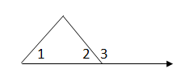

96. **Given:** ∠1  ∠3 ; ∠2  ∠4

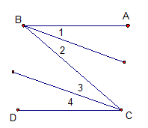 **Prove:** ∠  ∠

97. **Given:**  ;  ; ; 

**Prove: $B$** is the midpoint of 

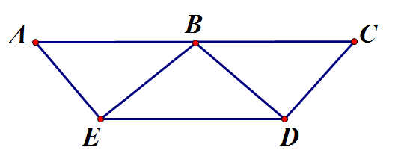

**Algebra Skills Practice**

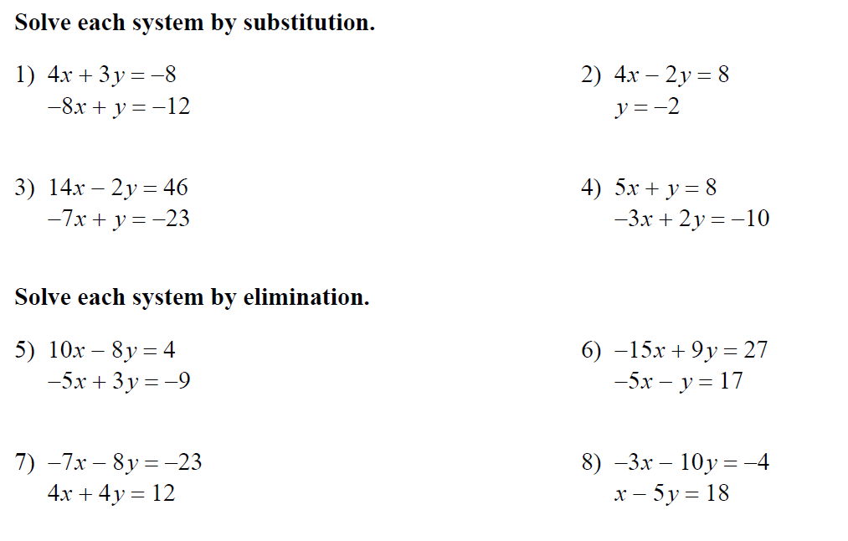

**Find all possible values of the given variable by factoring.**

1. 6x2-13x = 5 2. 10x = 25 - 3x2 3. 10x2+17x+3 = 0

4. 6x2 - 3 = 7x 5. 12x2 - 28x - 5 = 0 6. 14x2+1 = 9x

**MORE FACTORING PRACTICE**

