**Geometry 21Midterm Review Answer Key**

1. x = 7, HJ= 27 units, JK = 17 units

2. x = 6, HJ = 45 units, JK = 67 units

3. x = 8, ,

4. x = 7,

5. x 3,

6. line

7. plane

8. line

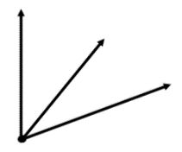9.

10. median

11.

12. x = 24 units

13. If a figure is a triangle, then it is a polygon.

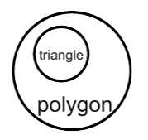

14. If a piece of food is broccoli, then it is a vegetable.

15. x = 10, y = 20

16. x = 55, y = 20

17. x = 8, y = 21

18. x = 32, y = 29

19. x = 25,

20. x = 13,

21. x = 43, y = 77

22. x = 17.5, y = 28.5

23. Conditional: If an angle measure is 32 degrees,

then it is an acute angle. (original)

Converse: If it is an acute angle, then the angle

measure is 32 degrees.

False converse…counterexample : a 40 degree

angle (or anything less than 90)

24. Conditional: If it is an equilateral triangle, then it

is a triangle with 3 congruent angles.

Converse: If it is a triangle with 3 congruent

angles, then it is an equilateral triangle.

Both true, so…

Biconditional: It is an equilateral triangle if and only if it is a triangle with 3 congruent angles.

25. Conditional: If x = 3, then x2 = 9

Converse: If x2 = 9, then x = 3

False converse…If x2 = 9, then x could be

negative 3 (x = -3)

26. m<1 = 138, m<2 = 42 $°$, m<3 = 138 $°$, m<4 = 42 $°$,

m<5 = 90 $°$, m<6 = 48 $°$, m<7 = 42 $°$, m<8 = 90 $°$,

m<9 = 48, m<10 =90.

27. m<1 = 127, m<2 = 53 $°$, m<3 = 127 $°$, m<4 = 37 $°$,

m<5 = 53 $°$, m<6 = 90 $°$, m<7 = 37 $°$,

m<8 = 143 $°$, m<9 = 37 $°$, m<10 =143.

28. x = 97, y = 96

29. x = 73, y = 41

30. x = 24.5

31. x = 65, y = 108

32. x = 23; angles measure 100o and 49 o  
33. x = 22; angles measure 440, 81,, and 125o

34. x = 51, angles measure 131, and 51

35. x = 13 o, angles measure 39 o, and 51 o

36. x = 78 o; angle measures = 51

37. x = 27; angles measure 55o, and 125 o

38. HL ≅ theorem

39. SSS ≅ postulate

40. AAS ≅ postulate

41. AAS ≅ postulate

42. SAS ≅ postulate

43. ≅ (or ≅)

44. ∠A≅∠D

45. ∠ACB≅∠DEC

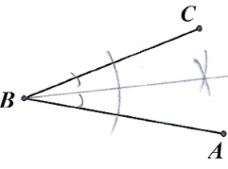46. a

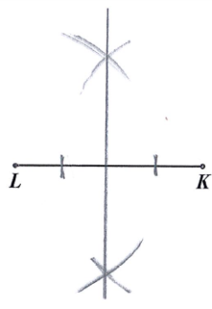47a) b)

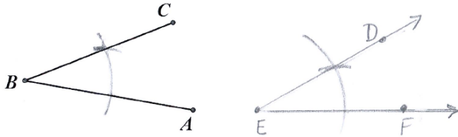

c)

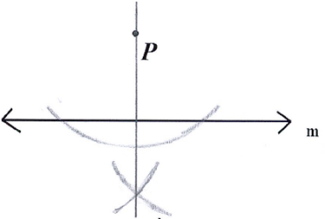d)

48. m∠ZYV=17˚ ; m∠ZYV=34˚

49. x=7

50. x=8

51. x=9

52. PL=13

53. x=5

54. PQ=PS=10; a) $\overline{PR}$ bisects ∠SPQ; b)n=10; c)m∠SPR=m∠QPR=30˚

55. = angle bisector

$\overline{SU }$ = median

$\overline{XY }$ = perpendicular bisector

$\overline{RZ }$ = altitude

56.

57. 110

58. *y* = 20 and *x* = 30

59. *x* = 13

60. 165

61. 10 sides

62. 18 sides

63. yes; alternate interior angles

64. yes; corresponding angles

65. no; b/c we don’t know that

66. yes; alternate interior angles

67. ; converse of corresponding angles

68. ; converse of alternate interior angles

69. ; converse of SSIA

70. ; converse of alternate exterior angles

71. 1 = 48° 2 = 90°

3 = 42° 4 = 90°

5 = 48° 6 = 48°

7 = 44° 8 = 136°

Yes No

72. a.) translation b.) reflection c.) dilation

73. original C (-6, -1), H (-2, -1) F (-5, -3) E (-2,-3)

New pts

Rule

74. original pts B (1, -1) O (5, -1) X (5, -4)

New pts B’(-5, 2) O’(1, 2) X’ (1, -1)

Rule-

75. a.) n = 1.5 b.) n = 2 c.) 0.5

76. No, the scale factors are different

77. KL= 13 units

78. x = 3, HJ = 8 units

79. x = -3, 7/2

80.

81. x = 5

82.

83.

84.

85. a.) yes b.) no c.) yes

86. Parallel lines- two or more coplanar lines that will never intersect

Skew lines- two are more non-coplanar lines that will never intersect

Intersecting lines- two or more lines that intersect

87. No. The lines can be skew if they are non-coplanar

88. The lines are parallel

89. $p∥ t$

|  |  |
| --- | --- |
| **Statements** | **Reasons** |
| $\overline{AD}≅\overline{BC}$; $\overline{AB}≅\overline{DC}$; | Given |
| $\overline{AC}$ ≅ $\overline{AC}$ | Reflexive prop of ≅ |
| $$∆ACD ≅ ∆CBA$$ | SSS ≅ postulate |
| ∠DAC  ∠BCA | CPCTC |
| $$\overline{AD}∥\overline{ BC}$$ | Converse of Alt. Int. angles theorem |

90.

|  |  |
| --- | --- |
| **Statements** | **Reasons** |
| $p∥ q$, ∠1∠2 | Given |
| ∠3∠1 | Corr. Angles postulate |
| ∠3∠2 | Substitution/ transitive prop |
| $$l∥ m$$ | Converser of alt. ext. angles theorem |

91.

|  |  |
| --- | --- |
| **Statements** | **Reasons** |
| $$l∥ m$$ | Given |
| ∠1∠3 | Alt. Ext. angles theorem |
| $$∠2 and ∠3 are a linear pair$$ | Def. of linear pair |
| $$∠2 and ∠3 are a supplementary$$ | Linear pair postulate |
| $$∠1 and ∠2 are a supplementary$$ | Congruent supplements theorem |

92.

|  |  |
| --- | --- |
| **Statements** | **Reasons** |
| $\overline{XY}≅\overline{XW}$; $\overline{XZ} bisects∠ YXW$; | Given |
| ∠YXZ∠WXZ | Def. of angle bisector |
| $\overline{XZ}$ ≅ $\overline{XZ}$ | Reflexive prop of ≅ |
| $$∆ZYX ≅ ∆ZWX$$ | SSS ≅ postulate |

93.

|  |  |
| --- | --- |
| **Statements** | **Reasons** |
| m∠1 + m∠3 = 180 | Given |
| ∠1 & ∠3 are suppl. ∠s | Defn. of suppl. ∠s |
| ∠2 & ∠3 form a linear pair | Defn. of linear pair |
| ∠2 & ∠3 are suppl. ∠s | Linear Pair Postulate |
| ∠1  ∠2 | Congruent Supplements Theoerm |

94.

|  |  |
| --- | --- |
| **Statements** | **Reasons** |
| X is the midpoint of $\overline{MN}$; MX = RX | Given |
| $\overline{MX}$ ≅ $\overline{XN}$ | Defn. of midpoint |
| MX = XN | Defn. of congruent segments |
| XN = RX | Substitution POE |

95.

|  |  |
| --- | --- |
| **Statements** | **Reasons** |
| ∠1∠3 ; ∠2∠4 | Given |
| m∠1=m∠3; m∠2=m∠4 | Defn. congruent angles |
| m∠1 + m∠2 = m∠ABC  m∠3 + m∠4 = m∠BCD | Angle Addition Postulate |
| m∠3 + m∠4 = m∠ABC | Substitution POE |
| m∠ABC = m∠BCD | Substitution POE |
| ∠ABC  ∠BCD | Defn. congruent angles |

96.

|  |  |
| --- | --- |
| **Statements** | **Reasons** |
| $\overline{AE}$ ⊥ $\overline{BE}$; $\overline{CD}$ ⊥ $\overline{BD}$; $\overline{AC}\overline{ED}$;  ∠BED∠BDE | Given |
| $\overline{BE}$ ≅ $\overline{BD}$ | Conv. Isosc. ∆ Thm. |
| ∠ABE & ∠BED are Alt. Int. ∠s;  ∠BDE & ∠CBD are Alt. Int. ∠s | Defn. Alt. Int. ∠s |
| ∠ABE∠BED; ∠BDE∠CBD | Alt. Int. ∠s Thm |
| ∠ABE∠CBD | Transitive .POC |
| ∆∠ABE ≅ ∆CBD | ASA Postulate |
| $\overline{AB}$ ≅ $\overline{BC}$ | CPCTC |
| B is the midpoint of $\overline{AC}$ | Defn. midpoint |

97.

**Algebra Skills Practice Answer Key**

1. (1 , 4)
2. (1, -2)
3. Infinitely many solutions
4. (2, -2)
5. (6 ,7)
6. (-3, -2)
7. (1, 2)
8. (8, -2)3
9. *x* = -1/3 and *x* = 5/2
10. *x* = -5 and 5/3
11. *x* = -1/5 and -3/2
12. *x* = 3/2 and -1/3
13. *x* = -1/6 and 5/2
14. *x* = 1/7 and 1/3
15. *x* = -3
16. *x* = -2 and 5
17. *e* = -9, -1
18. *a* = 1/3 and -7
19. *x* = -1/2 and 11
20. *a* = 5/1 and -7/2