Geometry **7-2 Similar Polygons** Name _____________________per_______

***Objective:*** *Students will be able to identify and apply similar polygons.*

**Similar Polygons** have the _____________________________ but *not necessarily* the same size. Symbol:

**Definition:** *Two polygons are* ***SIMILAR*** *polygons if corresponding* ***angles are congruent*** *and if the* ***lengths of corresponding sides are proportional***

* 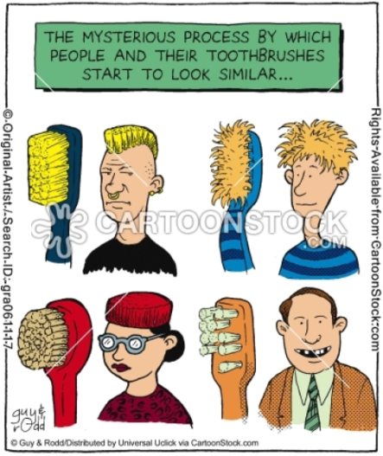how is this different from 2 polygons that are congruent??

|  |  |
| --- | --- |
| Diagram | Symbols |
|  |  |

When three or more ratios are equal you can write an ratio.

Ex: $\frac{AB}{GH} =\frac{BC}{HI} =\frac{CD}{IJ} = \frac{AD}{GJ}$

When 2 polygons are similar, we can write a **similarity statement**, in which **corresponding vertices** must be written **in correct order**. (just like in congruence statements)

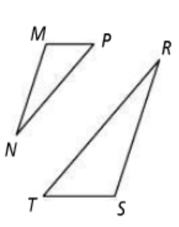**Understanding Similarity:**

$∆MNP \sim ∆SRT$

1. What are the pairs of congruent angles?
2. What is the extended proportion for the ratios of corresponding sides?

J

K

E

F

DEFG $\sim HJKL$

1. What are the pairs of congruent angles?

G

D

L

H

1. What is the extended proportion for the ratios of corresponding sides?

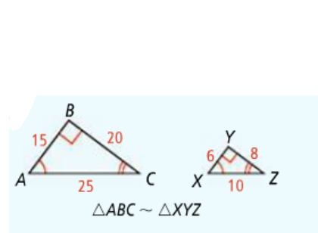**SCALE FACTOR** is the ratio of corresponding linear measurements of two similar figures. ***\*\*remember to match up***

***corresponding parts; shortest***

***side to shortest side, etc…***

   So the scale factor of  to is 

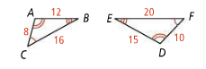Write a similarity statement, then find the scale factor of  to ;

Similarity statement;______________ Scale factor_____

1. **Are the polygons similar**? If they are, write a similarity statement and give the scale factor.

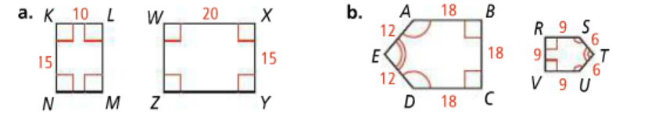

(**short to short, long to long)____________________ _________________________________

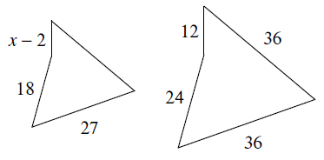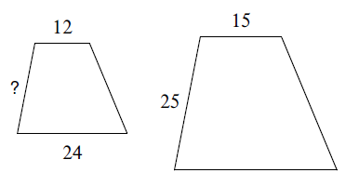**FINDING MISSING lengths;** The polygons are similar. Use the diagrams to help you write a proportion to solve for the missing side.

1. 8)

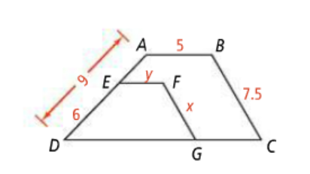

$9) ABCD \sim EFGD$ What is the value of x and y?

*10) Your class is making a rectangular poster for a pep rally. The poster’s design is 6in. high by 10in. wide. The space allowed for the poster is 4ft. high by 8ft. wide. If you enlarge your design so that the height fills the full 4 ft high space, how wide will the actual poster be?

In **SCALE DRAWINGS**… all lengths are proportional to their corresponding actual lenths. The is the ratio that compares each length in the scale drawing to the actual length.

1. 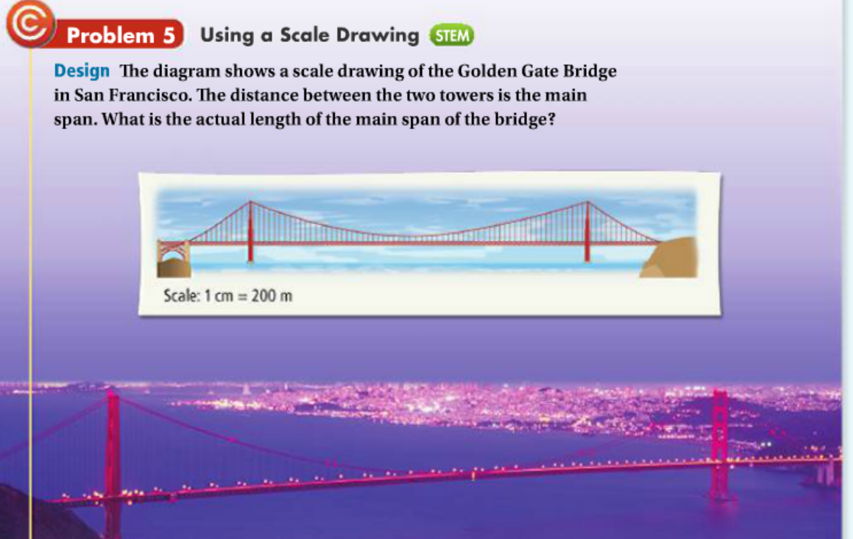 The length of the bridge span is 6.4 cm. Using proportions find the actual length of the bridge.
2. Ella is reading a map with a scale of 1 in. = 20 mi. On the map, the distance Ella must drive is 4.25 in. How many miles is this?
3. For art class, you need to make a scale drawing of the Parthenon using the scale 1 in. = 5 ft. The Parthenon is 228 ft long. How long should you make the building in your scale drawing?

HW: pg. 444-446 # 1-27 odd and # 37