Geometry 7.3 Proving Triangles Similar (day 1) Name ______________________per____

Objective: The students will be able to use the AA, SAS, and SSS Similarity Postulate/ Theorems.
Remember…
Two polygons are similar if corresponding angles are ___________________
AND if the lengths of the corresponding sides are ______________________.

- Therefore, for the similar triangles below, complete the statements about the angles and sides;
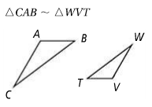
Angles: Sides:
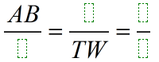
A ___
_________
_________

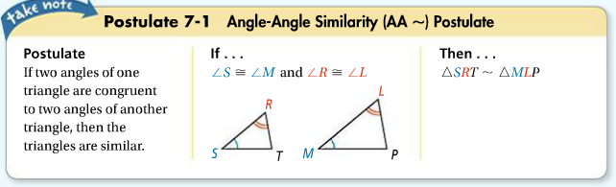
What information do we need to tell if 2 triangles are similar?

…so we only need to know 2 pairs of angles are congruent to know the 2 triangles are similar. (AA~)
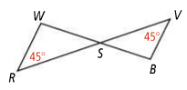
Are the 2 triangles similar? Explain how you know. List any theorems that help you find necessary information.
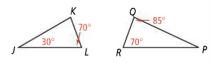
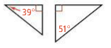
- 2) 3)

__________________________ _________________________________ _____________________
__________________________ _________________________________ _____________________

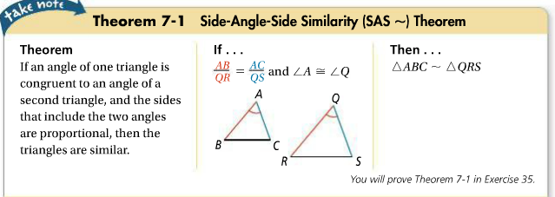

…so we only need to know 2 pairs of sides are proportional, and their included angles are congruent to know the 2 triangles are similar. (SAS~)
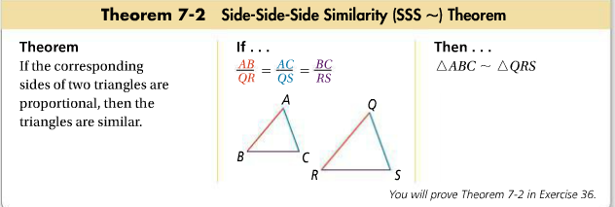

…so we only need to know that all the sides are proportional to know the 2 triangles are similar. (SSS~)
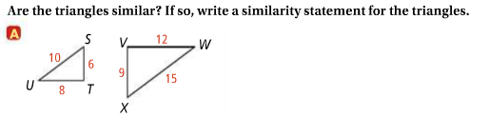
4)

****You must check that ALL 3 pairs of sides are proportional!!

Similarity statement _____________________
There are 3 ways of proving 2 triangles similar…AA~, SAS~, or SSS~
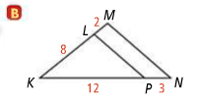
5)

Similarity statement _____________________
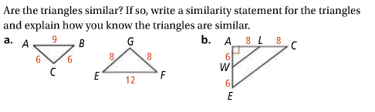
6)

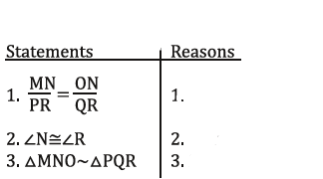
PROOFS: (yay! )
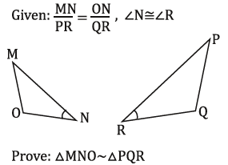
7)

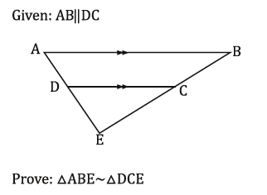
8)
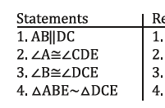

HW: pg. 455-456 #1-12 all, #18-21
PRACTICE
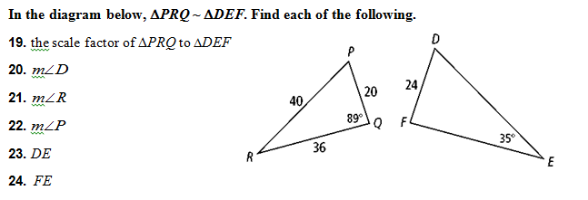
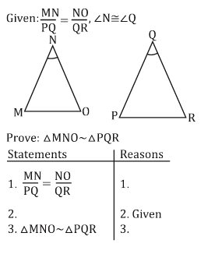
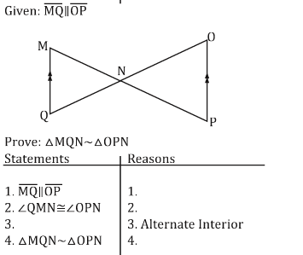
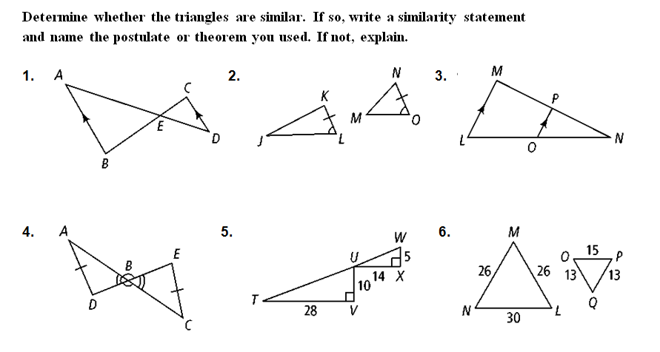
7. 8.

Geometry 7.3 Proving Triangles Similar (day 2) Name ______________________per____

Objective: The students will be able to use the AA, SAS, and SSS Similarity Postulate/ Theorems and indirect measurement to find missing side lengths.
If we know 2 triangles are similar, we can use proportions to find the lengths of unknown sides. Sometimes we need to use ‘indirect measurement’ to do this when lengths are hard to measure.
Shadow Method—
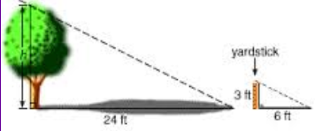
Case 1 -- Find the height of the tree using proportions.

Which postulate allows this to work? _____

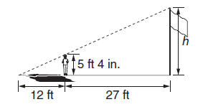
Case 2 -- Find the height of the flagpole using proportions.

Which postulate allows this to work? _____
You Try;
- Your sister is 4 feet 6 inches tall and her shadow at a certain time of day is 6 feet long. The telephone pole that she is standing next to is casting a shadow that is 32 feet long at the same time of day. How tall is the telephone pole? (draw and label a diagram to help you)

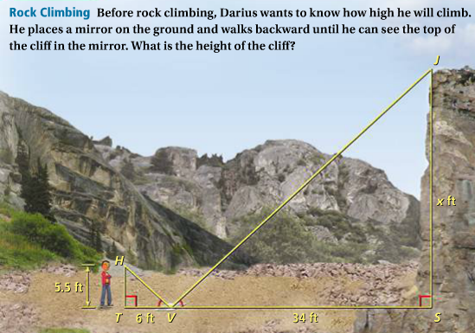
Mirror Method--

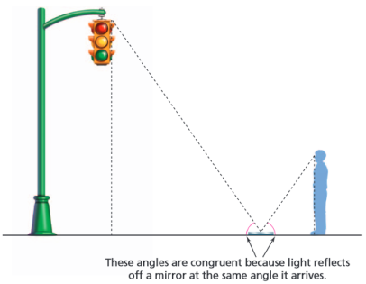
You try…
- Use the given information below to label the diagram
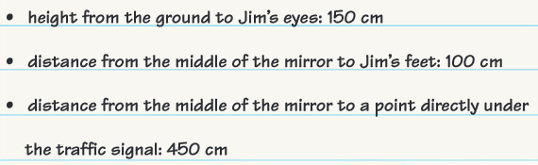
And find the height of the traffic light.

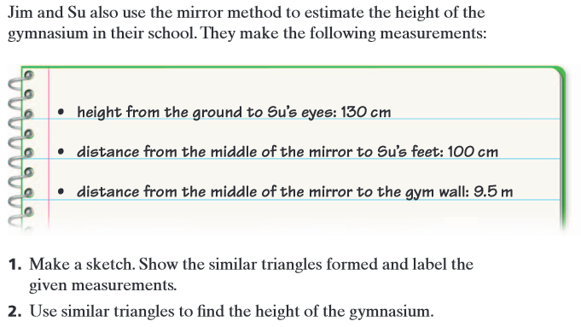

HW Pg. 455- 456 # 7- 23 odd

