Geometry 7.5 Proportions in Triangles Name ______________________per____
Objective: The students will be able to use the Side-Splitter Theorem and the Triangle-Angle-Bisector theorem.
I was looking for some
but this is what I found instead;

…well if that joke didn’t split your sides, this theorem will!
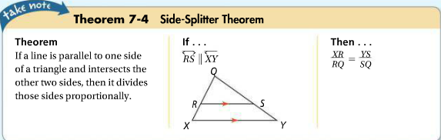

Let’s use the Side-Splitter Theorem;
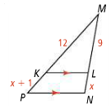
- Find the value of the variable in each diagram;
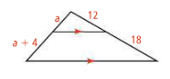
- b)

*****Please take CAREFUL NOTICE!!!***** The Side-Splitter Theorem CANNOT be used in examples like the following, when some of the information given is about the parallel sides, rather than both “split” sides.
- In a case like this, we use the properties of SIMILAR triangles to solve! (NOT Side-Splitter!)
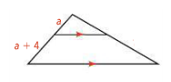
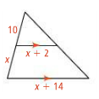
- b)

12

30
Again… NOT Side-Splitter!)
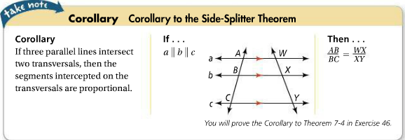
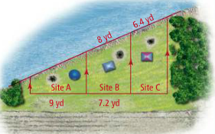
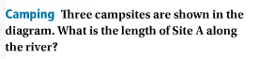

There is another theorem that helps us find missing sides in triangles;
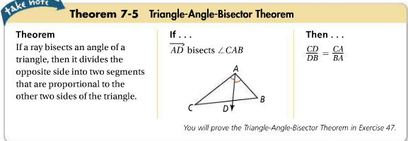

- Find the value of x;
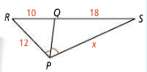
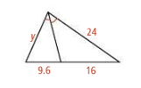
- b)

HW pgs 474-476 #9 – 35 odds. (plus # 37 for geo 21)

