Geometry 8.2 Special Right Triangles Name __________________________________
Objective: To use the properties of 45º-45º-90º and 30º-60º-90º triangles
Some right triangles have properties that allow us to use shortcuts to find side lengths instead of using the Pythagorean Theorem!
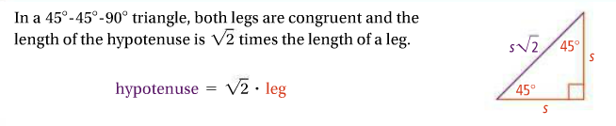
45º-45º-90º Triangle Theorem

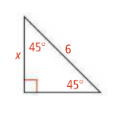
- What is the value of each variable?

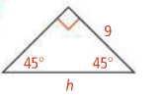
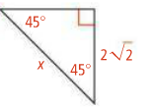

30º-60º-90º Triangle Theorem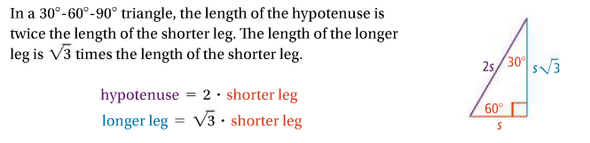

- What is the value of d in simplest radical form? What is the value of f in simplest radical form?

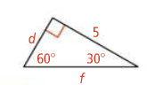

- What is the length of the hypotenuse of a 45º-45º-90º triangle with leg lengths ?

- The length of the hypotenuse of a 45º-45º-90º triangle is 10. What is the length of one leg?

- A high school softball diamond is a square. The distance from base to base is 60ft. To the nearest foot, how far does a catcher throw the ball from home plate to second base?

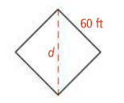
- You plan to build a path along one diagonal of a 100ft by 100ft square garden. To the nearest foot, how long will the path be?

- What is the height of an equilateral triangle with sides that are 12cm long? Round to the nearest tenth.

HW pgs. 503-505 # 1-29 odd (geo 21 also do #30 & 34)

