Geometry **8.3 Trigonometry** Name _______________________________

**Objective***: to use the sine, cosine, and tangent ratios to find the side lengths in right triangles.*

S O H C A H T O A =

**S**ine = **O**pposite/**H**ypotenuse, **C**osine = **A**djacent/ **H**ypotenuse, **T**angent = **O**pposite/**A**djacent

*To investigate Trigonometry, let’s first look at what we already know about right triangles…*

* Are all right triangles similar? Why?
* If you know that 2 right triangles each have an angle that is 42o, then are the 2 triangles similar? How do you know?
* If 2 right triangles are similar, then what do we know about the ratios of their sides?

**The ratios of the corresponding sides of similar right triangles are called the TRIGONOMETRIC RATIOS.**

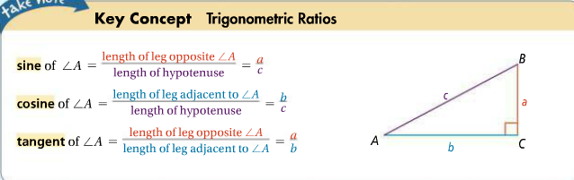

1. Use the diagram to right the trig. ratios for each. Leave your answers as fractions.

**\*\*Tip\*\***always find your hypotenuse and label that FIRST!!

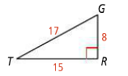

Example: sin G = 

1. sin T = ______ b) cos G = ______ c) cos T = ______

d) tan T = ______ e) tan G = ______

***\*\*Notice**you will NOT be asked to find the sine, cosine, or tangent of the right angle…only the 2 acute angles in the triangle.***

***To solve for the missing sides of a triangle using trigonometry;***

1. Label the hypotenuse with “hyp” or a capital “H”
2. Locate the ‘angle of interest’ *(Which angle is going to help us in this problem?)*
3. From the viewpoint of THAT angle, label the side opposite it with “opp” or capital “O” and label the side adjacent to it “adj” or capital “A” *(remember the hypotenuse is already labeled, you can’t label it again!)*
4. **Decide whether you will be using SIN, COS, or TAN**
5. Write a proportion in the form…

*this is just a sample…remember to use sin, cos, or tan…whichever is appropriate for the given* *problem.*

ex. sin 32o = x (opp)_ 🡪

1. 43 (hyp)
2. Solve the proportion by cross-multiplying and solving algebraically.

**Let’s try these**: You will need to find the trig. buttons on your calculator.

1.  2. 3.

Proportion: Proportion: Proportion:

__________________ __________________ __________________

x = ____________ x = ____________ x = ____________

***To solve for a missing angle of a triangle using trigonometry;***

Follow steps #1-4 above. Your ‘x’ is going to be where the angle measure goes.

Step 5) Write an equation in the form… sin x = (opp)

6) Then you will need to use the **“inverse button”**  before the trig buttons on your calculator, then enter the fraction that you have set up in your equation.

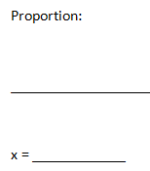**Let’s try these**;

4. 5.

Geometry Name ______________ date _____

**MCj02339660000[1]SOHCAHTOA More Practice MCj02339660000[1]**

*Use sine, cosine, or tangent to find the missing side length or angle measure “x”;*

|  |  |
| --- | --- |
| 1)    Equation ___________________    X = ________ | 2)    Proportion__________________    X = _________ |
| 3)      Proportion ______________________      X = ________ | 4)    Equation ____________________    X = ________ |
| 5)    Proportion ____________________  X = ________ | 6)    Proportion ___________    X = ________ |