**11.3 Surface Area of Pyramids & Cones** Name __________________________________per_____

Objective: the students will be able to find the lateral area and surface area of pyramids and cones.

A **PYRAMID** is a polyhedron that has **one** **base** (which is a polygon) and the lateral faces are _______________________________ that meet at a common **vertex**.

* A pyramid is named by the shape of its base.
* The **altitude** of a pyramid is the perpendicular segment from the VERTEX (point) to the BASE (polygon).
* The length of the altitude is the **HEIGHT** of the pyramid = the DISTANCE from the vertex to the base.
* A **REGULAR PYRAMID** is a pyramid whose base is a *regular polygon* and whose lateral faces are

congruent triangles.

* The **slant height** ( ) is the length of the *altitude of a lateral face* of the pyramid.
* The **lateral area** of a pyramid is the sum of the areas of the congruent lateral faces (without the BASE)

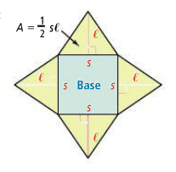

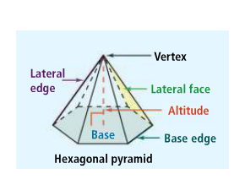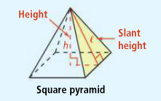

Finding this hidden triangle in a pyramid is

key to solving for SA and V.

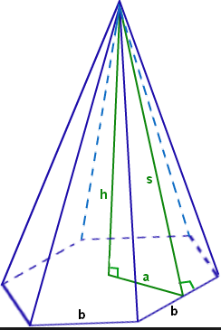**Notice the hidden triangles in the pyramids below;

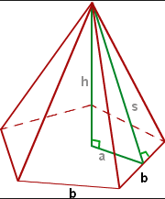

**Lateral and Surface Areas of a Pyramid**

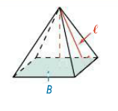 



 (notice… + B because there is only 1 base)

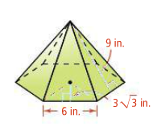

1. What is the surface area of the pyramid?
2. A square pyramid has base edges of 5m and a slant height of 3m. What is the surface area of the pyramid?
3. What is the surface area of the pyramid? Round to the nearest square foot.

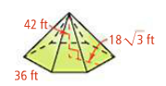

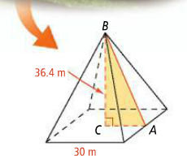

1. The Pyramid of Cestius is located in Rome, Italy. Using the dimensions in the figure below, what is the lateral area of the Pyramid of Cestius? Round to the nearest square meter.

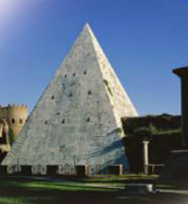

* A **CONE** is a solid that has one base and a vertex that is not in the same plane as the base.

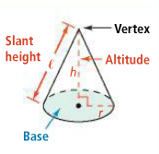

* The **base** of a cone is a ________________________________.

In a **right cone**, the **altitude** is a perpendicular segment from the vertex to the center of the base. The **height** is the length of the altitude. The **slant height** ( ) is the distance from the vertex to a point on the *edge* of the base.

The **lateral area** is half the circumference of the base times the slant height.

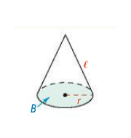**Lateral and Surface Areas of a Cone**

** 🡪 **

 a cone has a

hidden triangle too!

 or 

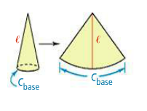By cutting a cone and laying it out flat, you can see how the formula for the lateral area of a cone resembles that for the area of a triangle.





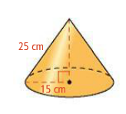

1. What is the surface area of the cone in terms of π?
2. The radius of the base of a cone is 16m and its slant height is 28m. What is the surface area in terms of π?
3. 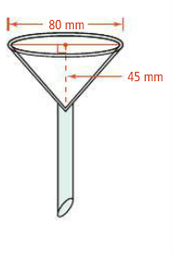In a chemistry lab experiment, you use the conical filter funnel shown at the right. How much filter paper do you need to line the funnel?
4. What is the lateral area of a traffic cone with radius 10 in. and height 28 in.? Round to the nearest whole number.