**11.5 Volume of Pyramids and Cones – NOTES and PRACTICE** Name____________________

***Objective****: the students will be able to find the volume of pyramids and cones*

Look for a pattern in the volumes of the prism and pyramid pairs below.

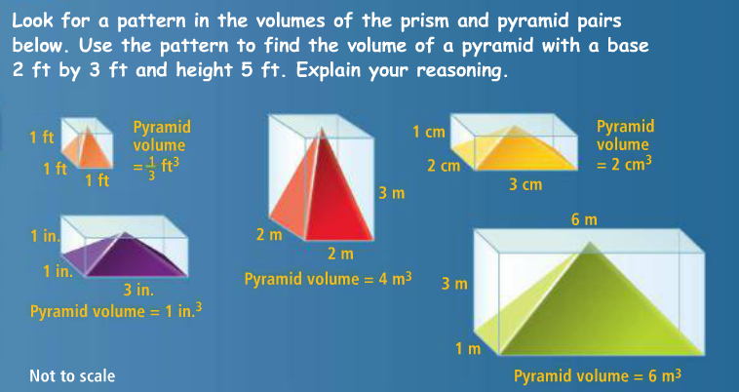

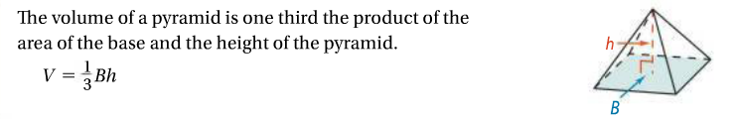 **Volume of a Pyramid**

** H**

**or** 

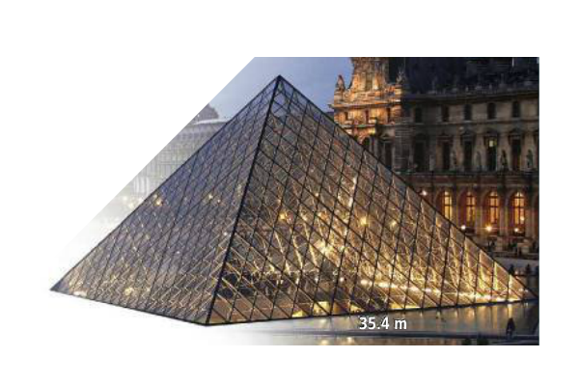

1. The entrance to the Louvre Museum in Paris, France, is a square pyramid with a height of 21.64m. What is the approximate volume of the Louvre Pyramid?
2. A sports arena shaped like a pyramid has a base area of about 300,0000ft2 and a height of 321 ft. What is the approximate volume of the arena?
3. 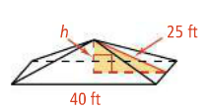What is the volume of the pyramid in cubic feet?
4. What is the volume of a square pyramid with base edges 24m and slant height 13m?

**Volume of a Cone**

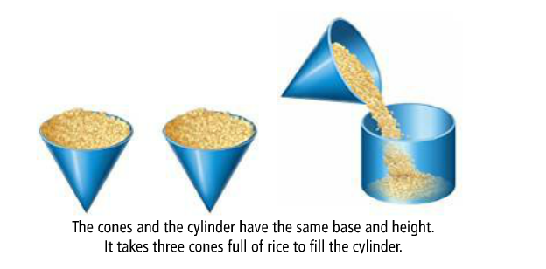

****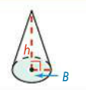

**or **

1. The covering on a tepee rests on poles that come together like concurrent lines. The resulting structure approximates a cone. If the tepee pictured is 12ft high with a base diameter of 14ft, what is the approximate volume?
2. The height and radius of a child’s tepee are half those of the tepee in problem 5. What is the volume of the child’s tepee to the nearest cubic foot?
3. 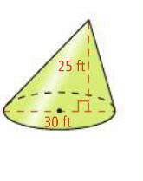What is the volume of the oblique cone in terms of π and rounded to the nearest foot?
4. 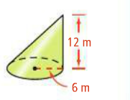What is the volume of the oblique cone in terms of π and rounded to the nearest meter?