Geometry ***Lesson 12.2: Chords and Arcs*** Name ____________________per____

*Objective: Students will use congruent chords, arcs, and central angles*

*Students will use perpendicular bisectors to chords.*

**Chord** – a segment whose endpoints are on a circle

What’s the largest chord that can fit in a circle?

|  |  |  |  |
| --- | --- | --- | --- |
| ***Theorem 12-4 and Its Converse*** | | | |
| **Theorem** | **If…** | **Then…** |  |
| Within a circle or in congruent circles, congruent central angles have congruent arcs. |  |  |
| **Converse** | **If…** | **Then…** |
| Within a circle or in congruent circles, congruent arcs have congruent central angles. |  |  |

|  |  |  |  |
| --- | --- | --- | --- |
| ***Theorem 12-5 and Its Converse*** | | | |
| **Theorem** | **If…** | **Then…** |  |
| Within a circle or in congruent circles, congruent central angles have congruent chords. |  |  |
| **Converse** | **If…** | **Then…** |
| Within a circle or in congruent circles, congruent chords have congruent central angles. |  |  |

|  |  |  |  |
| --- | --- | --- | --- |
| ***Theorem 12-6 and Its Converse*** | | | |
| **Theorem** | **If…** | **Then…** |  |
| Within a circle or in congruent circles, congruent chords have congruent arcs. |  |  |
| **Converse** | **If…** | **Then…** |
| Within a circle or in congruent circles, congruent arcs have congruent chords |  |  |

|  |  |  |  |
| --- | --- | --- | --- |
| ***Theorem 12-7 and Its Converse*** | | | |
| **Theorem** | **If…** | **Then…** |  |
| Within a circle or in congruent circles, chords equidistant from the center(s) are congruent. |  |  |
| **Converse** | **If…** | **Then…** |
| Within a circle or in congruent circles, congruent chords are equidistant from the center(s). |  |  |

Let’s Practice! ☺

1. 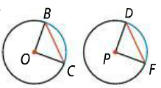In the diagram. .
2. Which arcs are related to ?
3. Which central angles are related to?
4. Given that , what can you conclude?
5. 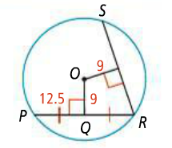Use the circle to the right to answer the following.
6. How is *PQ* related to *PR*?
7. How are the chords drawn in this image related?
8. What is the length of in? Explain.
9. 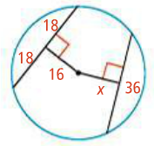What is the value of *x* in the circle to the right? Explain.

|  |  |  |
| --- | --- | --- |
| ***Theorem 12-8*** | | |
| **Theorem** | **If…** | **Then…** |
| In a circle, if a diameter is perpendicular to a chord, then it bisects the chord and its arc. |  |  |

|  |  |  |
| --- | --- | --- |
| ***Theorem 12-9*** | | |
| **Theorem** | **If…** | **Then…** |
| In a circle, if a diameter bisects a chord (that is not a diameter), then it is perpendicular to the chord. |  |  |

|  |  |  |
| --- | --- | --- |
| ***Theorem 12-10*** | | |
| **Theorem** | **If…** | **Then…** |
| In a circle, the perpendicular bisector of a chord contains the center of the circle. |  |  |

*Quick summary of Theorems 12-8 thru 12-10*

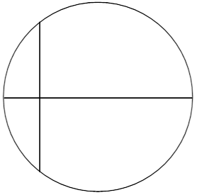

1. Find the values of the missing variables in the following problems.
2. 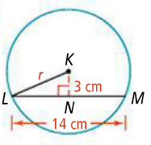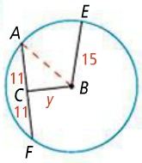 b.

Extra Practice:

1. What can you conclude in the following diagram if ?

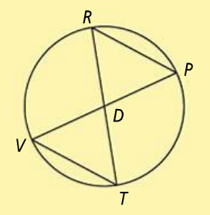

1. Find the value of the missing variables in the following problems.

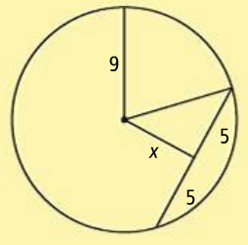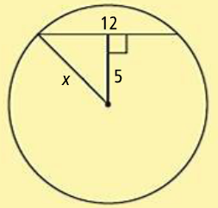

a. b.

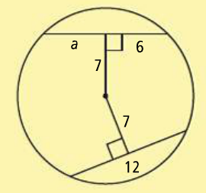c.