Geometry  ***Lesson 12.1: Tangent Lines*** Name ___________________per_____

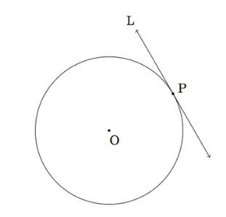

*Objective: Students will use properties of a tangent to a circle.*

*What does* ***perpendicular*** *mean?*

**Tangent to a circle**- a line in the plane of the circle that intersects the circle in exactly **one** point

**Point of tangency** – the point where a circle and a tangent intersect

|  |  |  |
| --- | --- | --- |
| ***Theorem 12-1*** | | |
| **Theorem** | **If…** | **Then…** |
| If a line is tangent to a circle, then the line is **perpendicular** to the radius at the point of tangency. |  |  |

|  |  |  |
| --- | --- | --- |
| ***Theorem 12-2*** | | |
| **Theorem** | **If…** | **Then…** |
| If a line in the plane of a circle is **perpendicular** to a radius at its endpoint on the circle, then the line is tangent to the circle. |  |  |

**Theorem 12-2 is the converse of Theorem 12-1

* **\*SO, when you are given a TANGENT line, immediately draw in a RIGHT angle!!**

|  |  |  |
| --- | --- | --- |
| ***Theorem 12-3*** | | |
| **Theorem** | **If…** | **Then…** |
| If two tangent segments to a circle share a common endpoint outside the circle, then the two segments are congruent. |  |  |

* \***in this situation, mark these two segments congruent**

*Practice:*

1. 

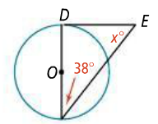

1. 

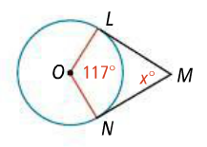

1. 

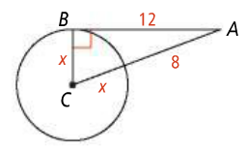

1. 

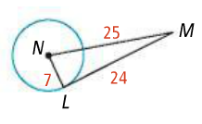

1. 

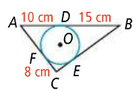

1. 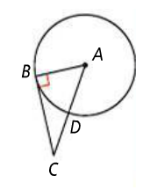
2. 
3. 

5. A classmate insists that  is a tangent to . Explain how to show that your classmate is incorrect.

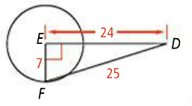

Lines that appear to be tangent are tangent. *O* is the center of each circle. What is the value of *x*?

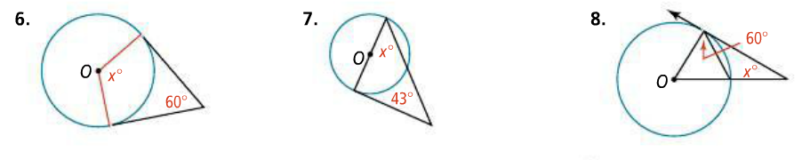

9. The circle at the right represents Earth. The radius of Earth is about *6400 km.* Find the distance *d* to the horizon that a person can see on a clear day from a height, *h*, of *5 km* above the Earth. Round your answer to the nearest tenth of a kilometer.

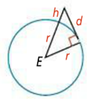

In each circle, what is the value of *x*, to the nearest tenth?

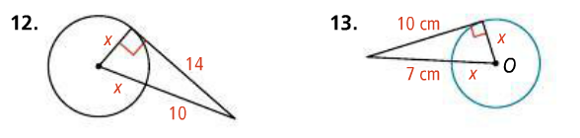

Determine whether a tangent is shown in each diagram. Explain.

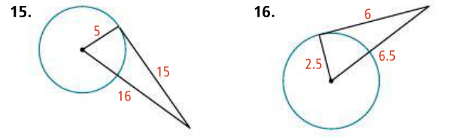

Each polygon circumscribes a circle. What is the perimeter of each polygon?

