**GEOMETRY 21: Review for Final Exam**

***Units 1, 2, 3 (First Semester)***

***Unit 1 - Modeling with Geometry and Definitions (Chapter 1)***

***Unit 2 - Rigid Motions (Chapter 9)***

***Unit 3 - Geometric Relationships and Properties (Chapters 2, 3, 4, 5, 6)***

***True or False***

1. ____ Any 2 lines always intersect at one point.
2. ____ Through any 2 points there is exactly one plane.
3. 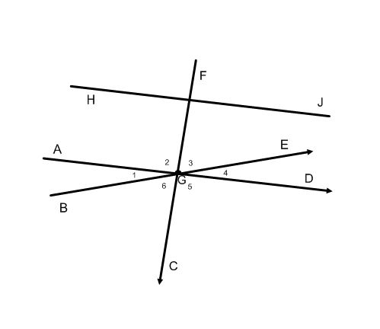____ Any 3 points are always coplanar.
4. ____ If bisects  at point E, then AE = EB.

**Use the diagram at right for questions #5-9.**

1. If ∡2 is a right angle and $m∡4 =4x+10$ degrees,

and $m∡6=8x – 4$ degrees, find $x$ and m∡3.

$x =____________$ m∡3 =_________

1. If m∡6 = y, then write an expression for the

m∡BGF. ____________________

1. If the m∡5 = 90°, then name 2 angles that are

the complements of ∡4. _________ and ________

1. If m∡5 = 90°, name 2 angles that are supplementary,

but do ***not*** form a linear pair. _______ and

$\overline{HJ}⏊\overline{FC}$ ________

1. and $\overline{AD}⏊\overline{FC}$, then $\overline{AD} _____\overline{HJ}$

**For #10-12, identify the type of transformation (translation, reflection, rotation).**

1. 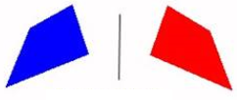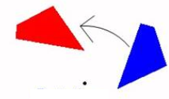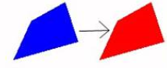 11) 12)

**For #13-16, use the following statement: “Linear pairs are supplementary, adjacent angles.”**

13) Rewrite the statement as a conditional.

14) Write the converse of the conditional.

15) Write the statement as a biconditional.

16) Is the statement a definition? Explain your reasoning.

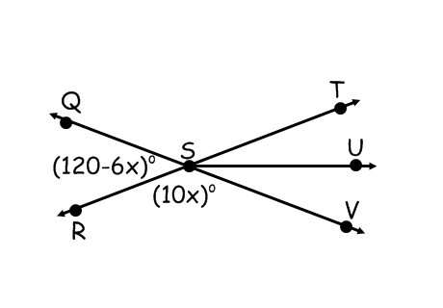**For #17-18, determine the value of *x* in the given diagram.**

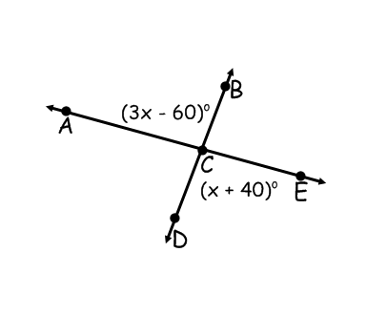

17) 18)

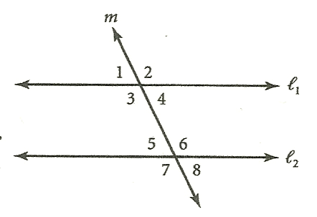

***Multiple Choice.***

_____ 19) What type of angles are ∡3 and ∡6?

a. alternate interior b. alternate exterior

c. same-side interior d. corresponding

_____ 20) If || and m∡1 = 110°, then m∡6=

*(diagram for #19 -23)*

a. 35° b. 55° c. 70° d. 110°

_____ 21) If || and m∡5=75°, then m∡3 =

a. 15° b. 75° c. 90° d. 105°

_____ 22) If m∡5 = 55° and m∡4 = 35° , then $l_{1}$ and $l_{2}$_______.

a. are perpendicular b. are parallel

c. intersect at an acute angle d. intersect at an obtuse angle

_____ 23) Suppose ∡1 and ∡2 are alternate interior angles formed b parallel lines n and p

and transversal t. Which of the following must be true?

a. ∡1 and ∡2 are complementary b. ∡1 and ∡2 are congruent

c. ∡1 and ∡2 are supplementary d. ∡1 and ∡2 have a common vertex

_____ 24) What is the sum of the measures of the interior angles of a hexagon?

a. 180° b. 360° c. 540° d. 720°

_____ 25) If the measure of an exterior angle of a regular polygon is 18°,

how many sides does the polygon have?

a. 6 b. 8 c. 15 d. 20

_____ 26) The measure of an interior angle of a regular polygon is 140°. How many sides does it have?

a. 10 b. 9 c. 8 d. 5

_____ 27) The measure of an interior angle of a regular polygon is four times

the measure of its exterior angle. How many sides does the polygon have?

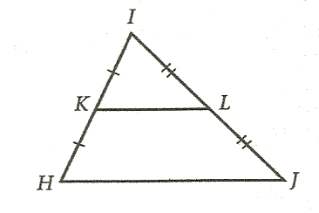 a. 15 b. 12 c. 10 d. 8

_____ 28) If HJ = 26, then KL = _____.

a. 13 b. 26 c. 30 d. 52

_____ 29) If $HJ = 3x – 1$ and $KL = x + 1$, then HJ = _____.

a. 3 b. 4 c. 8 d. 10

*(diagram for #28-29)*

***True or False***

_____ 30) Two lines that are not parallel must intersect.

_____ 31) Two noncoplanar lines cannot be parallel.

_____ 32) A line and plane must either be parallel or intersect.

_____ 33) If two parallel planes are cut by a third plane, then the lines of intersection cannot intersect one another.

_____ 34) If P, Q, and R are noncollinear, only one line can be drawn through P parallel to $\overline{QR}$.

***Decide whether there is enough information to prove the triangles are congruent. State the postulate or theorem that you would use to prove the triangles congruent.***

35) 36) 37)



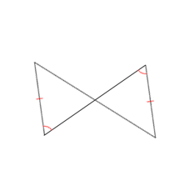

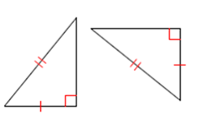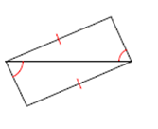

38) 39) 40)

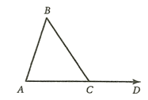***Multiple Choice.***

_____ 41) If $m∡A = x + 5$, $m∡B = x$, and $m∡BCD = 125$ °, then $m∡A$ =

a. 55° b. 60° c. 65° d. 185°

_____ 42) If $\overline{AC}≅\overline{BC}$ and $m∡BCD$ = 108°, then $m∡A$ =

a. 54° b. 72° c. 36° d. 90°

*(diagram for #41-42)*

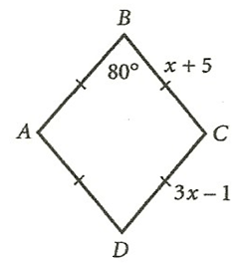

_____ 43) What type of quadrilateral is *ABCD*?

a. square b. rhombus c. rectangle d. trapezoid

_____ 44) What is the length of side ?

a. 3 b. 6 c. 8 d. 9

_____ 45) What is the measure of ∡A?

*(diagram for #43-45)*

a. 80˚ b. 90˚ c. 100˚ d. 180˚

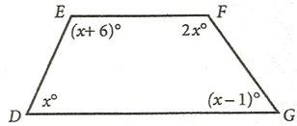_____ 46) What is m∠G in quadrilateral DEFG?

a. 35˚ b. 70˚ c. 71˚ d. 77˚

*(diagram for #46)*

47) Determine whether each statement is Sometimes, Always, or Never true.

Justify each sometimes answer.

1. If a figure is a parallelogram, then it can be a trapezoid.
2. A square is a rhombus.
3. A rectangle is a square.
4. If a figure is a quadrilateral, then it has all right angles.
5. The diagonals of a square are perpendicular.

48) is the midsegment of trapezoid *ABCD*. If AB= 𝑥2 + 3𝑥 + 7, DC = 𝑥2 + 6, and EF = 7𝑥 − 1,

determine the length of EF.

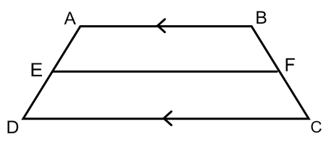

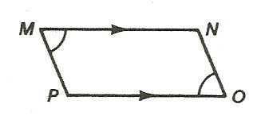49) Write a two-column proof.

**Given: **| | ; ∡M ≌ ∡O

**Prove: **| | 

STATEMENTS

REASONS

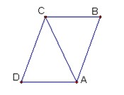50) Write a two-column proof

**Given**: ∡D≌∡B ||

**Prove:** 𝛥DCA≌ 𝛥BAC

STATEMENTS

REASONS

***Units 1, 2, 3 - Answer Key***

1. F
2. F
3. T
4. F
5. x=7,m∡3=52°
6. m∡BGF= 180 – y
7. ∡3 and ∡6
8. ∡DGF and ∡AGF
9. Parallel
10. Rotation
11. Reflection
12. Translation
13. If angles are a linear pair, then they are supplementary, adjacent angles
14. If angles are supplementary, and adjacent, then they form a linear pair.
15. Angles are a linear pair if and only if they are supplementary and adjacent.
16. Yes, both conditional and converse are true.
17. x=50°
18. x=15°
19. A
20. C
21. D
22. C
23. B
24. D
25. D
26. B
27. C
28. A
29. C
30. F
31. T
32. T
33. T
34. T
35. Yes, AAS or ASA
36. Yes, any AAS, ASA, SAS or SSS
37. No
38. No
39. Yes, AAS or ASA
40. Yes, HL
41. C
42. A
43. B
44. C
45. C
46. B
47. a. Never; b. Always; c. Sometimes, when it has 4 congruent sides; d. Sometimes, when it is a rectangle or square; e. Always
48. EF=16.5 or 20

………………………………………………………………………………………………………………………..

49.50. 

**Unit 4 - Coordinate Geometry (1.7, 3.7, 3.8, 6.7, 6.8, 6.9)**

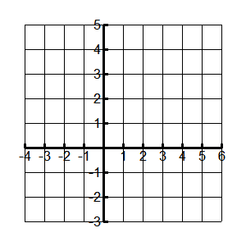

1) Given A( 1, 3) B (6, 3) C (3, -1) D (-2, -1). Plot the points on the grid provided. Label your points, including coordinates.

a. Find the slope of the segments.

slope of  slope of 

slope of  slope of 

b. Find the length of the segments indicated. Show your calculations.

AB =

BC =

CD =

AD =

c. What is the most precise classification of quadrilateral ABCD?

d. Find the area of quadrilateral ABCD.

2) Determine whether the triangle with the given coordinates is right triangle.

A(3, -1) B ( -2, -1) C ( -2, 3)

3) The midpoint of  is (−2, 1). One endpoint is (−5, 7). What are the coordinates of the other endpoint?

4) Determine the missing coordinates in square ABCD.

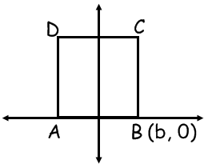

A __________ C __________

5) MATH is a square with diagonals and  Use distance, slope and/or midpoint formulas to prove each statement. Show all work.

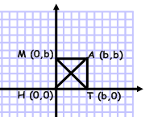

a. Diagonals are congruent.

b. Diagonals bisect each other.

c. Diagonals are perpendicular to each other.

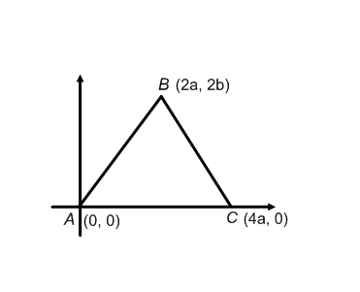6) Prove the following using a coordinate proof:

***The midpoints of the sides of an isosceles triangle will connect to form another isosceles triangle.***

***Unit 4 - Answer Key***

1) a. ; 

b. AB=BC=CD=AD=5

c. rhombus

d. area=20 u2

2) slope of AB = $\frac{-1+1}{-2-3}=\frac{0}{-5}=0$ (horizontal line)

Slope of BC = $\frac{3+1}{-2+2}=\frac{4}{0}=undefined$ (vertical line)

Slope of AC = $\frac{3+1}{-2-3}=\frac{4}{-5}$

Therefore, AB is perpendicular to BC which forms a right angle and triangle ABC is a right triangle.

3) other endpoint (1, -5)

4) A(-b, 0), C(b, 2b)

5) a. distance formula; MT=AH= b

b. midpoints both equal 

c. slope of $\overline{MT}$ = -1 and slope of =1 so 

6) midpoints of AB, BC, and AC using midpoint formula; $\left(\frac{x_{2}+x_{1}}{2},\frac{y_{2}+y_{1}}{2}\right)$

Midpoint of AB = $D\left(\frac{2a+0}{2},\frac{2b+0}{2}\right)=D\left(a,b\right)$

Midpoint of BC = E $\left(\frac{2a+4a}{2},\frac{2b+0}{2}\right)=E\left(3a,b\right)$

Midpoint of AC = F $\left(\frac{4a+0}{2},\frac{0+0}{2}\right)=F\left(2a,0\right)$

Distance formula to find side lengths of triangle DEF; $d= \sqrt{{\left(x_{2}-x_{1}\right)}^{2}+{\left(y_{2}-y_{1}\right)}^{2}}$

DE= $\sqrt{{\left(3a-a\right)}^{2}+{\left(b-b\right)}^{2}}$ = 2a

EF = $\sqrt{{\left(3a-2a\right)}^{2}+{\left(b-0\right)}^{2}}$ = $\sqrt{a^{2}+b^{2}}$

FD = $\sqrt{{\left(2a-a\right)}^{2}+{\left(0-b\right)}^{2}}$ = $\sqrt{a^{2}+b^{2}}$

Since EF = FD, then triangle DEF is an isosceles triangle and the midpoints of the sides of an isosceles triangle will connect to form another isosceles triangle.

**Unit 5 - Similarity (7.1-7.5)**

*Multiple-Choice*

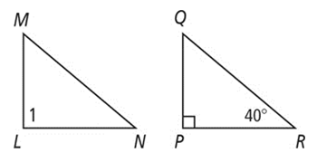

______ 1. The pair of polygons at right are similar. Determine the measure of angle 1.

a. 90° b. 40° c. 50° d. 95°

______ 2. Which of the following theorems/postulates is NOT a way to determine if triangles are similar?

a. SAS b. ASA c. $AA$ d. SAA

______ 3. On a map of Florida, one-fourth of an inch represents 10 miles. If it is approximately 2 inches from Orlando to Ocala on the map, what is the actual distance in miles?

a. 16 b. 64 c. 80 d. 20

______ 4. Which pair of polygons are definitely **not** similar?

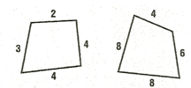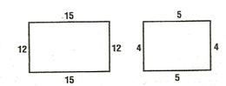

a. b.

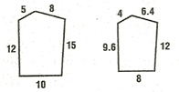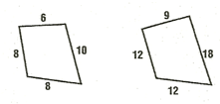

c. d.

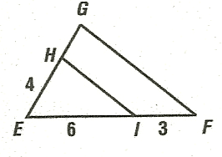

______ 5. Given ΔEGF with || , EI = 6, IF = 3, and EH = 4, find HG.

a. 2 b. 3 c. 6 d. 10

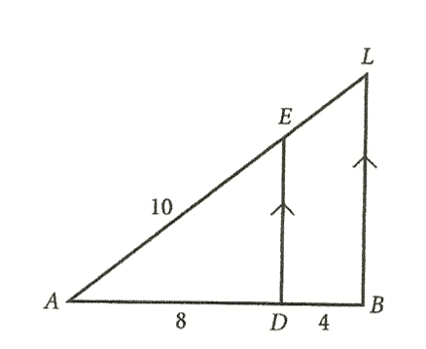

______ 6. Which proportion illustrates the Side-Splitting Theorem?

a. $\frac{AD}{AB}=\frac{AL}{AE}$ b. $\frac{AD}{EL}=\frac{AB}{AL}$

c. $\frac{AD}{AE}=\frac{AL}{AB}$ d. $\frac{AD}{DB}=\frac{AE}{EL}$

______ 7. In ΔADE, if ED = 6 what is BL?

a. 3 b. 5 c. 9 d. 12

______ 8. Suppose ΔABC is similar to a triangle whose sides have lengths 3, 7, and 6. Which of the following

could be the perimeter of ΔABC?

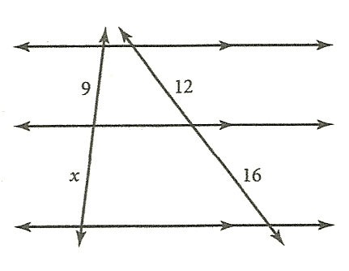 a. 8 b. 16 c. 32 d. any of these

______ 9. What is the value of $x$ in the figure at the right?

a. 8 b. 12 c. 14 d. 16

______ 10. The shadow of a man 6 feet tall is 30 inches long. At the same time of day, a building casts a shadow 125 inches long. How tall is the building?

a. 15 ft b. 25 ft c. 30 ft d. 50 ft

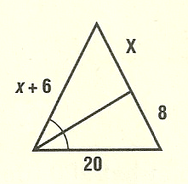

______ 11. For the figure at the right, find the value of $x$.

a. 3 b. 4 c. 5 d. 6

______ 12. Which polygon is similar to other polygons of its classification?

a. rectangle b. rhombus

c. regular octagon d. isosceles triangle

______ 13. The measures of the angles of a triangle are in the extended ratio 2:4:9. Which is a measure of one of the angles?

a. 12 b. 36 c. 48 d. 105

*For #14-17, complete each statement with the word* ***always****,* ***sometimes,***  *or* ***never.***

14. Two equilateral triangles are ___________________ similar.

15. Two similar triangles are __________________ congruent.

16. Two congruent triangles are ___________________ similar.

17. Two isosceles right triangles are ___________________ similar.

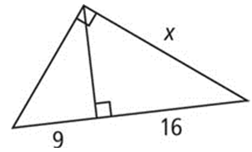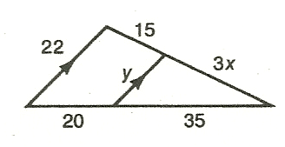18. Find the values of x and y. 19. Find x.

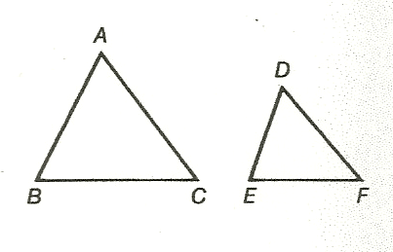20. Using the given information, write a similarity statement for the triangles. The diagram is not drawn to scale.

a. ______________________

b. _______________________

c. _______________________

d. _______________________

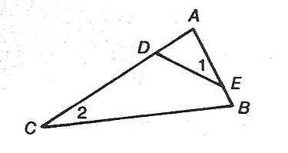

21. Given:

Prove:

STATEMENTS

REASONS

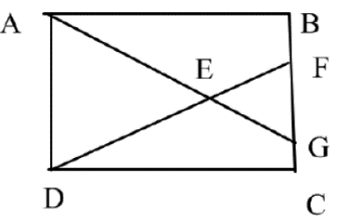

22. Given: Rectangle ABCD

∠EFB≅∠EGC

Prove: ∆ABG∼∆DCF

STATEMENTS

REASONS

***Unit 5 - Answer Key***

1) a

2) d

3) c

4) c

5) a

6) d

7) c

8) d

9) b

10) b

11) b

12) c

13) c

14) always

15) sometimes

16) always

17) always

18) x = 35/4 8.75, y = 14

19)

20) a. ∆BAC∼∆FDE

b. ∆ABC∼∆FDE

c. ∆ABC∼∆EFD

d. ∆ABC∼∆DEF

21) 1. ∠1≅∠2 1. Given

2. ∠A≅∠A 2. Reflex. POC

3. ∆EAD∼∆CAB 3. AA∼

4. 4. Definition of similar polygons

22) 1. Rectangle ABCD 1. Given

2. ∠B and ∠C are rt ∠s 2. Defn. rectangle

3. ∠B ≅ ∠C 3. All rt ∠s are ≅

4. ∠EFB & ∠EFG are lin. pr 4. Defn. linear pair

∠EGC & ∠EGF are lin. pr

5. ∠EFB & ∠EFG are suppl. 5. Linear Pair Postulate

∠EGC & ∠EGF are suppl.

6. ∠EFB ≅ ∠EGC 6. Given

7. ∠EFG ≅ ∠EGF 7. Congr. Suppl. Thm.

8. ∆ABG∼∆DCF 8. AA∼

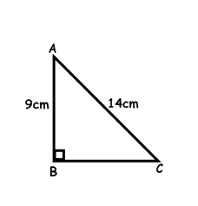**Unit 6, Part A– Right Triangles/Trigonometry (Chapter 8)**

1. In the triangle at right, find BC when AB = 9cm and AC = 14.

*Leave answer to the nearest tenth.*

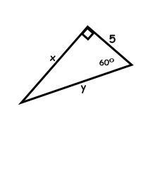

1. In the triangle below, find $x$ and $y$. Leave answers as simplified square roots when necessary.

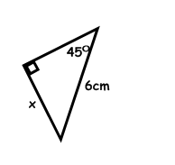

1. Given the triangle at right, find $x$. Leave answers as simplified square roots when necessary.
2. 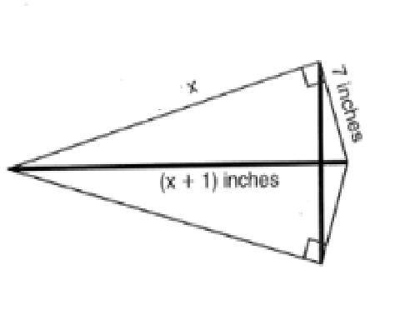 A kite needs a vertical and a horizontal support bar attached at opposite corners. The upper edges of the kite are 7 inches, the side edges are $x$ inches and the vertical support bar is $(x + 1)$ inches. What is the measure of the vertical support bar in inches?
3. A wire attached to the top of a pole reaches a stake in the ground 20 feet from the foot of the pole and makes an angle of 58° with the ground. Find the length of the wire.
4. 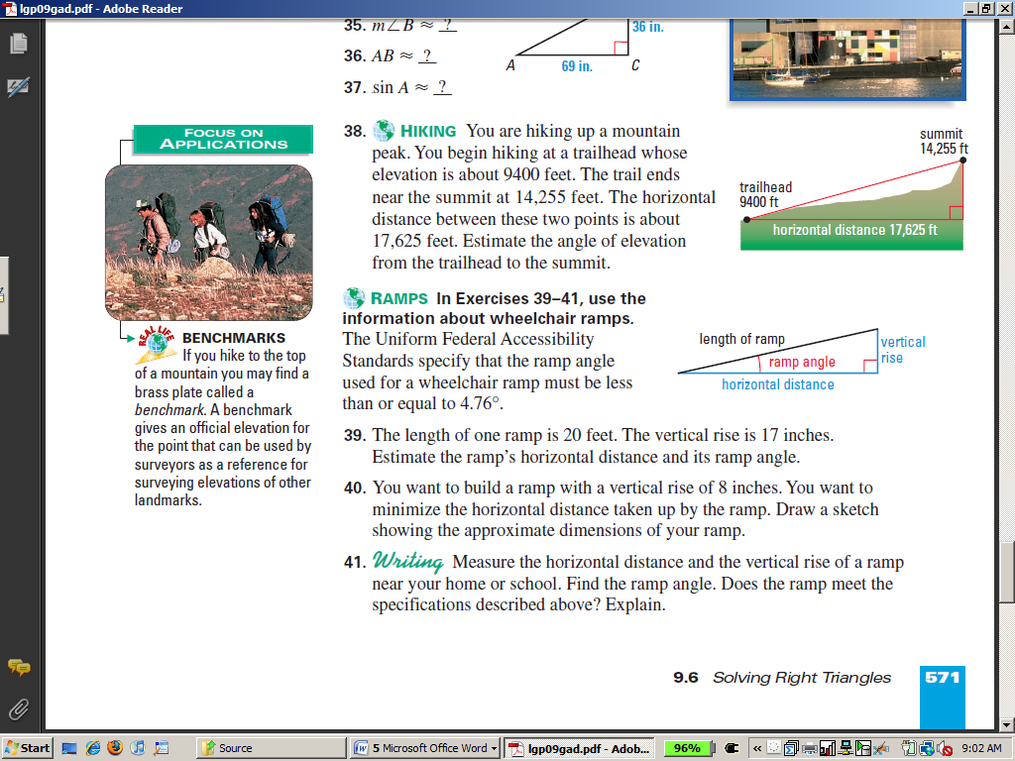The Uniform Federal Accessibility Standards specify that ramps built for wheelchairs must be built at specific angle measures. What is the ramp angle for a ramp with a length of 20 feet and a vertical rise of 1.6 feet?

1. Solve for x. Write your answer in simplest radical form. Round to the nearest tenth.

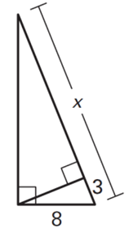

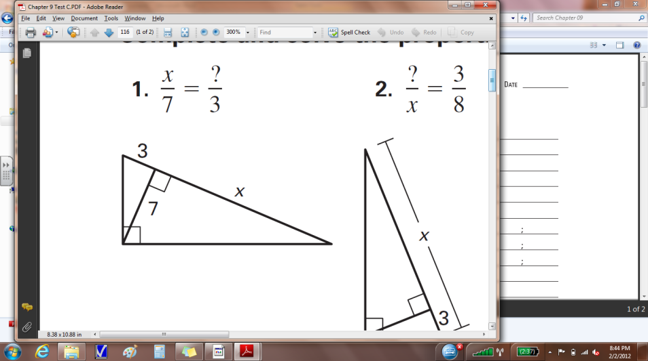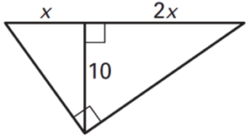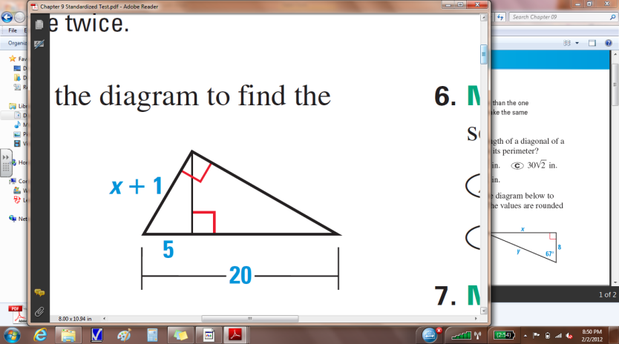 a. b. c. d.

1. Find the value of *x* and *y* in the following. Leave your answer in simplified radical form when appropriate and round to the nearest tenth

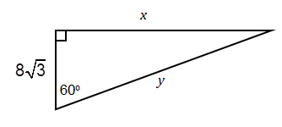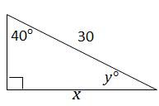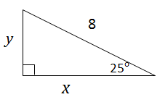

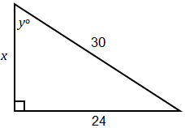a. b. c. d.***.***

1. A helicopter is directly over a landing pad. If Billy is 110 ft from the landing pad, and looks up to see the helicopter at 65° to see it. How high is the helicopter?
2. A man in a lighthouse tower that is 30 ft. He spots a ship at sea at an angle of depression of 10°. How far is the ship from the base of the lighthouse?
3. A ladder is learning up against the side of a house. The angle between the ground and the ladder is four times as big as the angle between the house and the ladder.
4. What are the angles?
5. How long is the ladder if it is 5 feet from the house at ground level?
6. A triangle’s three angles are in the ration of 5:7:8. What is the angle measure of the smallest angle?

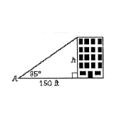

13. Determine the height of the building at right to the nearest tenth, when ∡A = 35°

14. A slide 4.1 m long makes an angle of 27° with the ground. How high is the top of the slide above the ground? Round your answer to the nearest tenth.

15. Tom drives 16 km up a hill that is at a grade of 10°. What horizontal distance, to the nearest tenth of a kilometer, has he covered?

16. Find the area of an octagon whose side length is 14 in.

17. Each of the following triples represents the sides of a triangle. Determine whether the triangle is right, acute or obtuse.

a. 14, 48, 50 b. 4, 8, 9 c. 2√3, 4, 6

***Unit 6, Part A - Answer Key***

1. BC = 10.7 cm
2. $x=5√3$, $y=10$
$x=3\sqrt{2}cm$

$x=24in$ $$vertical support bar=25 in$$

$x=37.74 ft$

$x=4.58°$

3. a. $x=16.3$ b. $x=24.3$  
   c. $x=2.2$

d. $x=9$

1. a. $x=18$, $y=53.1°$

b. $x=24$, $y=16√3$

c. $x=7.3$, $y=3.4$

d. $x=19.3$, $y=50°$

1. 235.9 ft
2. 170.1 ft
3. a. $18° and 72°$  
    b. 16.2 ft

13. 105.0 ft

14. 1.9 m

15. 15.8 km

16. 946.37 in2

17. a.right, b. obtuse, c. obtuse

**Unit 6, Part B – Area (Chapter 10)**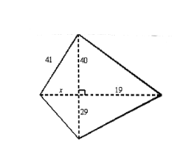

1. Find the area of the quadrilateral.

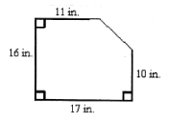2. What is the area of the figure?

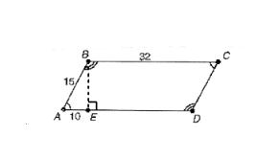

3. Find the area of the parallelogram ABCD. Leave answer in exact form (simplified square root).

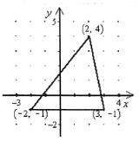

4. Find the area of the triangle to the nearest tenth.

5. In rhombus ABCD, $AB = 16$ and $AC = 28$. Find the area of the rhombus to the nearest tenth.

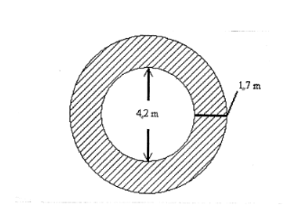

6. The figure below is an overhead view of a deck surrounding a hot tub.

What is the area of the deck to the nearest tenth?

7. Determine the area of an equilateral triangle whose side length is 14 in. Leave answer in simplified square roots if necessary.

8. A regular hexagon has an apothem of 2cm and a side length of $\frac{4\sqrt{3}}{3}$ cm. Determine its area exactly.

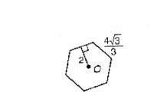

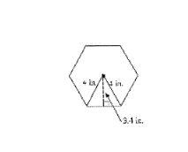

9. What is the perimeter of the regular hexagon to the nearest inch? (Radius is 4 in., apothem is 3.4 in.)

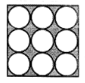

10. In the figure, each circle has a radius of 2 inches. What is the area of the shaded region rounded to the nearest hundredth?

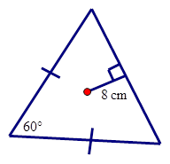

11. Find the area of the triangle if the length of the apothem is 8 cm.

***Unit 6, Part B - Answer Key***

1. 966 u2
2. 254 in2

3) 160 u2

4) 12.5 u2

5) 216.9 u2

6) 31.5 m2

7) 49 in2

8) 8 cm2

9) p=24

10) 30.90

11) 192 or 332.55 cm2

**Unit 7 - Surface Area and Volume (11.1-11.6)**

**For #1-4, determine the surface area and volume of a right prism with the given base shape, base dimensions, and prism height, h. Round to the nearest tenth, if necessary.**

1. Square base whose side measures 3 meters; h = 14 meters

2. Regular hexagon base whose sides measure 10 cm; h = 4 cm

3. Equilateral triangle base whose sides measure 6 inches; h = 8 in

4. A right triangle base whose hypotenuse is 17in and one leg is 15 in; h = 5 in

For #5-9, find the surface area and volume of the solid. Give an exact, simplified answer.

5. 6. 7.

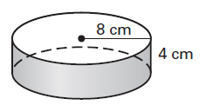

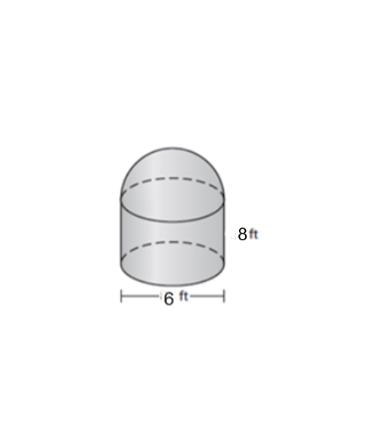

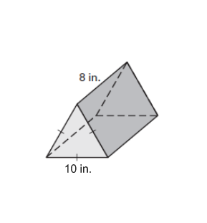

8. 9.

**For #10-13, determine the unknown value for a right cylinder with the given radius, r, height, h, surface area SA, and volume, V.**

10. r = 26’, h = 16’ SA = _______________ 11. SA= 98 in2, h = 14 in, r = ______________

12. V = 144 cm3, r = 12 cm h = ________________ 13. V = 80 in3, h = 16 in r = ______________

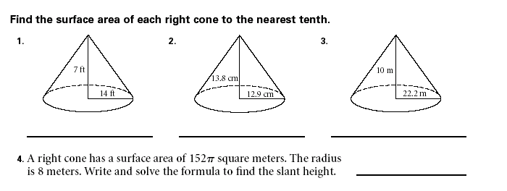**For #14-15, determine the surface area of each right cone.**

14. 15.

16. A right cone has a surface area of 152π square meters. The radius is 8 m. Determine the slant height.

**For #17-18, determine the volume of each right cone.**

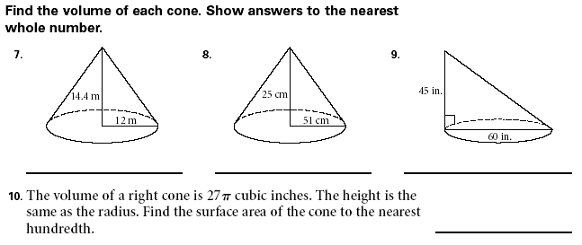17. 18.

19. The volume of a right cone is 27π cubic inches. The height is the same as the radius. Determine the surface area of the cone to the nearest hundredth.

20. Determine the surface area of a sphere with a diameter of 4”. Leave answer in terms of π.

21. Determine the length of a radius if the surface area of a sphere is 36π cm2.

22. Determine the volume of a sphere with a radius of 14 cm.

23. Determine the volume of a sphere if the surface area is 100 cm2.

24. Determine the volume of a sphere if the surface area is 100π cm2

**For #25-26, determine the surface area and volume of each figure. Write answers in exact form and rounded to the nearest hundredth.**

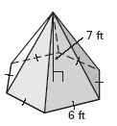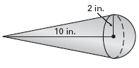25. 26.

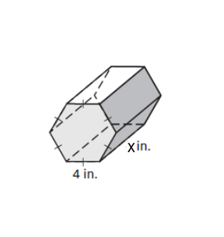

27. Find the volume of the prism below in terms of x.

***Unit 7 - Answer Key***

*(*All SA are in square units, all V in cubic units.)*

1) SA=186 V=126

2) SA= V= or SA=759.6, V=1039.2

3) SA=144+18 V=72 or SA=175.2, V=124.7

4) SA=320 V=300

5) SA = 472 V = 672

6) SA=192 V=256

7) SA = 324 V=972

8) SA = 240 + 50 V=200

9) SA = 75 V= 108

10) 2184

11) r = 1.04 (need quad form for this one)

12) h = .3

13) r = 1.3

14) 415.1 (1304.2)

15) 1033.37 (3246.4)

16) l= 11 m

17) (68,094)

18) V = 691.2 (2171)

19) r=4.33, SA=142.15

20) 16

21) r = 3

22) 11,494.04

23) 94.03

24) 523.6

25) SA = (4 + 8) in2

SA89.21 in2

V = 56 in3

V 58.64 in3

26) SA = (126 + 54) ft2

SA 250.45 ft2

V = 126 ft3

V 218.24 ft3

27) 24 *x* in3

**Unit 8 - Circles (10.6, 10.7, 12.1, 12.3, 12.4, 12.5)**

Given ⨀Q, m∡ABC=72° and m $\hat{CD}=46°$. $\overline{BD}$ is a diameter. Find the indicated measures.





In the circle to the right,, , , , and . Find each of the following:



11. If the length of an arc on a circle is 26 cm and the radius of that circle is 10 cm, what is the degree measure of the arc? Leave your answer in exact, simplified terms.

12. If the radius of a circle is 22 mm and the degree measure of one of the arcs on the circle is 160°, find the length of the arc. Write your answer in exact, simplified terms.

For each of the following problems, find the m∡1.



13. 14. 15. 16. 17.

18. Find the area of the shaded region. Round your answer to the nearest hundredth.

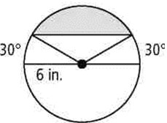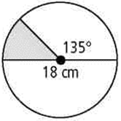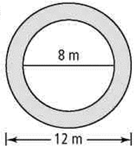a. b. c.

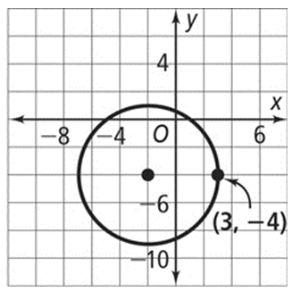

19. Write the standard equation of the circle in the diagram at the right.

20. What is the standard equation of the circle with center (8, -2) that passes through the point (1, 4)?

***Unit 8 - Answer Key***

1) 144˚

2) 134˚

3) 98˚

4) 23˚

5) 49˚

6) 49˚

7) 12

8) 78˚

9) 300˚

10) 60˚

11) (468/π)˚

12) (176π/9)mm

13) 65˚

14) 40˚

15) 57.5˚

16) 52˚

17) 63˚

18) a. 62.83 m2

b. 31.81 cm2

c. 22.11 in2

19)

20)