**Geometry 22 Final Exam**

**Formula Sheet**

Area of a Parallelogram  Area of a Trapezoid 

Area of a Triangle  Area of a Regular Polygon 

Area of a Rhombus  Area of a Kite 

Area of a Circle  Circumference of a Circle or 

Pythagorean Theorem 

Surface Area of a Right Prism  Volume of a Prism 

Surface Area of a Right Pyramid  Volume of a Pyramid 

Surface Area of a Right Cylinder  Volume of a Cylinder 

Surface Area of a Right Cone  Volume of a Cone 

Surface Area of a Sphere  Volume of a Sphere 

Equation of a Circle in Standard Form 

Arc Length  or  Area of Sector  or 

Distance Formula d =  Midpoint Formula $\left(\frac{x_{1}+x_{2}}{2},\frac{y_{1}+y_{2}}{2}\right)$

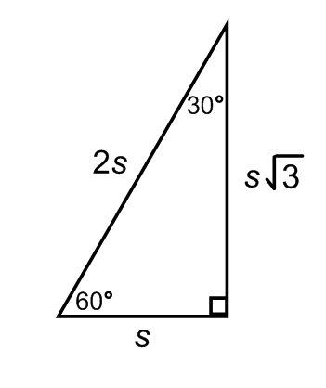Slope Formula *m* = $\frac{y_{2}- y_{1}}{x_{2}- x_{1}}$ Sum of the Interior Angles of a Polygon $180(n-2)$

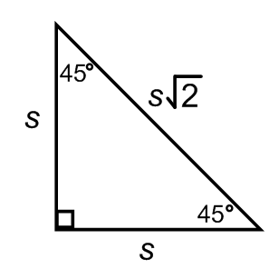Special Right Triangle Relationships: