**Geometry 21 Final Exam Formulas:**











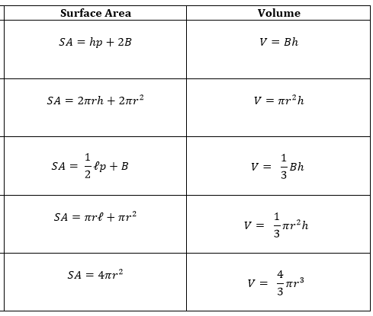

or $S=\frac{M}{360} πr^{2}$

$\frac{L}{2πr}=\frac{M}{360}$ or $L=\frac{M}{360}2πr$