Final Exam Review- Geometry 22

Section 1
1.) a. false: two planes intersect at infinitely many points
b. true c. true d. false: any 2 points are collinear, and 3 are coplanar
e. false: any 2 lines are coplanar
2.) a. $\overline{MN}$ $\overline{MX}$ b. N c. A, N, X d. ANC or MNX e. no
f. $\vec{AX}$ and $\vec{NR}$ g. $\vec{NX}$ and $\vec{NA}$ h. true i. false
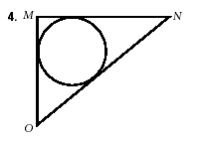
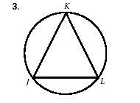
3.) a. b.

4.) a. b. c.
A
B
A
B

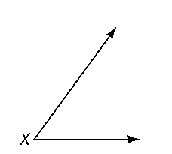
d. e.

5.) a. reflection b. rotation c. translation

Section 2
1.) x = 5 2.) x = 4 3.) x = 7 4.) x = 5 5.) 64°
6.) a. x = 15 b. x = -3 c. x = 12 d. x = 34°
7.) a. If angles form a linear pair, then they are supplementary and adjacent.
b. If two angles are supplementary and adjacent, then they form a linear pair.
c. A pair of angles form a linear pair if and only if they are supplementary and adjacent.
d. yes because both the conditional and converse are true.
8.) If a person is a pediatrician, then he/she is a doctor.

Section 3
1.)
a. c.

b. d.
Section 3 (continued)
2.) x = 5 ∠BCA and ∠CFH are congruent (corresponding). ∠BCA and ∠BCD form a linear pair (=180°)
3.) x = 3 ∠BCA and ∠CFH are congruent (corresponding).
4.) a. 360° b. bisect each other c. congruent
d. rhombus, square, kite e. trapezoid f. four, four
g. parallelogram, congruent h. parallelogram i. quadrilateral
j. 2 pairs of parallel opposite sides, 2 pairs of congruent opposite sides, 4 right angles, congruent &
bisecting diagonals
5.) a. 70° b. 110° c. 2 in d. 3 in 6.) a. 92° b. 44° c. 90°
7.) a. x = 6 b. x = 22 8.) a. 25 units b. x = -4 c. midsegment
9.) a. slope = $\frac{6}{5}$ midpoint = $\left(\frac{3}{2}, 7\right)$ distance = $\sqrt{61}≈7.81$
b. slope = 3 midpoint = $\left(9, 3\right)$ distance = $\sqrt{40}≈6.32$
10.) same, opposite reciprocal
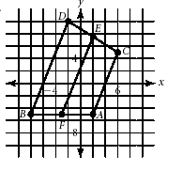
11.) a. b. trapezoid; one pair of parallel sides with the same slope
$\overline{DC}∥\overline{BA}$ with slopes = $\frac{5}{2}$

Section 4
1.) ABCD HEFG
2.) a. not congruent b. not congruent c. congruent by AAS≅
3.) a. not congruent b. not congruent c. congruent by HL≅, $∆FGJ≅∆HJG$
d. congruent by AAS≅, $∆NMO≅∆ZYX$ e. congruent by HL≅, $∆WXY≅∆EGR$
f. congruent by SSS≅, $∆ABD≅∆CBD$
4.) a. need ∠DUT≅∠TUS b. a. need ∠L≅∠T c. need $\overline{WV}≅\overline{MV}$
5.) a. not similar b. similar by AA~ ∆ABC~∆DEF
c. similar by SSS~ ∆DGF~∆RTS d. similar by SSS~ ∆ABC~∆XZY
e. similar by SAS~ ∆TUV~∆WXY f. similar by AA~ ∆WXY~∆VZY
6.) a. not enough info b. similar, scale factor 2:3 or $\frac{2}{3}$ c. similar, scale factor 2:1 or 2
d. similar, scale factor 1:2 or $\frac{1}{2}$
7.) a. x = 0.8 y = 126 b. x = 3.3 y = 7.6
8.) AN = 2.5 cm 9.) ∆s are similar by AA~ length of lake = 1.35 mi
10.) a. x = 6 b. x = 36 c. x = 3
11.) a. 63 ft b. 32 ft c. 26.67 ft

Section 5
1.) a. b = $\sqrt{27}=3\sqrt{3}$ ≈ 5.2 units b. c = 20 units c. a = 10.95 units
2.) a. x = $9$ y = $9\sqrt{2}$ b. x = 10 y = 5
c. x = 22 y = 22 d. x = $7\sqrt{3}$ y = 73.)
12.) a. QR = $6\sqrt{3}$ ≈ 10.4 units b. QS = $3\sqrt{3}$ ≈ 5.2 units c. SR = 9 d. 31.18 units²
Section 5 (continued)
13.) a. 8 m² b. 10.6 ft²
14.) a. 80 ft² b. 120 mm² c. 80 mi² d. 170 in² e. 90 m²
f. 126 cm²
15.) a. C = 16π mm A = 64π mm² b. C = 26π cm A = 169π cm²
c. C = 52π ft A = 676π ft²
16.) C = 50.27 mm A = 201.06 mm² 17.) a. r = 16 in b. 19.1 ft
18.) 4 cm 19.) 15 ft 20.) 10 in 21.) 49 u² 22.) 171.68 u²
23.) a. 30.28 cm² b. 39 cm²

Section 6
1.) a. triangular prism b. ABC and EFD c. $\overline{AC}$ and $\overline{ED}$ d. $\overline{AC}$ and $\overline{ED}$ e. 12 u³
2.) 16.12 in
3.) a. SA = 72 cm² V = 32 cm³ b. SA = 48 in² V = 18 in³
c. SA = 672 u² V = 930 u³ d. SA = 376.99 cm² V = 452.39 cm³
e. SA = 282.74 ft² V = 314.16 ft³ f. SA = 266.4 u² V = 256 u³
g. SA = 144 cm² V = 101.88 cm³ h. SA = 309.6 m² V = 362.51 cm³
i. SA = 785.4 cm² V = 1170.77 cm³ j. SA = 1206.37 in² V = 2412.74 in³
k. SA = 452.39 cm² V = 904.78 cm³ l. SA = 1017.88 in² V = 3053.63 in³
j. SA = 288 cm² V = 336 cm³ k. SA = 89.22 in² V = 58.65 cm³
l. SA = 203.58 cm² V = 218.18 cm³
4.) a. 1.038 b. 6.95
5.) a. 46 b. 1.26
6.) a. $120-120=0$ (both boxes have the same volume) b. $184-158=26$ in²
c. 92:79
7.) 30 in

Section 9
1.) a. 154° b. 86° c. 240° d. 86° e.206° f. 240° g. 86°
2.) a. M = 71.62° b. L = 11$\frac{1}{3}π$
3.) a. $\overline{FH}$; chord is bisected b. $\overline{MK}$ and $\overline{KH}$; All radii ≌ c. $\sqrt{3}$ or 1.73 d. FH= 4
4.) a. 14.42 b. 32
5.) Answers may vary: a. $\overline{AL}$ b. $\overline{BE}$ c. ∡FOE d. $\hat{AF}$ e. $\hat{BEL}$ f. $\hat{BFE}$ g. $\overline{OF}$ h. $\overset{⃡}{GF}$ i. F
6.) a. 39° b. 39° c. 102° d. 51° e. 90° f. 90° g. $\hat{EC}$; $\hat{ACB}$
h. $\hat{MA}$; diameter i. tangent; chord j. 10.68 k. 26.58
7.) 60° 8.) 110° 9.) 35° 10.) 30° 11.) 130° 12.) 90° 13.) 60°
14.) 250° 15.) a. 140° b. 20° c. 3.75 d. 10.67
16.) ${(x-2)}^{2}+{(y-4)}^{2}=49$ 17.) ${(x+3)}^{2}+{(y+1)}^{2}=324$
18.) Center: (7, -12); r = 12 19.) Center: (-5, -8) r = 15

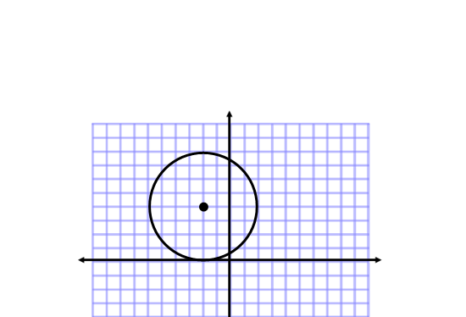
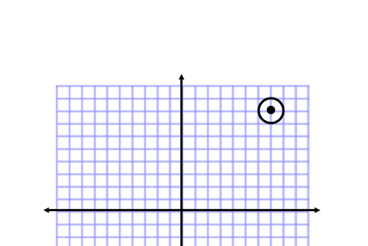
20.) a. b. c.
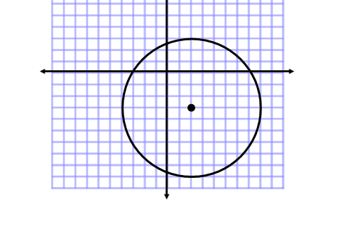

Section 10
1.) a. $\frac{\sqrt{10}}{10}$ b. $\frac{3}{7}$ c. $\frac{2\sqrt{29}}{29}$ d. $\frac{5}{2}$
2.) a. y = 17.2 b. w = 18.09 c. x = 21.21 d. b = 0.23
3.) a. θ = 30° b. θ = 40° c. θ = 39° d. θ = 37°
4.) Base of the ramp = 39 in.; Length of the ramp = 41 in.
5.) θ = 56°; d = 1.8 m.

Proofs:
1.) 1. Given
2. Definition of right triangles
3. Reflexive Property of Congruence
4. Hypotenuse Leg (HL) Theorem
5. Corresponding Parts of Congruent Triangles are Congruent (CPCTC)

2.) 1. Given
2. Given
3. Definition of vertical angles
4. Vertical Angles Theorem
5. Side-Angle-Side (SAS) Theorem
6. ∡CBA ≌ ∡CDE; Corresponding Parts of Congruent Triangles are Congruent (CPCTC)

3. 2. Definition of Linear Pair
4. Definition of Supplementary angles
5. Substitution Property of Equality
6. Subtraction Property of Equality
7. Substitution Property of Equality
8. Definition of Angle Congruence
9. Definition of Corresponding Angles
10. Converse of Corresponding Angles Theorem

4. 2. Isosceles Triangle Theorem
3. Definition of Angle Congruence
4. Given
5. Triangle Sum Theorem
6. Substitution Property of Equality
7. Combine like terms
8. Subtraction Property of Equality
9. Division Property of Equality

