**How Tall?** Name___________________________

***An Application of Trigonometry (SOH-CAH-TOA)***  Partner _________________________

1. 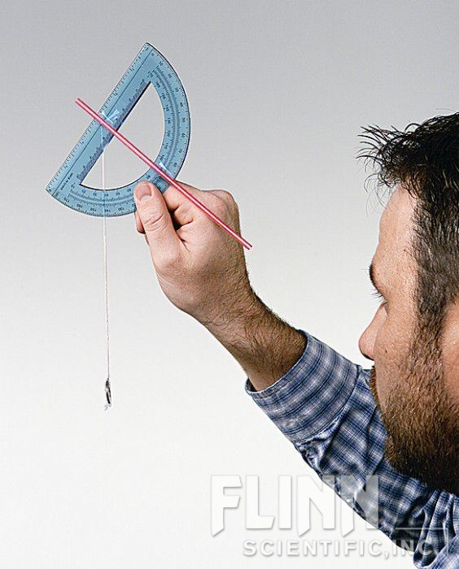Construct your CLINOMETER as directed by the video <http://www.youtube.com/watch?v=GMLcU1Qknts>

It should look a bit like the picture 🡪 *straw (lines up with 90o)*

*String and plumb line*

1. During classtime, you will go outside and calculate

the approximate heights of 3 tall objects. You may choose which objects.

Stand within 50 feet of the object*. (you will need to measure this distance later)*

1. For each object use your clinometer to determine the height by following

these steps;

1. Hold the clinometer with the rounded part of the protractor

closest to your eye so that you are looking through the straw toward the hole in the protractor.

1. aim the end of the straw

at the top of an object. *Read this ACUTE angle measure*

1. Record the angle measure that lines up with the string.
2. Next, use the tape measurer to find the distance that you are standing from the object.
3. Sketch a diagram of your position. (see example below)
4. Use trigonometry to write an equation and solve for the height of the object*. (hint: you will also need to know your approximate height)*
5. Fill out the chart on the back of this sheet and SHOW work for finding solutions.
6. C:\Users\Meyers Family\AppData\Local\Microsoft\Windows\Temporary Internet Files\Content.IE5\BTL6LNFS\MC900351349[1].wmfRepeat for 2 more objects.

x

EXAMPLE: 22o

30 ft.

5 ft

|  |  |  |
| --- | --- | --- |
| **DIAGRAM** | **EQUATION and calculations** | **HEIGHT of object** |
| 1. We measured a _________________from ______ feet away. |  |  |
| 1. We measured a _________________ from ______ feet away. |  |  |
| 1. We measured a _________________ from ______ feet away. |  |  |