GEOMETRY – Performance Task TRIGONOMETRY Name__________________________ Per______
Due Date _____________ Group Members___________________________
________________________________________

The Fairfield Museum is in the process of building a scale model of the town of Fairfield. They have asked the public to help verify the heights of several tall objects in town. With your group of 3, you will find the height of 1 object of your choice using 3 different trigonometric/similar triangle methods. You may choose any 3 of the methods that we have discussed during our trigonometry unit, or you may use another method that you research and discover on your own.
You must choose a building, house, flagpole, etc. in Fairfield that is greater than 20 feet tall. All three group members will need to meet at the location of the object to do the measuring together.
Each individual must turn in:
- The “Measuring Heights Worksheet” (attached) with all questions answered completely.
Include detailed diagrams and explanations! The more details the better.
- An organized collection of photos or video clip(s) documenting the process for each method. These should include captions that specifically describe what is shown.

Preliminary Notes with Group:
(In this section, brainstorm some possible methods, objects to measure, meeting dates, etc.)

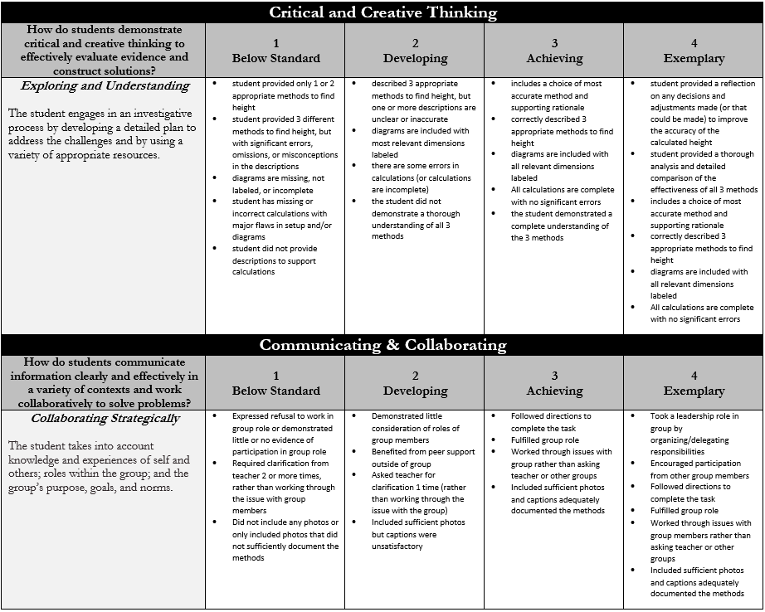
Scoring Rubric for Geometry Trigonometry Performance Task:

Measuring Heights Worksheet – TRIGONOMETRY Performance Task

Your Name _______________________________________ Period _______ Date _____________

Group Members ____________________________________________________________________

Object/Location: ______________________________________________________________________________________________________

Method 1 (Please describe in detail the method you used to find the height of the object.)
_____________________________________________________________________________________________________________________________________________________________________________________________________________________________________________________________________________________________________________________________________________________________________________________________________________________________________________________________________________________________________________________________________________________________________________________________________________________________________________________________________________________________________________________________________________________________________________________________________________________________________________________________________
Diagram showing Method 1 (Please draw a diagram that includes the triangles used in your method and label all relevant dimensions.) You may include your photos here as well if you prefer.

Method 2 (Please describe in detail the method you used to find the height of the object.)
_____________________________________________________________________________________________________________________________________________________________________________________________________________________________________________________________________________________________________________________________________________________________________________________________________________________________________________________________________________________________________________________________________________________________________________________________________________________________________________________________________________________________________________________________________________________________________________________________________________________________________________________________________
Diagram showing Method 2 (Please draw a diagram that includes the triangles used in your method and label all relevant dimensions.) You may include your photos here as well if you prefer.

Method 3 (Please describe in detail the method you used to find the height of the object.)
_____________________________________________________________________________________________________________________________________________________________________________________________________________________________________________________________________________________________________________________________________________________________________________________________________________________________________________________________________________________________________________________________________________________________________________________________________________________________________________________________________________________________________________________________________________________________________________________________________________________________________________________________________
Diagram showing Method 3 (Please draw a diagram that includes the triangles used in your method and label all relevant dimensions.) You may include your photos here as well if you prefer.

Please rate yourself and your group members on participation in this project.
[1 = little to no participation, 2 = partial participation, 3 = participated fully, 4 = took a leadership role]

Your name: _______________________________ Score: 1 2 3 4
Group member: _______________________________ Score: 1 2 3 4
Group member: _______________________________ Score: 1 2 3 4

Comments (optional):
Process and Results - TRIGONOMETRY Performance Task

Most likely you did not get the exact same height for your object as the result of each method. Please analyze which method you feel was most accurate and describe your reasoning below. Include any mistakes you may have made and how you fixed (or could fix) them. Also, explain whether the differences in your results were significant and why they may have occurred. Based on your analysis, report what you consider to be the actual height of your object. Remember, your audience is the committee at the Fairfield Museum. The committee needs to be convinced that you were thorough and accurate in your measuring techniques so as to be sure your reported height of the object is acceptable for their scale model.

Performance/Score based on Academic Expectations Rubric: Please refer to rubric and assess yourself below;
Critical and Creative Thinking |  |  |  |  | Final scores
Exploring And Understanding | 1  Below Standard | 2  Developing | 3  Achieving | 4  Exemplary
STUDENT self evaluation
TEACHER’s
evaluation of student
Communicating and Collaborating
Collaborating Strategically | 1  Below Standard | 2  Developing | 3  Achieving | 4  Exemplary
STUDENT self evaluation
TEACHER’s
evaluation of student
TOTAL

