Vol. 2 Issue 10
It’s the final countdown!
We’ve had a great year here at FLHS filled with lots of fun and excitement. School counselors have been hard at work attending transition meetings for 8th grade students and perfecting student schedules for the 2018-19 school year. Schedules will be available to all students in August, so try as you might, but your school counselor WILL NOT show you your schedule until they’re finalized! The construction will continue on campus throughout the summer, so be on the lookout for new updates before the school year starts! Have a great summer…we’ll see you in August!

Fairfield Ludlowe High School Counseling Newsletter

Check out our department's website here!

Summer School
Summer school is scheduled for July 2nd-July 27th. Classes run either 8-10 or 10-12. More information can be found here: http://forms.fairfieldschools.org/summerSchool/

Please see your school counselor to confirm your eligibility for summer school!

JUNIORS!! JUNIORS!! JUNIORS!!
Visiting Colleges?
Making the most of your college visits:
- Act like a tourist: take pictures and videos, write notes, and ask questions…this could be your one time on campus before applying!
- Eat on campus and talk to current students. Remember your tour will show you the best of the best, so be sure to see the rest!
- Drive through the area: see what else goes on around campus.

Dates to Remember
- Senior Internship – 5/29-6/18
- Senior Internship Reception – 6/19
- Senior Award Night – 6/19 @ 7:00pm
- GRADUATION – 6/20 @ 6:00pm
- Graduating senior transcripts sent to colleges – completed by 6/28
Looking forward…
- First day for Freshmen – 8/29
- First day for all students – 8/30
- ACT – 9/8 @ FWHS
- SAT – 10/6 @ FWHS

FINAL EXAMS:
- Seniors - June 11th-14th
- Underclassman - June 15th, 18th-20th

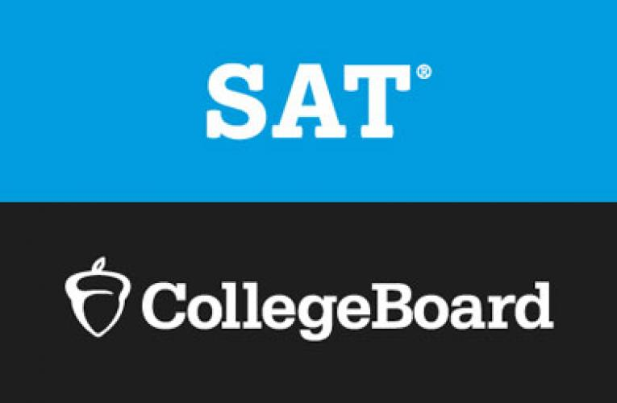 AUGUST SATs
For the first time ever, CollegeBoard is offering an August SAT session. This is great for students wishing to add one more set of scores to their college applications, but don’t want to juggle test prep with school work and other senior events in early fall. Neither Ludlowe or Warde are available to give the SAT during this testing session, but there are test centers close by! Register at www.collegeboard.org:

August test centers near us: Bassick HS (Bridgeport), Christian Heritage School (Trumbull), Shelton HS (Shelton), and Weston HS (Weston).

Got Summer Plans?
- How to create the most of your summer:
  - Create a resume using Naviance’s resume builder
  - Stop in the College and Career Center for employment/volunteer opportunities
  - Work in town
  - Get involved or volunteer
- Any opportunity is a meaningful opportunity!
  - Examples- work locally, babysit, attend or work at a camp, yardwork for your neighbors, travel, standardized test prep

“Summer afternoon, summer afternoon; to me those have always been the two most beautiful words in the English language.”

– Henry James

AP Textbook and Summer Work Pickup Schedule
Students who have registered for AP classes for next year must check out all AP textbooks in bookroom 355 during final exam week.

Bookroom 355 will be staffed between 8:00 am and 12:00 pm on June 15, 18, 19 and 20. All AP books will be checked out during exams. AP summer reading books are available for checkout in the library or on OverDrive (ebooks and audio).

All students who have requested the following AP classes for the 2018-19 school year are required to meet on the date and time indicated to pick up AP Summer Work. All meetings will be at 12:00 pm.

June 15 - Friday
- AP Chemistry – Room 213 – Golrick – students whose last name starts with A - L
- AP Biology – Room 347 – Kelly, Smigala, Coelho AP Physics 1 – Room 151 – Cardoso, Francois AP Psychology – Room 223 – LeFebvre
- AP Studio Art – Room 2 – Zimmermann, Hermsen
- AP Statistics – Room 228 – Mirrer (either Friday or Monday)

June 18 - Monday
- AP Language & Comp – Room 358 – Schiavo AP MEH – Room 317 – Samuelson (Pugliese)
- AP American Studies - Room 257 – Parisi, Nulf, Hilton, Moir AP French – Room 282 – Lavigne
- AP Government & Politics – Room 205 – Kempner, Bourque AP Statistics – Room 228 – Mirrer (either Friday or Monday) APES – Room 312 – Grasso

June 19 - Tuesday
- AP Literature – Room 320 – Ingram, Nulf AP US History – Room 225 - Newberg
- AP Spanish – Room 255 – Frankel
- AP Computer Science – Room 233 - Benjamin
- AP Comparative Governement – Room 316 – Bourque, Sousa

June 20 - Wednesday
- AP Calculus AB – Room 327 – Reisert, Poole AP Calculus BC – Room 150 - Barba
- AP Physics 2 – Room 181 – Schrynemakers
- AP Chemistry – Room 213 – Golrick – students whose last name starts with M – Z

Get $100 Toward Summer Tutoring Programs
Dear parents,
I am writing today to let you know about a great giveaway from Revolution Prep.
Revolution Prep is a national leader in online tutoring and test prep, and with summer approaching they’re giving away a $100 gift card to all Ludlowe families!
We know summer should be spent relaxing, but summer is also a fantastic time for sophomores and juniors to get ahead on test prep – and it’s important for all students to stay engaged with academics, as research shows extended time off can lead to many students falling behind.
So please take advantage of this $100 toward the tutoring program of your choice. Whether it’s private tutoring, a test prep course, or Revolution’s unlimited Homework Help program, there is no purchase necessary. Just $100 toward your child’s summer enrichment.
Click Here to claim your gift card. Make sure to redeem it by June 30, 2018. And if you have any questions or want to learn more, reach out to our school’s dedicated Academic Advisor, Michelle Sullivan, at 860.924.7334 or Michelle.Sullivan@revolutionprep.com.
Enjoy!
Taryn Mesaros | Senior Director | Revolution Prep
Direct: (203)745-2899 | www.revolutionprep.com |
Beyond Grades. Beyond Tests. Beyond Tutoring. Revolution Prep.

