- Log-in: Go to the FLHS website and click on the Naviance link, on the right hand side.
  - Enter your login and password
  - Login and password information will be sent to parents from Naviance. Contact your child’s school counselor if you do not receive this information by Friday, January 11.

- Navigating Naviance: Click on various topics on the top right side of the website for subject specific search engines and information.

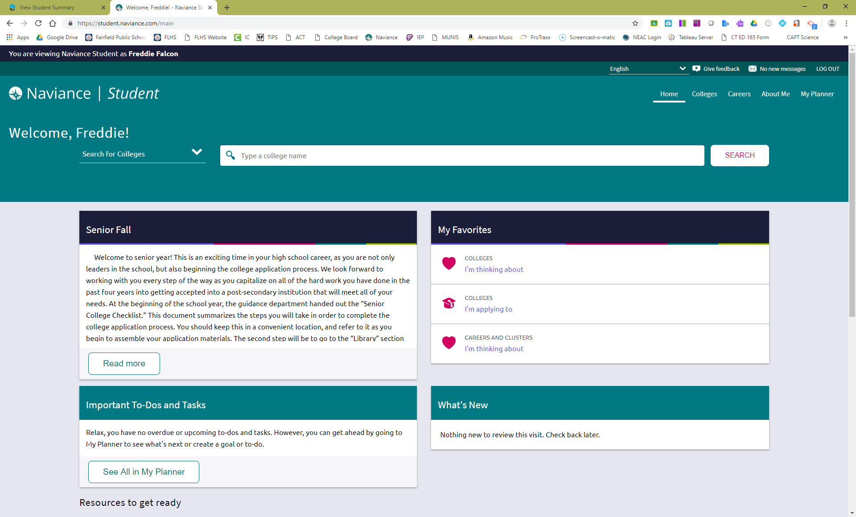

- Navigating Naviance Topics:
- Update My Account Information (About Me tab)
- Demonstrate College Search
  - Advanced College Search (College tab>Find Your Fit>Advanced College Search)
- Colleges I’m Thinking About (College tab)
  - Deadlines
  - Delivery Type
- Compare Me (Select a specific college, scroll down, click “compare me with all accepted applicants”)
- Scattergrams (College tab>Find Your Fit>Scattergrams)
- Signing up for a College Visit (College tab>Research Colleges>College Visits)
- Scholarships (College tab)

If time permits:
- Do What You Are Report (About Me tab>My Assessments>Do What You Are)
- Resume (About Me tab>My Stuff>Resume)

