FWHS GARDEN CLUB BULB FUNDRAISER
The Fairfield Warde Garden Club is a student run club that works to maintain the vegetable gardens at FWHS. We design and plant the garden boxes in the Townsend courtyard and sometimes venture out to other areas of the school. The money we raise we use to buy seeds, materials, and equipment for the garden. Monetary and/or bulb donations are greatly appreciated and the bulbs are to be planted on school grounds.

Tulips and Daffodils are The Art & Soul of Spring.
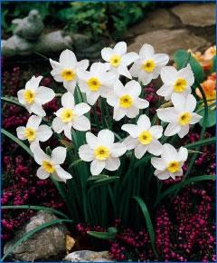
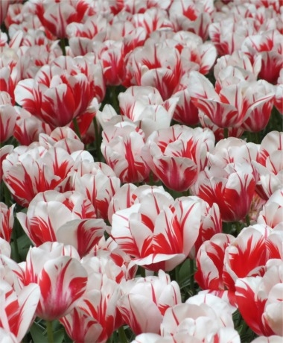
Daffodil: Narcissus Goblet
This award-winning 1952 bi-color has a partially overlapping, glistening white perianth and a trumpet-shaped, brilliant golden-yellow cup with ruffled edge. The cup pales to lemon-yellow as it matures. Bulb size: 14/16 cm. April. 16" to 18". HZ: 3-7.
Cost is $9 per 10

Please email jracioppo@fairfieldschools.org with any questions or orders.
Tulips: Tulip Sorbet

A brilliant, five-time award-winner, Sorbet is ivory-white with ever changing vibrant, swirling raspberry-red flames. Bulb size: 12 cm/up. May. 24". HZ: 3-8.

Cost is $8 per 10
Delivery will be early November.
Receipt of payment
Quanitity Cost
Tulips $8/10 ________ x $8 ________
Daffodils $9/10 ________ x $9 ________
Total paid ________

--------------------------Please cut here return to Mrs. Racioppo at T36 by October 23rd-----------------------------------
Name: _______________________________
Delivery Location: ___________________________ or Flower Donation _____ or Financial Donation ____
Quantity Cost
Tulips $8/10 ________ x $8 ________
Daffodils $9/10 ________ x $9 ________
Total paid ________

Please make check to FWHS Garden

Sold by: ______________________________ HR_____

