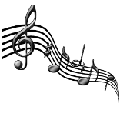The annual Carillon Concert will go on tonight as scheduled. 1st show - 6:30 ; 2nd show - 8:30

