**Biology 21: Final Exam Study Guide 2018**

**Science Skills**

* + Interpret information presented in graphs and data tables.
  + Identify independent and dependent variables, including those that are kept constant and those used as controls.

**Ch. 8 Cell Division (Mitosis and Meiosis)**

1. Describe how the movement of chromosomes in mitosis and meiosis differ.

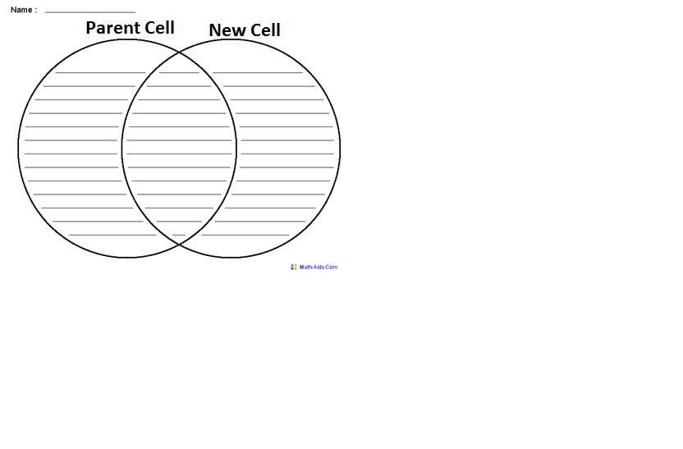

1. Compare and contrast the end products of mitosis vs. meiosis.
2. Describe crossing over and the importance of it in sexually reproducing organisms.

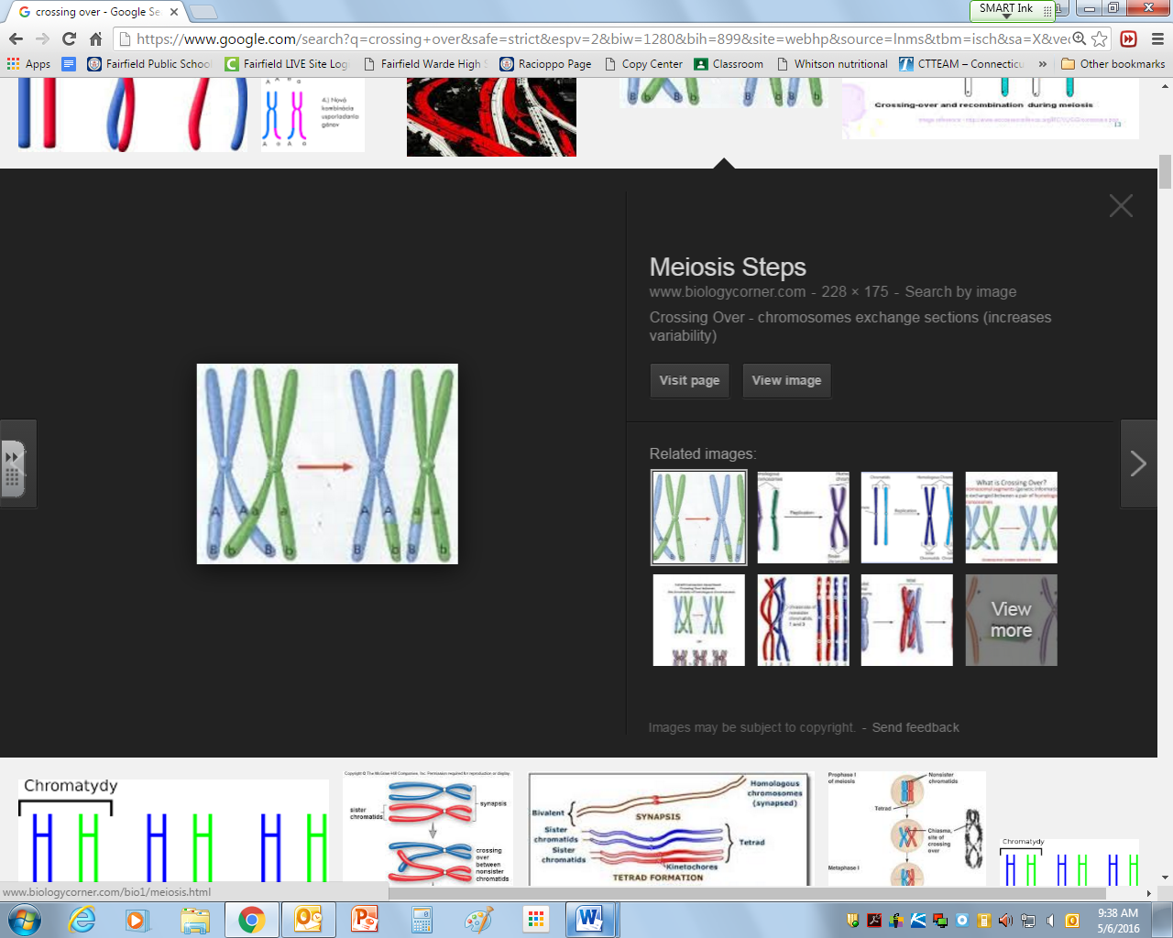

1. Compare and contrast cell division in animal and plant cells

|  |  |  |
| --- | --- | --- |
| Similarities/Differences | Plants | Animals |
|  |  |  |
|  |  |  |
|  |  |  |
|  |  |  |
|  |  |  |

1. Describe the process of creating a unique individual including cell division, fertilization and growth.
2. Analyze the benefits and risks of genetically modified foods.

**Genetics** (Chapter 12)

1. Use Punnett squares to compare the results of various patterns of inheritance:

* 1. dominant and recessive traits

*In corn, there are two alleles for the gene for sugar content. High sugar content is recessive to low sugar content. Cross a high sugar content plant with a heterozygous low sugar plant. What is the probability of getting a high sugar corn producing corn plant?*

* 1. co-dominance

*A cross between a chestnut horse and a white horse yield a palomino (brown and white spotted horse). What percentage of offspring would you expect when a palomino is crossed by a chestnut horse?*

* 1. incomplete dominance

*In some cats the gene for tail length shows incomplete dominance. Cats with long tails and cats with no tails are homozygous for their respective alleles. Cats with one long tail allele and one no tail allele have short tails.  What would be the expected genotypes and phenotypes of offspring resulting from a cross between two short tailed cats?*

* 1. sex-linked

*Male pattern baldness is a recessive sex-linked trait on the X chromosome. A woman, whose father had male pattern baldness, marries a man with this trait. What is the probability that any son born will have pattern baldness?*

* 1. multiple alleles (e.g. blood typing)

*A man with group A blood marries a woman with group B blood. Their child has group O blood. What are the genotypes of these individuals? What other genotypes and in what frequencies would you expect in offspring from this marriage?*

* + - 1. Interpret and analyze pedigrees: predict the genotypes and phenotypes of individuals who could be carrier, affected, and non-affected.

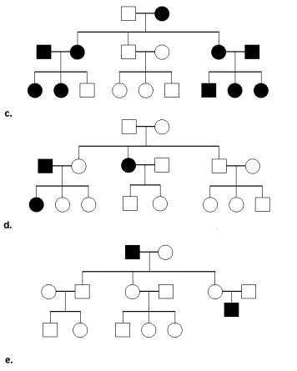

*Using the pedigree at right, would the trait be inherited by an autosomal dominant, recessive, or sex-linked trait? Explain.*

**Classification** (Chapter 17)

1. List the taxa in the correct order.
2. Identify and distinguish between the 3 different domains.
3. Identify relatedness between species using Linnaean taxonomic hierarchies. Which two species are the least related to the others?

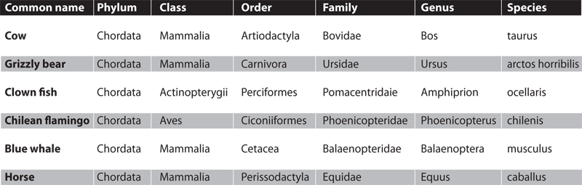

1. Write the name of the blue whale correctly using binomial nomenclature.
2. What can organisms that are the same species do? What can organism that are different species NOT do?
3. Interpret evolutionary relationships using phylogenetic trees. Which two organisms are the most related?

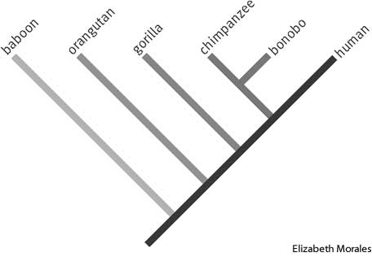

1. Create a cladogram using the data below.

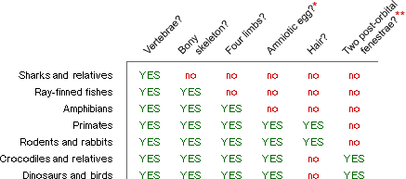

1. Use the dichotomous key below to identify the organism at right.

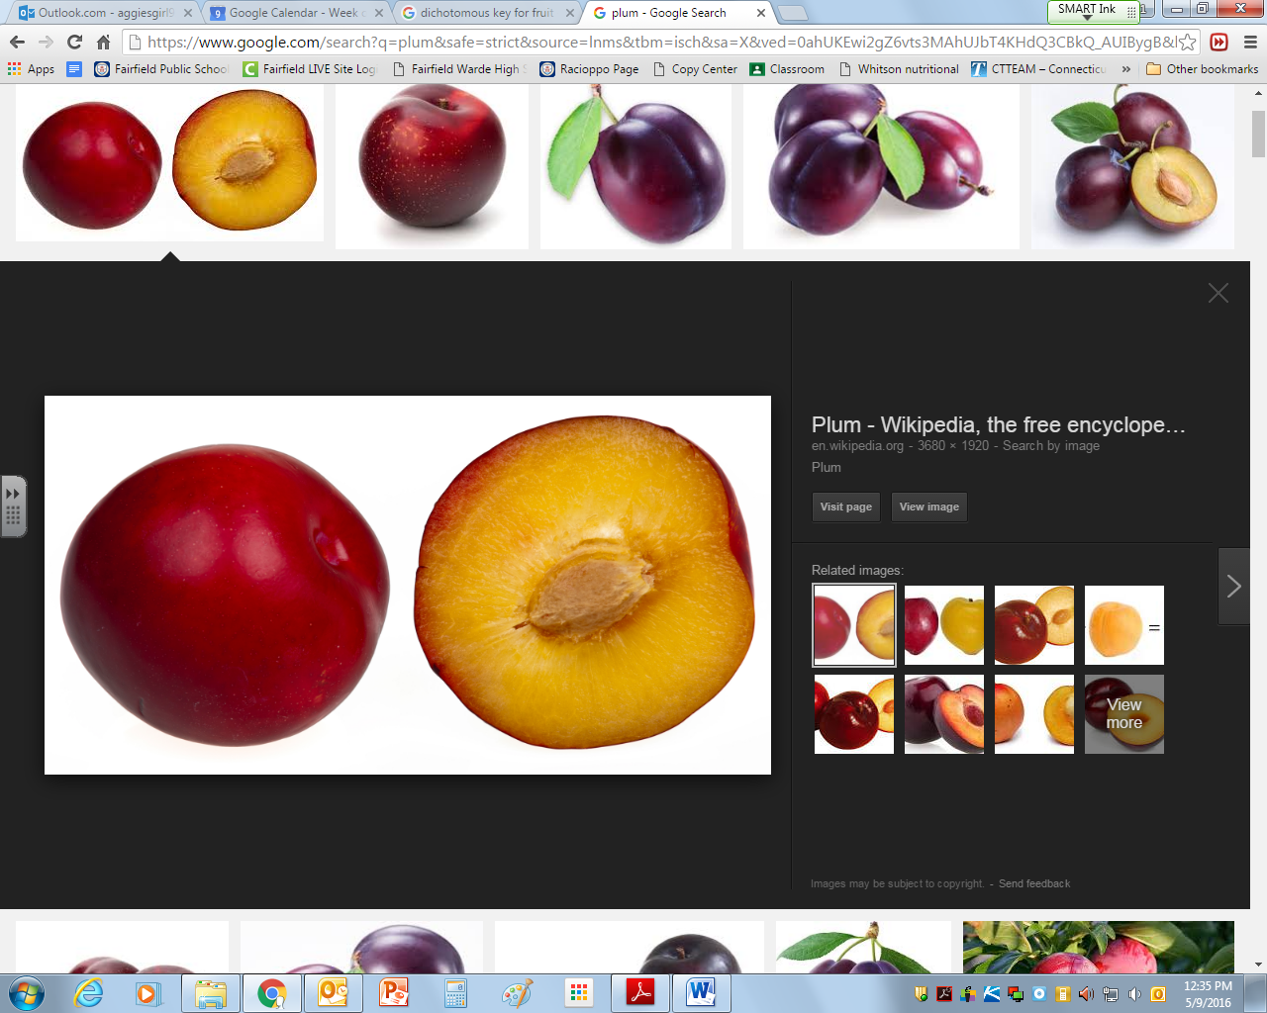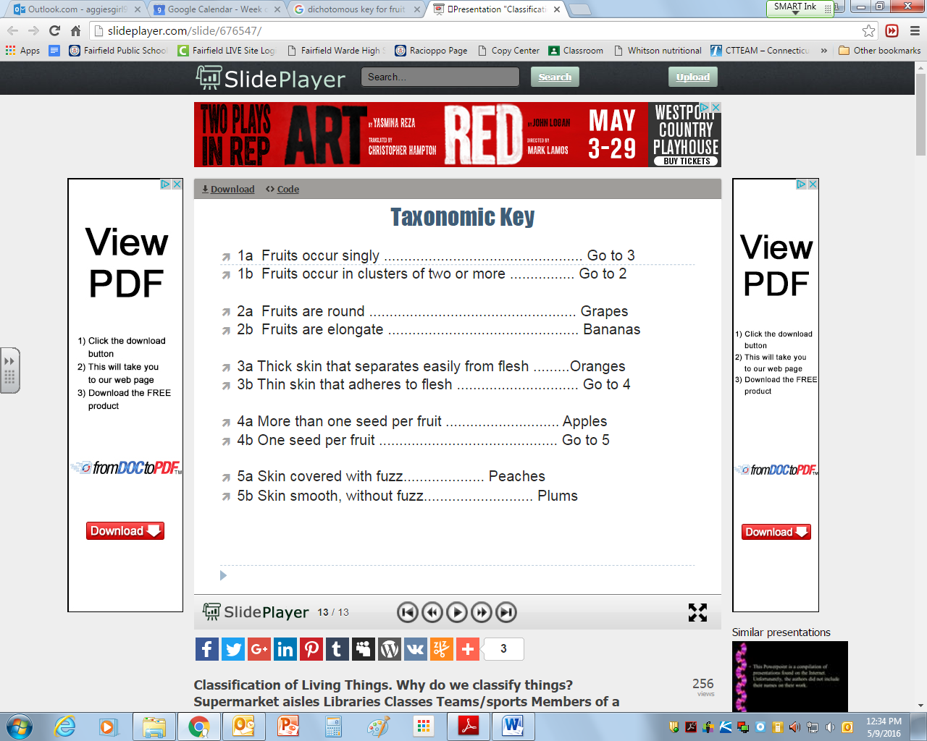

**Microbiology (Chapters 23 and 24)**

1. Compare and contrast bacteria and viruses based on:

|  |  |  |
| --- | --- | --- |
| **CHARACTERISTIC** | **BACTERIA** | **VIRUS** |
| **Basic Structure** |  |  |
| **How do they reproduce** |  |  |
| **How are they treated?** |  |  |

1. Compare and contrast the lytic and lysogenic cycles of viruses.

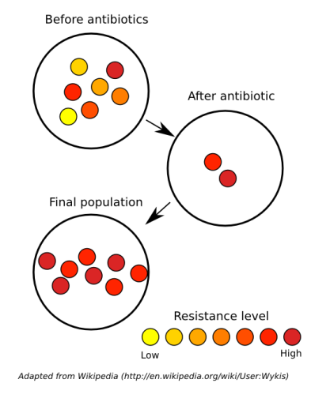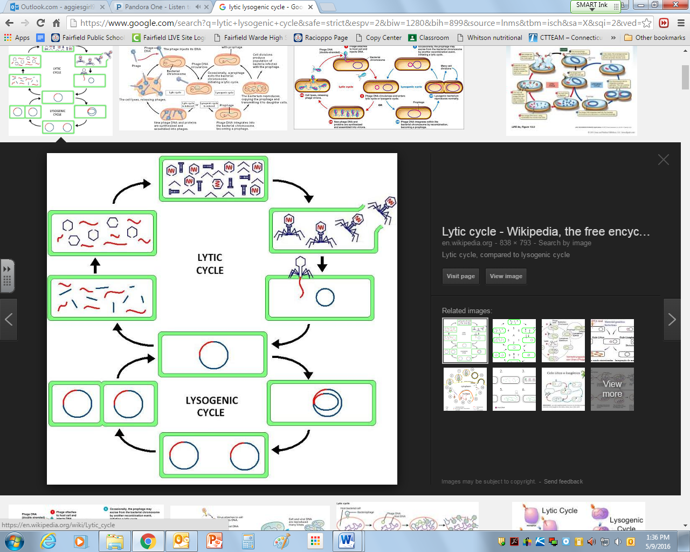

1. Explain bacterial evolution in terms of resistance.

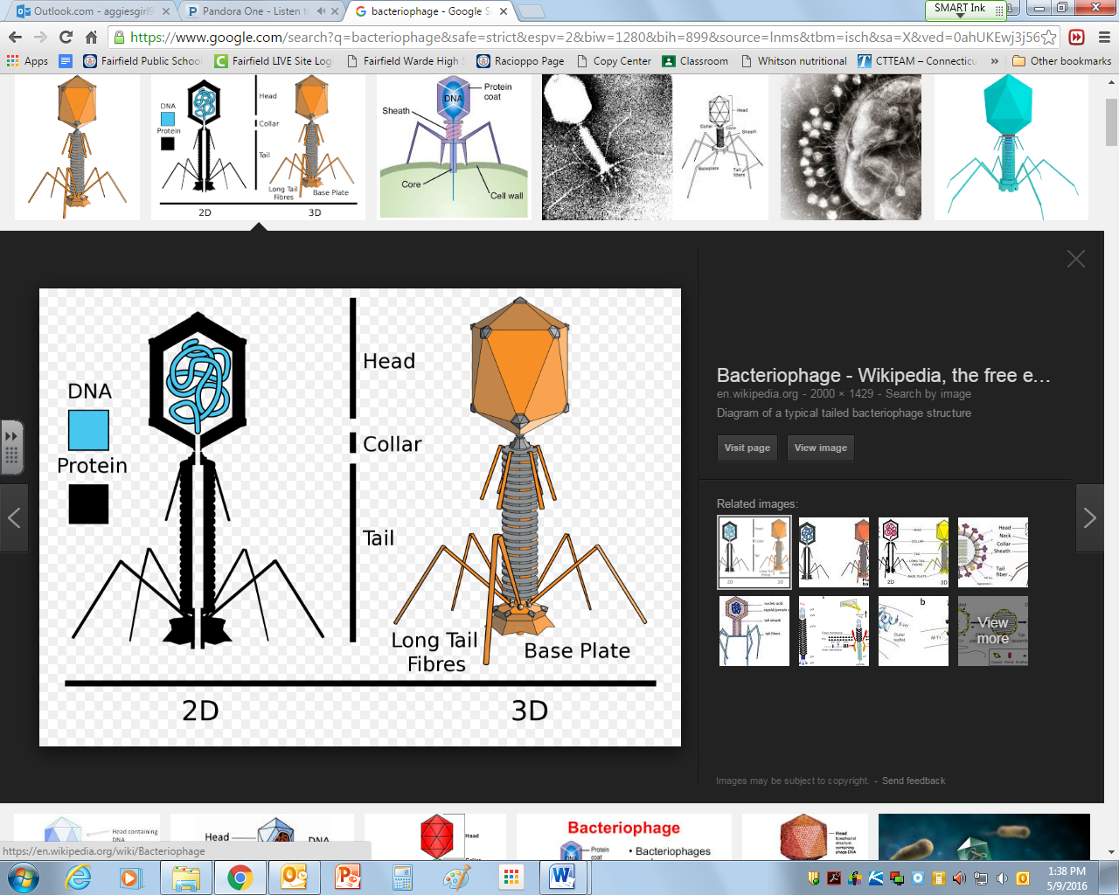

1. Describe viral morphology: capsid and core genetic material.
2. What is in a vaccine and how does it work?
3. If you were to go to the doctor because you were not feeling well, how might they treat a bacterial and viral infection differently?
4. How does your body fight off an infection? Both specific and non-specific immune defenses.

**Evolution (Chapters 15 and 16)**

1. Describe the evidence to support the theory of evolution.
   1. **How might the images below be used to show a common ancestor?**

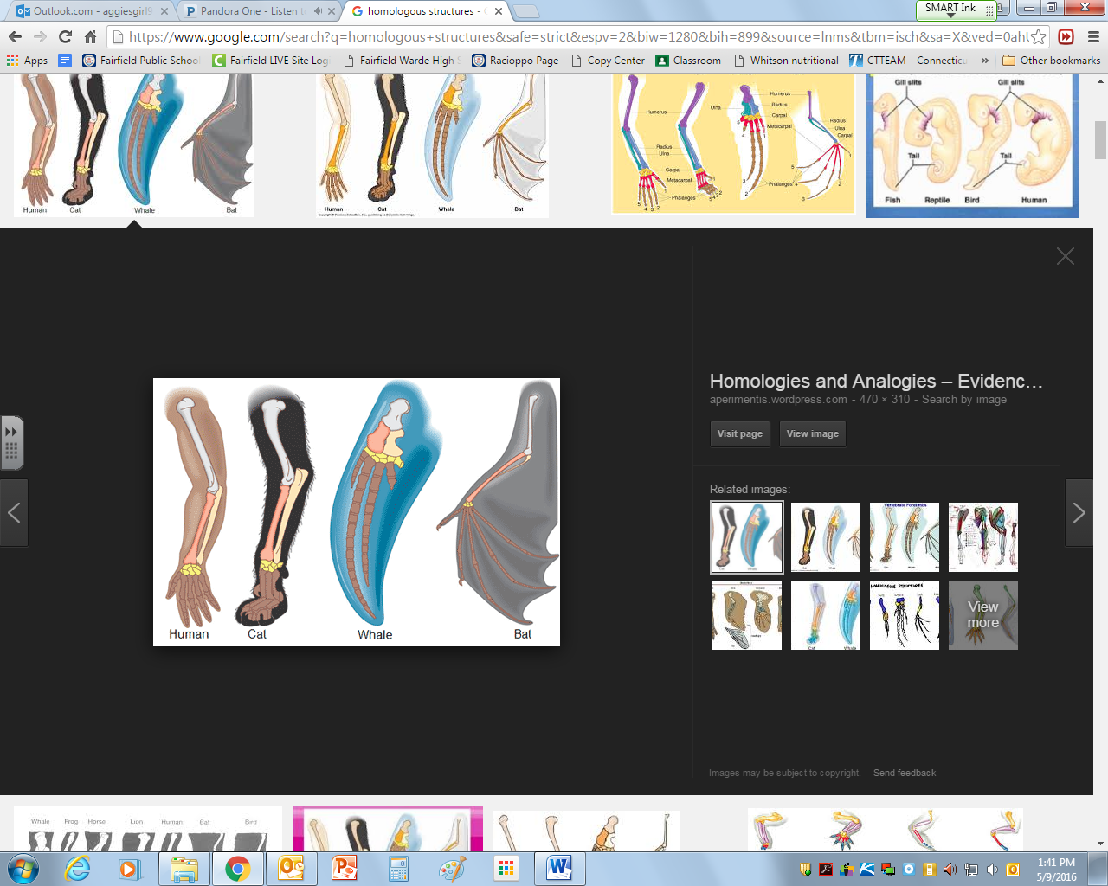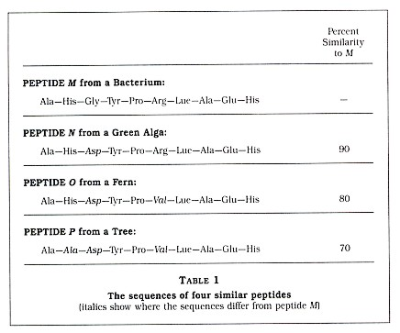

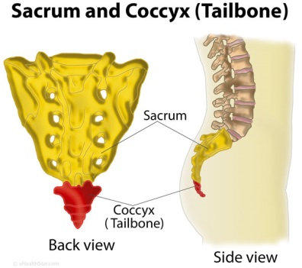

1. 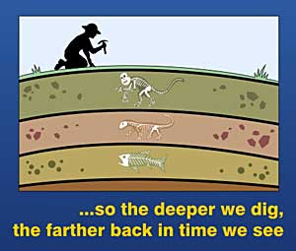Explain the relationship of the fossils found at the various layers. What type of information might be inferred from the diagram of sedimentary rock layers?
2. Explain examples of evolution using Darwin’s finches and his theory of evolution by natural selection.

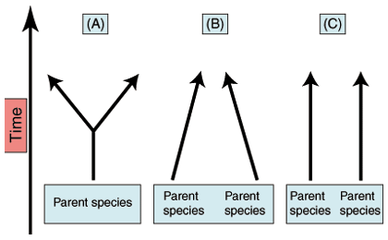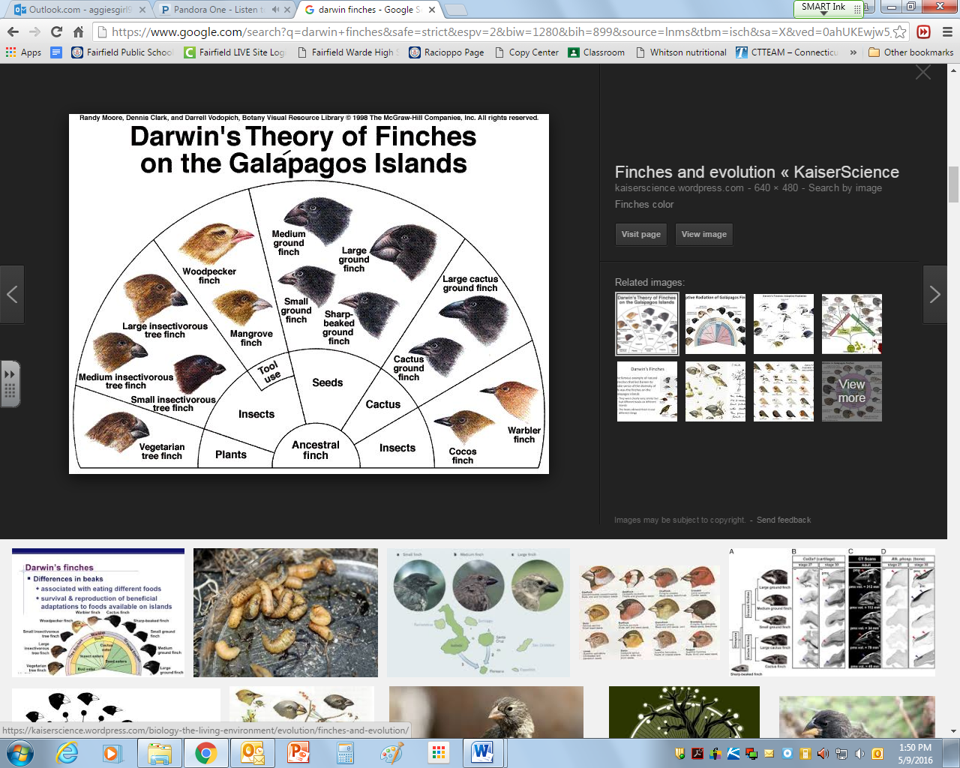

1. Compare and contrast patterns of convergent, divergent, and co-evolution.
2. Compare and contrast gradualism and punctuated equilibrium.

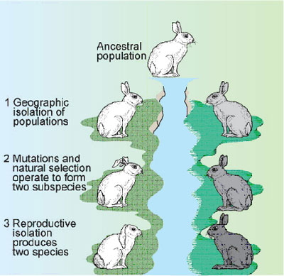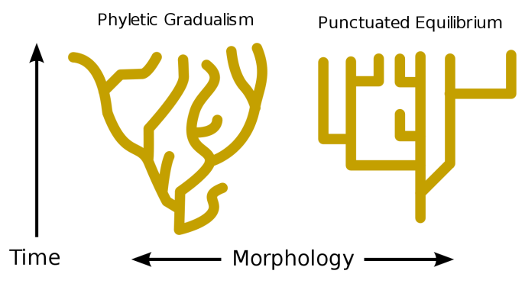

1. Describe the process of speciation through mechanisms such as geographic and reproductive isolation using the diagram at right.
2. Describe how gene frequencies can change in the population of gray rabbits in the diagram at right. Provide a possible explanation.

**Animal Evolution** (Selected sections from Units 8 and 9)

1. Explain the adaptations that made it possible for animals to evolve from water to land. For example:
   1. methods of reproduction
   2. methods of gas exchange
   3. methods of transporting materials throughout the organism
   4. overcoming gravity
   5. movement
   6. prevention of desiccation
   7. overwintering (migration, hibernation, endothermy).

**Plant Evolution** (Selected sections from Unit 7)

1. Describe the key structural characteristics that distinguish plants from other kingdoms.
2. Explain the structural characteristics that made it possible for plants to evolve from water to land. For example:
   1. Vascular tissues
   2. development and modification of roots, stems, and leaves
   3. methods of reproduction
   4. Prevention of desiccation.
   5. Gas exchange

**Ecology** (Chapters 18, 19 and 20)

1. Compare and identify the various levels of ecological organization.
2. Distinguish between the abiotic and biotic components in an ecosystem.
3. How does energy travel through an ecosystem?
4. 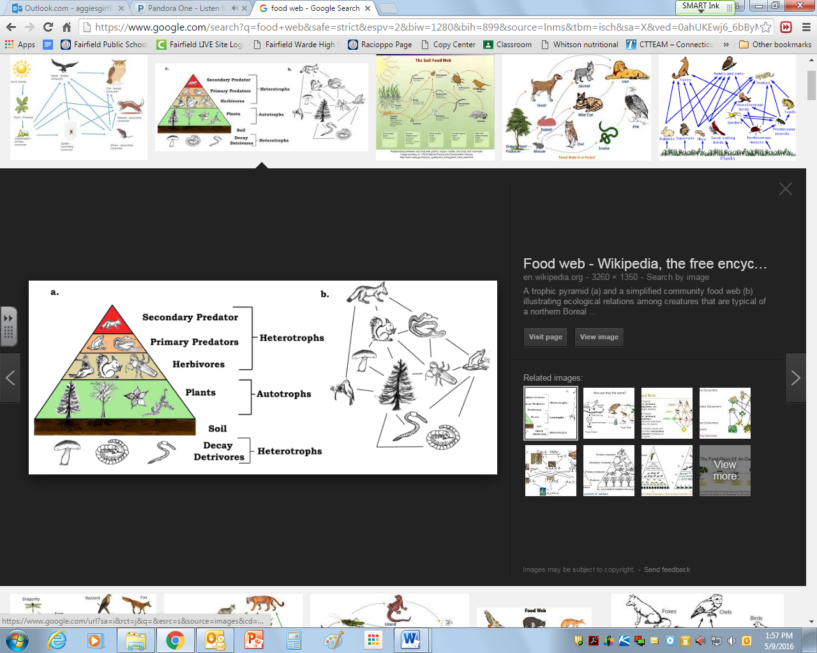Using the diagram below answer the questions that follow:

a). Which organism would have the most energy in the food web above?

b). Which organism would have the least?

c). If the herbivore has 65,000kj of energy, how much would the producers, primary predators and secondary predators have?

d). Which organism above has the largest biomass and explain why it has to?

1. Describe the following symbiotic relationships and how organisms might interact in an ecosystem.
   * 1. Predation
     2. Parasitism
     3. Mutualism
     4. commensalism

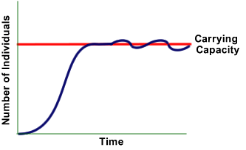

1. Describe the factors that affect the carrying capacity of the environment.
2. What happens to organisms in the population once the size of the population exceeds the carrying capacity? How does it decrease?
3. 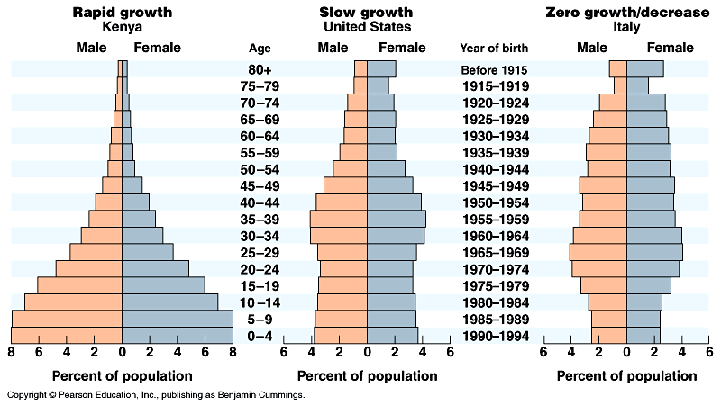Explain how population size is affected by emigration, immigration, birth rate and death rate.
4. Compare age structure diagrams for a developed, developing and underdeveloped country. And identify the factors that affect a population’s age structure.