Getting into Beta Classroom IC and setting up your gradebook.

**Setting up Beta**

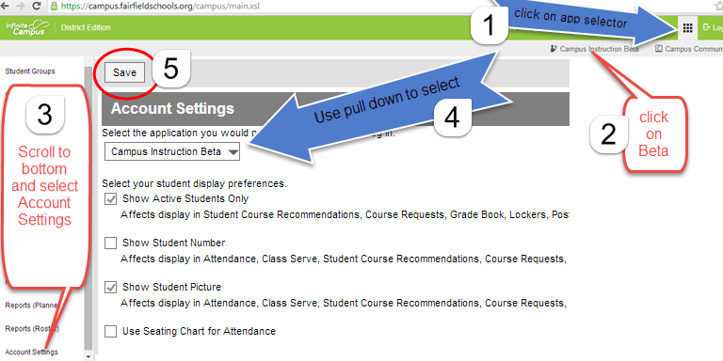

**Setting up your gradebook**

**A B**

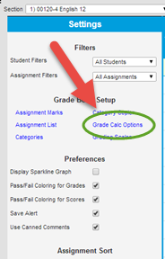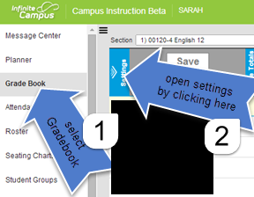

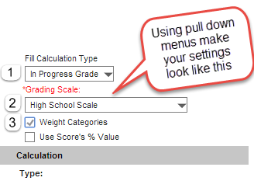

**Work above the grey bar to affect all grading**

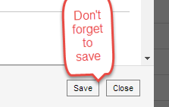

**Repeat for all classes.**

Setting up Categories