**INFinite Campus**

**Video**

Link- <http://goo.gl/a1gLOe> 

**How to set up your gradebook**

1. 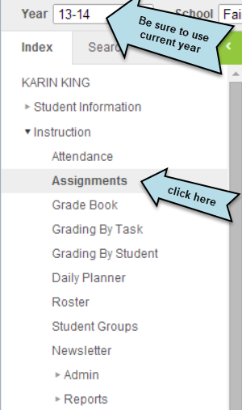 Setting up the grading scale for your gradebook. You need to do this for each class that you teach.

A.

B.

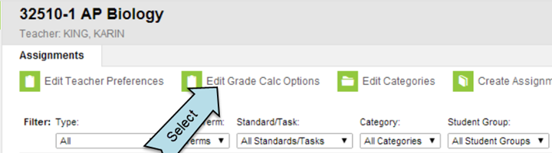

C.

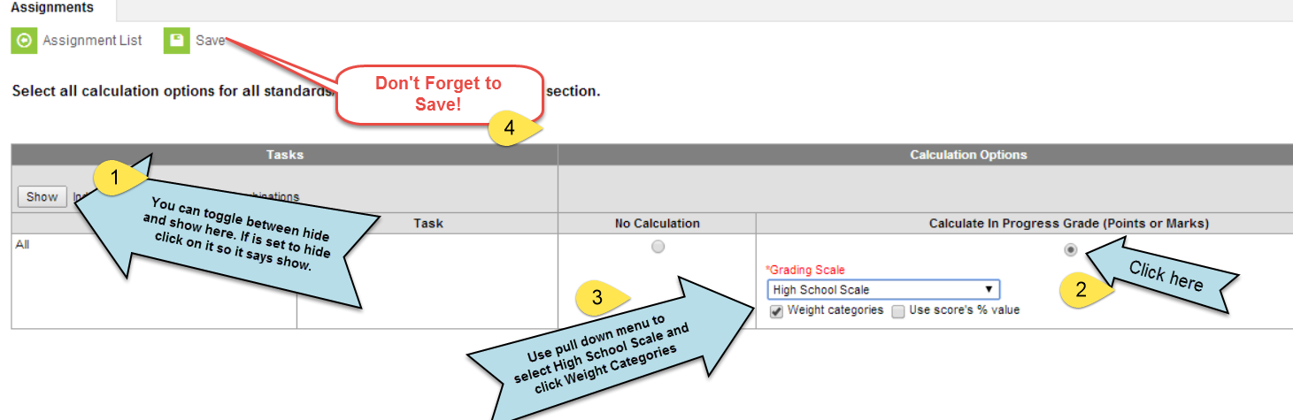

1. 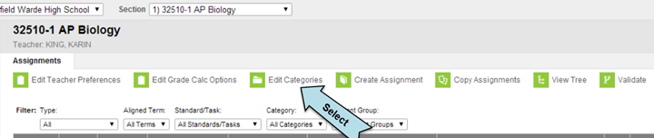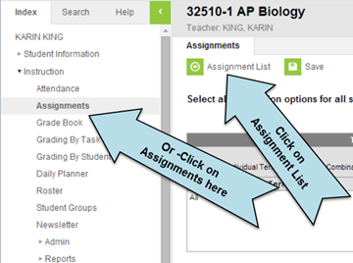Setting up categories for each part of your gradebook.

B.

C.

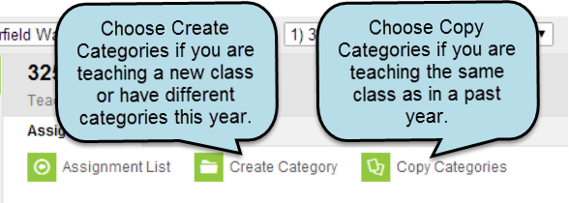

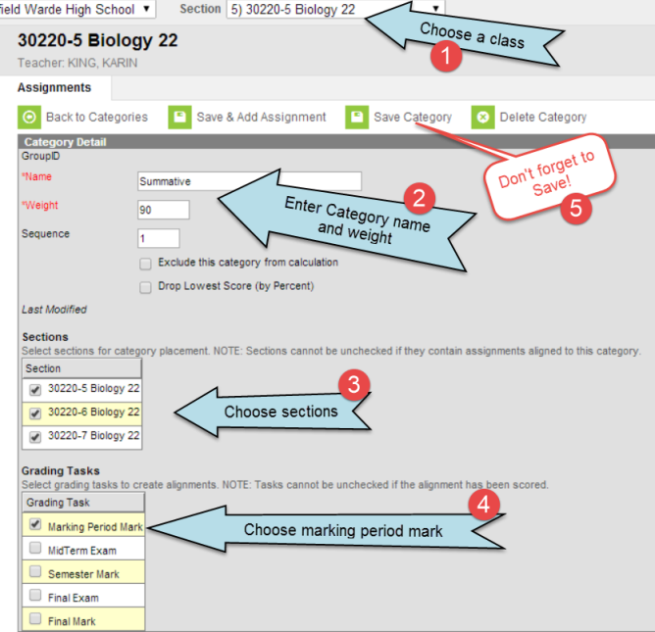To Create Categories:

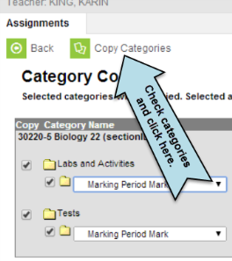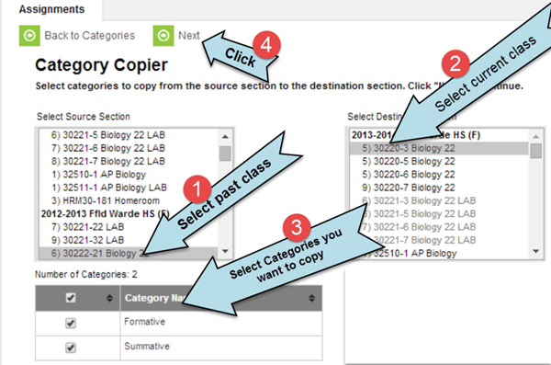To Copy Categories: