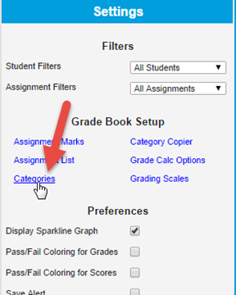
Setting up Categories in Infinite Campus
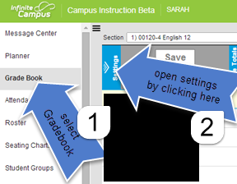

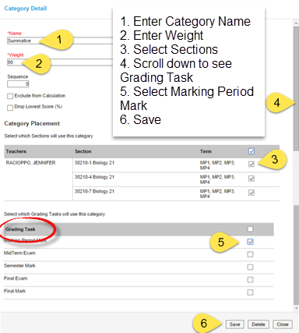
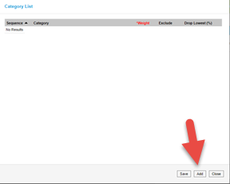

Repeat for Additional Categories
Midterm and Final Exam Categories
Categories must be made before you can enter grades into your gradebook. You just entered the categories for your marking period grades. In order to enter grades for Midterm and Final you must do the same thing.
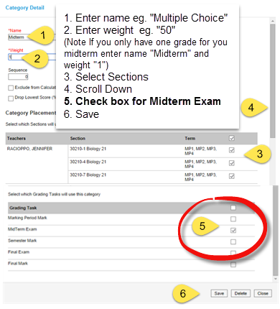
Repeat for Final Exam. Under Grading Task select Final Exam

