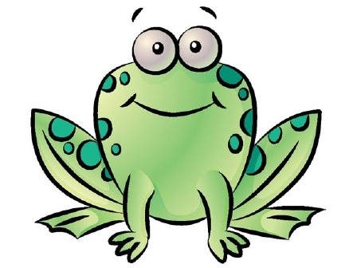ANIMAL EVOLUTION Outline

PROJECTS & LABS:

Phyla Cut out

Phyla Presentation

Animal Lab

OBJECTIVES:

|  |  |  |
| --- | --- | --- |
|  | PRE DATE: ___ | PRE DATE: ____ |
| I am able to describe the key structural characteristics that distinguish the 9 major phyla: porifera, cnidaria, platyhelminthes, nematoda, annelida, mollusca, arthropoda, echinodermata, chordata (classes- fishes, amphibians, reptiles, aves, mammals) |  |  |
| I am able to Describe the structural characteristics   * + Symmetry   + Cephalization   + # of tissue layers presence of body cavity   + # of openings   + segmented body |  |  |
| * I am able to explain the adaptations that made it possible for animals to move from water to land: * Methods of reproduction * method of gas exchange * methods of transporting materials throughout the organism * overcoming gravity * movement * prevention of desiccation   overwintering (migration, hibernation, endothermy) |  |  |



**Animal Evolution Terminology**

1. What is symmetry? _________________________________

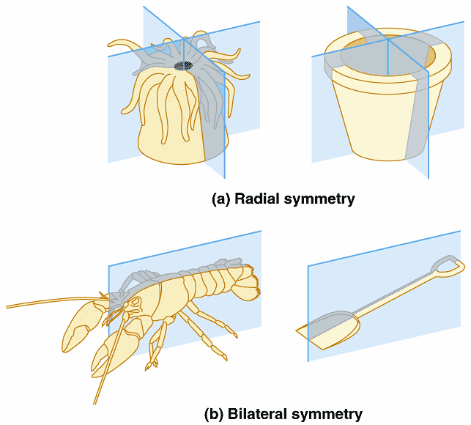 What are the 3 types of symmetry? Label below and explain what the three types would look like on an animal.

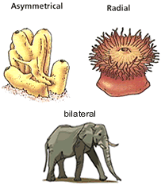

1. **_______________**

**_______________**

**_______________**

1. **_______________**

**_______________**

**_______________**

1. **_______________**

**_______________**

**_______________**

1. What do the pre-fix mean?
   1. Endo-
   2. Ecto-
2. What is cephalization? What is the benefit to cephalization? Label the parts of an organism due to cephalization.

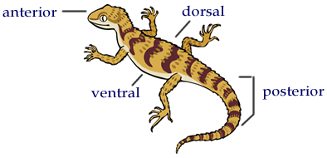

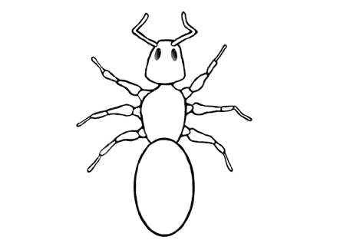

1. Explain what segmentation of a body is. Describe the benefits and give some examples.

1. What are the possible three tissue germ layers in an animal? Label it on the picture below and explain what body system each layer can form into. (most animals have **all three**)

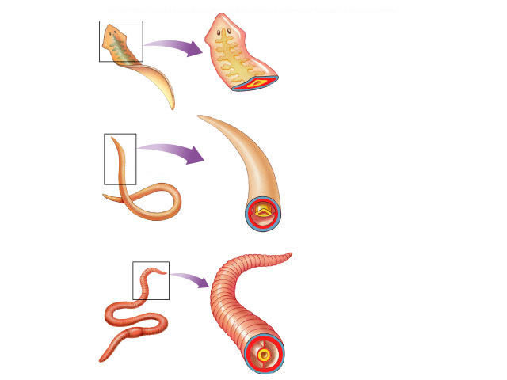

1. Which organism doesn’t have any true tissue? ________________________
2. Which organism has only ectoderm and endoderm tissue? _________________

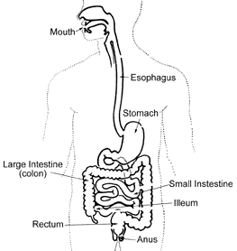

1. Explain the how the # of openings in digestion helped the evolution of an animal.

Give some examples.

1. [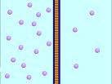](http://www.google.com/imgres?imgurl=http://www.indiana.edu/~phys215/lecture/lecnotes/lecgraphics/diffusion.gif&imgrefurl=http://www.indiana.edu/~phys215/lecture/lecnotes/diff.html&usg=__up-nCC6vkYdfPIAYtQlXePWSsMY=&h=480&w=640&sz=377&hl=en&start=5&sig2=itRQJP3dbNt4bGSNCqImPQ&itbs=1&tbnid=DZtShptJxRkATM:&tbnh=103&tbnw=137&prev=/images?q=diffusion&hl=en&gbv=2&tbs=isch:1&ei=gMb7S8GAC4aglAfT-pXaDw)Refresher….. What is diffusion and how does it work?
2. What is desiccation?
3. What is an open and closed circulatory system?