Name: ____________________________
Animal Evolution Review
- How do animals differ from all the other kingdoms?
Euk, multicell, tissue and organs, heterotrophic

- Why are they (animals) different?
Multicell, specialized cells

- Why do animals have specialized cell?

To be more efficient with organs, can get larger in size

- Describe how living on land is in more difficult that living in the water. What must the animals adapt to?
Dry air: makes reproduction, obtaining oxygen, desiccation are all DIFFICULT on land (must have lungs, skin, internal fert/develop

- What are the 2 main types of symmetry and what is the benefit of each?
Radial: regeneration, ext fertiliz in water
Bilateral: head region, more complex nervous system
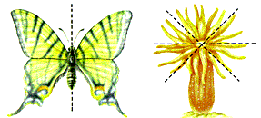

- What are the main challenges of living on land? State what is required for each.
Dry air: makes reproduction, obtaining oxygen, desiccation are all DIFFICULT on land (must have lungs, skin, internal fert/develop

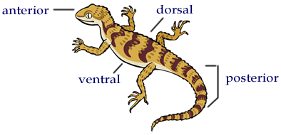
- What is cephalization and why is it relevant?

Head region: complex nervous system with centralized sensory

- Which organisms are segmented? What does it mean to have segmentation? (see diagram below)
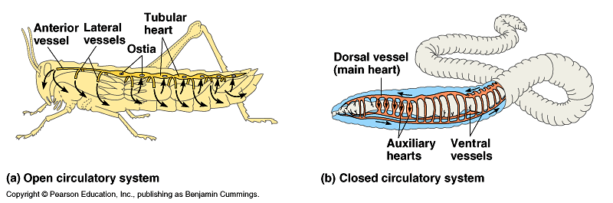
head, abdomen, thorax
Worms and grasshoppers

- What do the following terms have in common: cuticle (plants), exoskeleton, skin?
Prevent desiccation

- How does an organisms like a sponge and worms do gas exchange? How is that simliar to a human?
Simple diffusion through skin or cells
Humans use lungs but process is still diffusion through a moist semipermeable layer

- Compare the differences between how animals reproduce:
jellyfish, ext fert & devel
amphibians, ext fert & develop
reptiles, and int fert, ext develop
mammals. Inter fert & develop

- What is the difference between a
fish egg, must be in the water at all times
chicken (or lizard) egg and dry shell for surviving on land, need yolk

human egg? Still in fluid, but inside Mom

- Describe the different ways that animals deal with colder temperatures.
  - Migration moving to where it is warmer

  - Hibernation hide and sleep

  - Endothermy (warm blooded) maintain body temper, no need to move

- Give an example of an organism that uses each of the following for gas exchange.
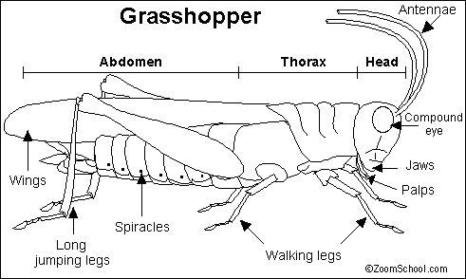
  - Lungs humans, dogs

  - Gills shark, fish, lobsters, crab

  - Skin worms

  - Spiracles grasshoppers

- How are the following organism adapted to living and reproducing on land?
  - Mammals inter fert & develop, land is dry

  - Reptiles inter fert but develop ext in an egg

  - Birds inter fert but develop ext in an egg

  - How are fishes different? Ext fert & devlop but must be in water

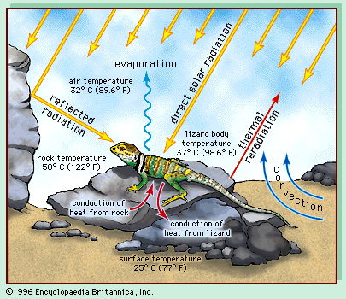
- What is the difference between an ectotherm and an endotherm? Which is more complex? Give an example of each.
Ectotherm: body temp is same as outside, ex. fish
Endotherm: regulate body temp at a constant homeostasis temp, more complex, must use energy
Ex. human

- Which is most effective, ecto- or endo- thermy?
Endo because it is always the same.
When it is cold things slow, when it is warm things move fast.
- Draw a cladogram to show all of the organisms listed in this review packet. Use a characteristic to separate the various groups.

