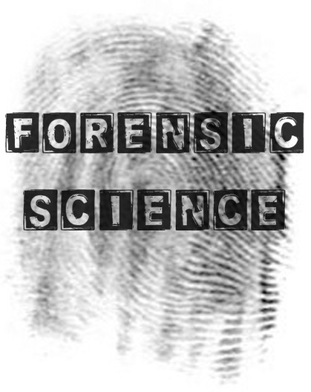
Name: ______________________________
CHAPTER 1
INTRO TO FORENSICS
Unit Objectives
Students will be able to:
- describe how the scientific method is used to solve forensic problems.
- describe the applications of forensics.
- describe the relationship of science, forensics and the law.
- explain forensics practices using specific court cases throughout the course.
- discuss the importance of the work of various forensics pioneers.
- discuss the careers that contribute to the field of forensics.
- discuss the “CSI effect” on the field of forensics and juries.

- Forensic science incorporates which two disciplines?

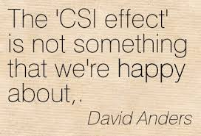
- Which sciences does forensics include?

- What is the CSI effect?

- What do forensic scientists do?

- Describe the Locard Principle. Draw a diagram if it helps.

- Apply the Locard Principle to the Richard Craft/Helle Crafts case.

- What is the job of the forensic team?

- What series of steps does a forensic scientist use? State the steps and briefly describe each.
  - ____________________:

  - ____________________:

  - ____________________:

  - ____________________:

  - ____________________:

- What do the following acronyms stand for and generally what do they do? Place a * next to the organizations that have their own crime labs.
  - FBI:

  - DEA:

  - USPS:

  - ATF:

  - US FWS:

  - SS:

- What is the difference between deductive and inductive reasoning?

