CHARACTERISTICS OF LIFE
In your notebook:

Create a graphic organizer, something like this:

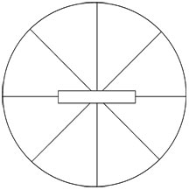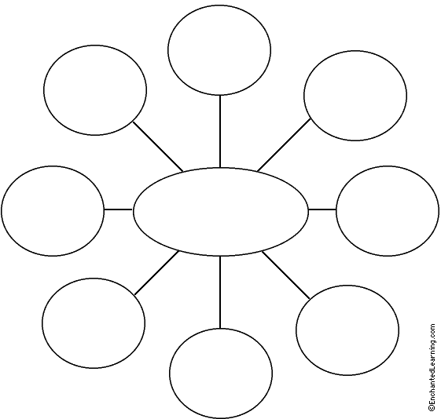

Include the major functions of life and what they are used for.
Then organize the characteristics and make connections. Be sure to give a specific example of each.

ON THE BACK OF YOUR GRAPHIC ORGANIZER, answer the following:
- How is a candle like a living organism?

- How is a candle not like a living organism?
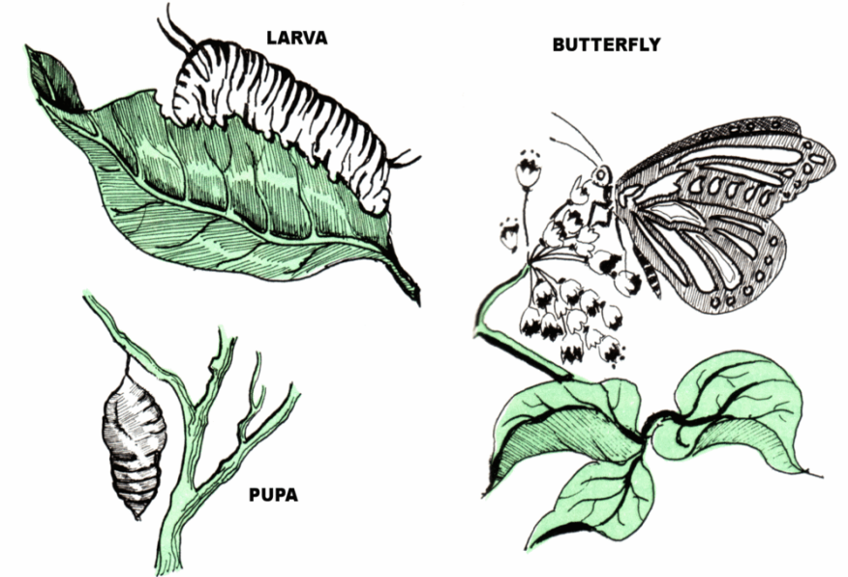
- What is the diagram above showing?

- List and describe each of the characteristics that are exhibited by the diagram above.

