Name_____________________

Cladistics

Cladistic taxonomists agree that organisms that share a derived character, like feathers in birds, probably share it because they inherited it from a common ancestor. Derived characters, particularly a group of several shared derived characters, are strong evidence of common ancestry.

Terminology
Character- inheritable trait possessed by an organism
Derived character- a modified version of a more primitive condition of that character.
(Arose later in the evolution of the group of organisms.)
Cladograms- Ancestry diagrams made by means of cladistic analysis.

Constructing Cladograms

Part one
The following table presents data on some characteristics found in modes of transportation. A “+” indicates that the vehicle has a particular characteristic and a “-“ indicates that a vehicle does not have a particular characteristic.

Characteristics

Vehicle Wheels Engine Wings

Horse drawn cart + - -
Car + + -
Plane + + +
Space Shuttle + + +

Using this data, complete the cladogram below. Each branch point should indicate a vehicle.

__________ _________ _________ _______________

Wings

Engine

Wheels

Part two
The following table presents data on some characteristics found in vertebrates. Using these data, construct a cladogram. Each branch point should indicate a common ancestor. Write the name of the shared derived character that is common to all organisms about each branching point.

Characteristics

Organism Backbone Four Limbs Watertight egg

Fishes + - -
Amphibians + + -
Mammals + + +
Reptiles + + +

__________ _________ _________ _______________

__________

__________

_________

Part three
The following table presents data on some characteristics found in vertebrates. Using these data, construct a cladogram. Each branch point should indicate a common ancestor. Write the name of the shared derived character that is common to all organisms about each branching point.

Characteristics

Organism Has Fur Four Limbs Has Tail Walks bipedally

Fishes - - + -
Reptiles - + + -
Monkeys + + + -
Apes + + - -
Man + + - +

Note: A shared derived character can actually be the absence of a structure common to organisms below that point on the tree.

The following table presents data on some characteristics found in vertebrates. A “+” indicates that the organism has a particular characteristic and a “-“ indicates that the organism does not have a particular characteristic.

Characteristics

Organism Jaws Limbs Hair Lungs Tail

Lamprey - - - - +
Turtle + + - + +
Cat + + + + +
Gorilla + + + + -
Lungfish + - - + +
Trout + - - - +
Human + + + + -

Using these data, construct a cladogram. Each branch point should indicate a common ancestor. Write the name of the shared derived character that is common to all organisms about each branching point.

Note: A shared derived character can actually be the absence of a structure common to organisms below that point on the tree.
The following table presents data on some characteristics found in vertebrates.

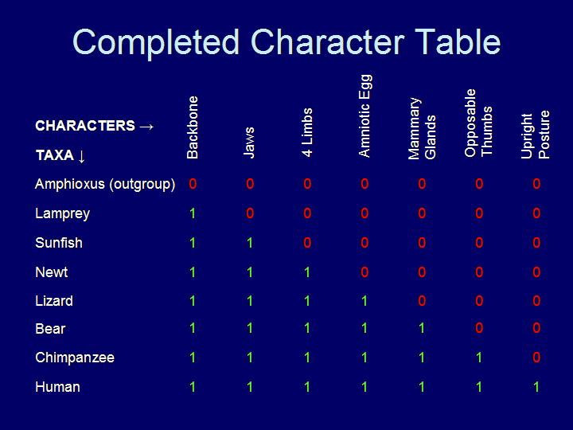

http://www.eeescience.utoledo.edu/faculty/dwyer/biodiversity/constructingcladograms.htm

Name: _________________ CLADOGRAM FORMATIVE ASSESSMENT

Use the table below to create a cladogram. Write the name of the organisms on the top of the vertical lines and the characteristics on the angled line. The first one is done for you.

Derived Characters
 | segmented | jaws | hair | placenta | multicellular | limbs
kangaroo | + | + | + | - | + | +
earthworm | + | - | - | - | + | -
amoeba | - | - | - | - | - | -
lizard | + | + | - | - | + | +
cat | + | + | + | + | + | +
sponge | - | - | - | - | + | -
salmon | + | + | - | - | + | -

Amoeba

Youngest
Most Devel.

Oldest/Least Developed
http://www.bu.edu/gk12/eric/cladogram.pdf

