Name: ______________________ ENZYME REACTIONS

1. Identify 2 ways to speed up the rate of a chemical reaction.
2. Explain the functions of the substrate and the active site in an enzyme-catalyzed reaction.

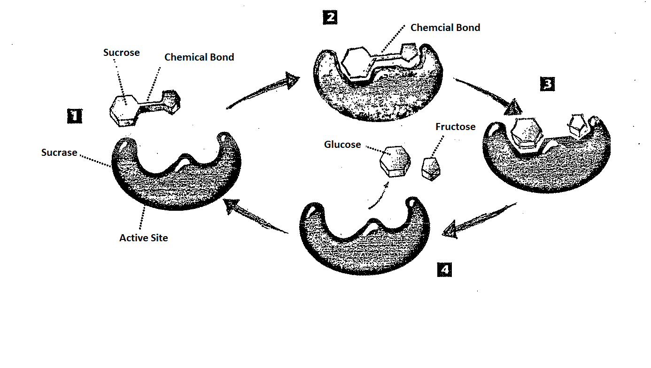

1. Which substance in the diagram is the substrate? Explain.
2. At which step does the chemical reaction actually take place?
3. What chemical reaction is catalyzed by the enzyme?
4. How can you tell from the diagram that sucrase is not used up in the reaction?
5. Why does a cracker begin to taste sweet after a few minutes of chewing?

**CRITICAL THINKING**

A certain experiment was designed to determine the effect of pH on the rate of enzyme action for two protein-digesting enzymes. Enzyme A is found in the stomach. Enzyme B is found in the intestines. Data collected during the experiment are illustrated in the graph.

1. What is the optimum pH for Enzyme A? Enzyme B?
2. Compare the rates of enzyme action at a pH of 5.
3. Based on the data, what can you infer about the relative pH of the stomach? Explain.
4. Based on the data, what can you infer about the relative pH of the intestine? Explain.
5. Suppose a mutation caused the location of the enzymes to be switched. What effect might his have on the digestive process of the organism?
6. 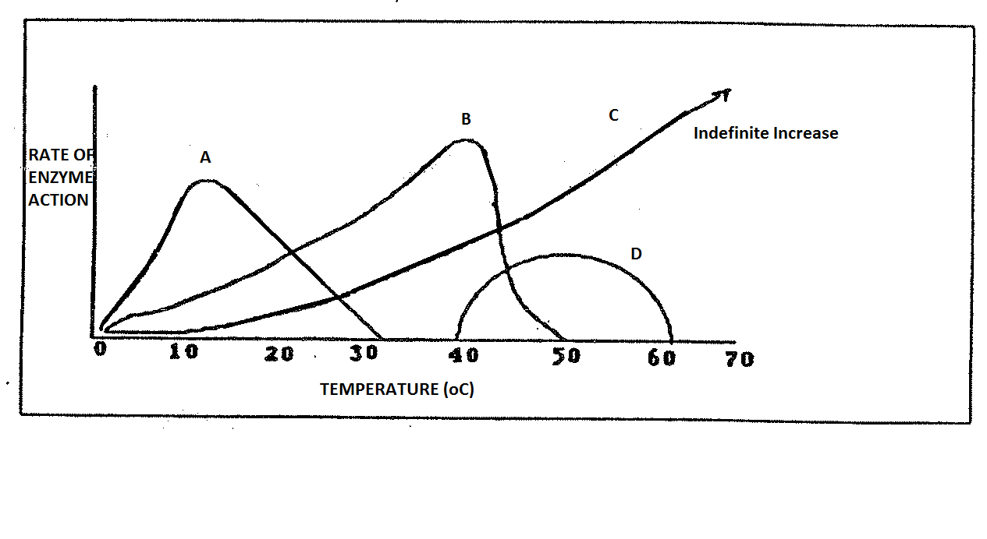 Using the temperature graph at right, which of the enzymes shown below (A, B, C or D) is most likely to represent a human enzyme? Why?
7. Using the pH graph below, which enzyme would most likely be found in the human stomach?

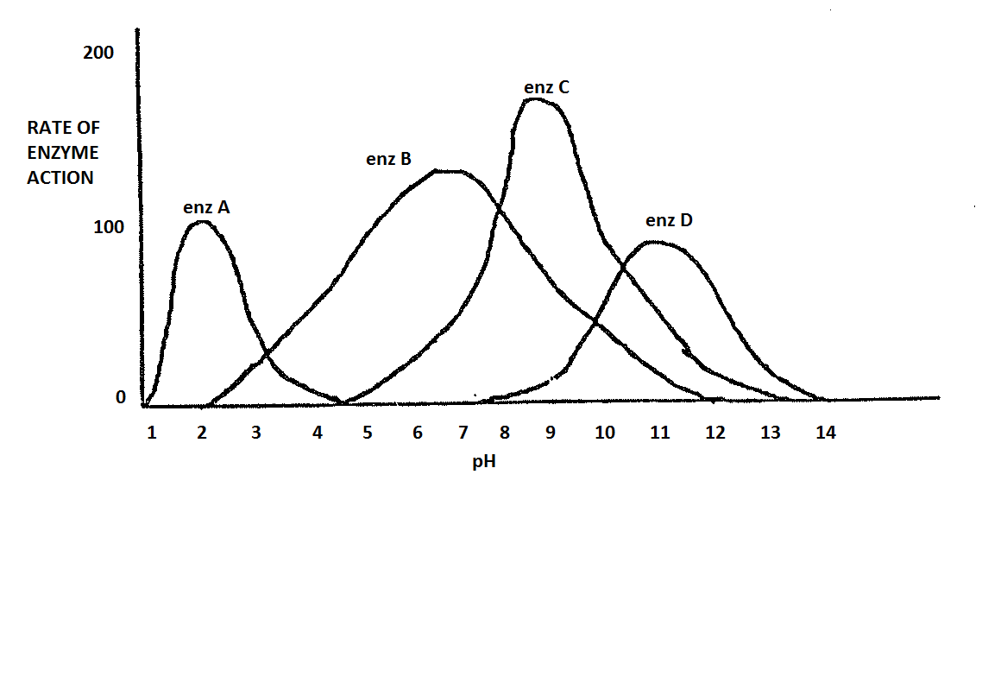

1. Given an animal intestinal pH of 8.5, what can you say about both enzymes B and C? Which is more effective? Use the pH graph at left.

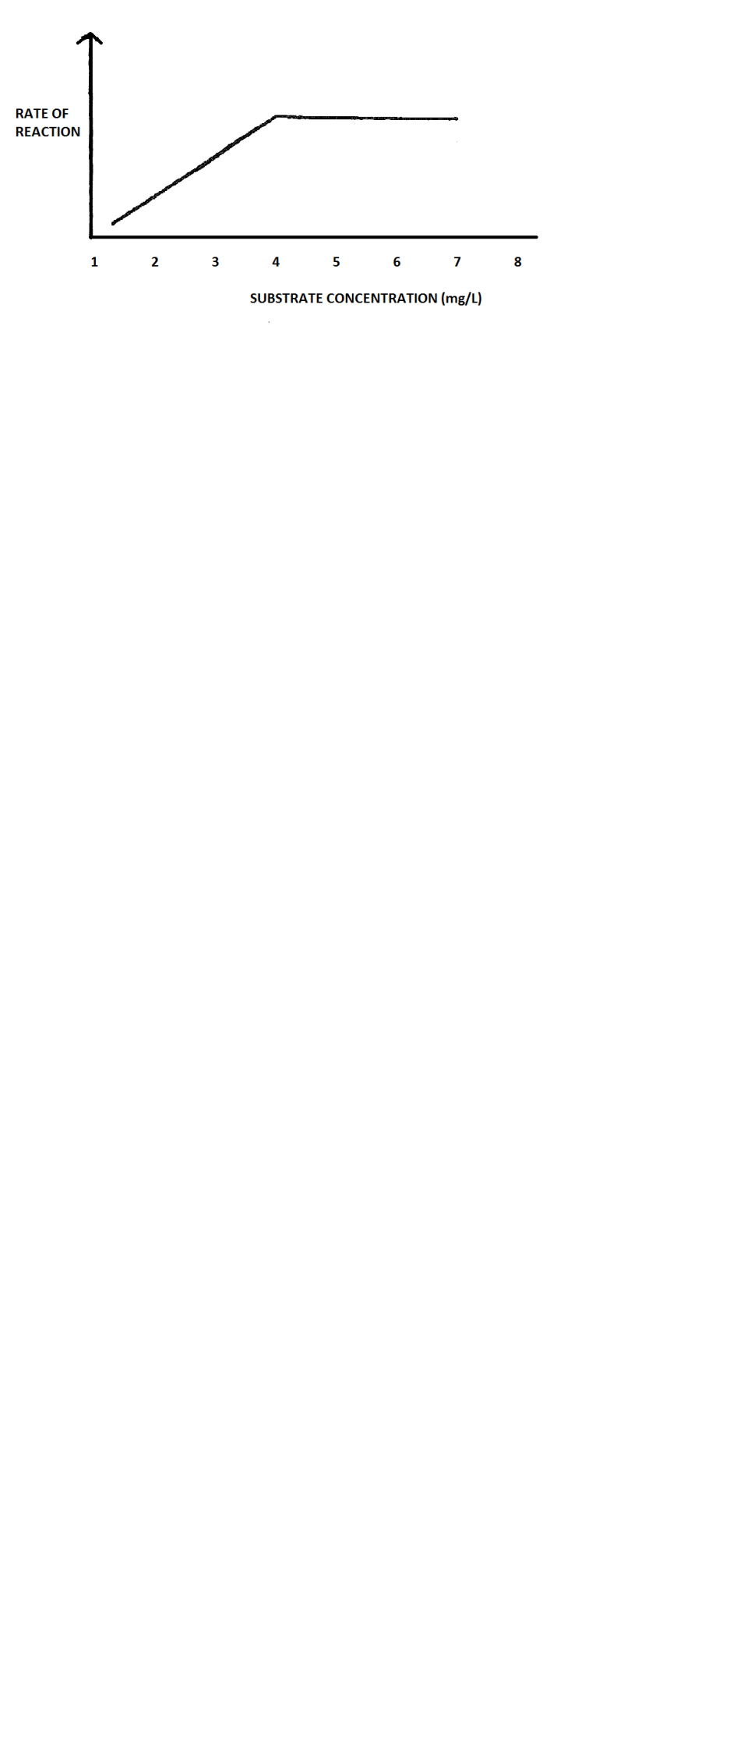

1. What information does the graph below tell you about enzyme activity?
2. What information does the graph below tell you about the rate of reaction?
3. What information does the graph below tell you about enzyme concentration? Substrate concentration?