NAME ____________________________________________
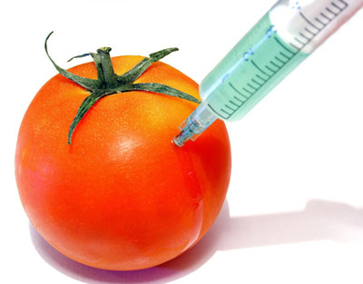
GENETICALLY MODIFIED FOODS

CONTENT | POINTS
Definition of GMF (5 points)
Examples of GMF’s (5 points)
3 Pro’s of GMF’s with explanation (15 points)
3 Con’s of GMF’s with explanation (15 points)
Your stance on GMF’s (10 points)
Your stance on mandatory labeling of GMF’s (10 points)
FORMAT
Citations (minimum of 3 sources) (15 points)
Parenthetical references (5 points)
Organization (10 points)
Pamphlet appearance (10 points)

Total Points (100) _______________

