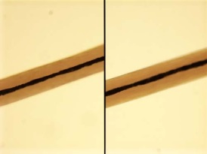
Name: _____________________________
HAIR
Please use the following numbered scale to indicate your confidence in your knowledge of topics in Unit 3: Hair.
Please use the following numbered scale to indicate your confidence in your knowledge of topics in Unit 3: Hair.
4 | I understand the material so well I can teach it to others
3 | I feel confident I fully understand the material
2 | I get the idea, but I feel there is more to learn
1 | This is a totally new concept for me

# |  | Pre Date: _________ | Post Date: ____________
1 | I am able to describe the parts of the hair.
2 | I am able to explain the lack of evidentiary value of hair comparisons.
3 | I am able to compare a hair or fiber sample to a control sample.
4 | I am able to identify the types of scales.
5 | I am able to identify a human hair verses an animal hair.
6 | I am able to explain what can be determined from a hair and what can not.
7 | I am able to compare the value of a hair follicle verse a hair shaft.

- What techniques are used specifically to collect hair and fiber samples?

- What can be determined by hair found at a crime scene?

- What type of evidence does hair fall into?

- What is a control sample? Why are they used?

- Label the parts of the hair and follicle.

- What is hair made of?

- What is a hair follicle?

- Label the following parts of the hair. What are the following parts of a hair?

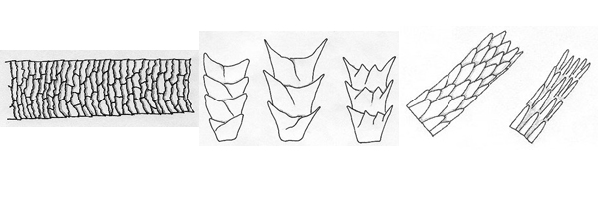
- What are the main types of scales on hair?

- What types of scales do humans have?

- What is the purpose of the cortex?

- What are the two major characteristics of the cortex?

- Which part of the hair is the medulla?

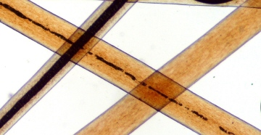
- What are the four types of medulla?

- What type of hair tends to have which of the following types of cross-sections of hair?
  - Round
  - Oval

  - Crescent Moon

- What type of information could a forensic scientist use from a hair follicle?

- What is the difference between a hair follicle fallen out naturally and pulled out?

- Fun hair facts:

