Moss
http://www.aquamoss.net/Erect-Moss/Erect-Moss.htm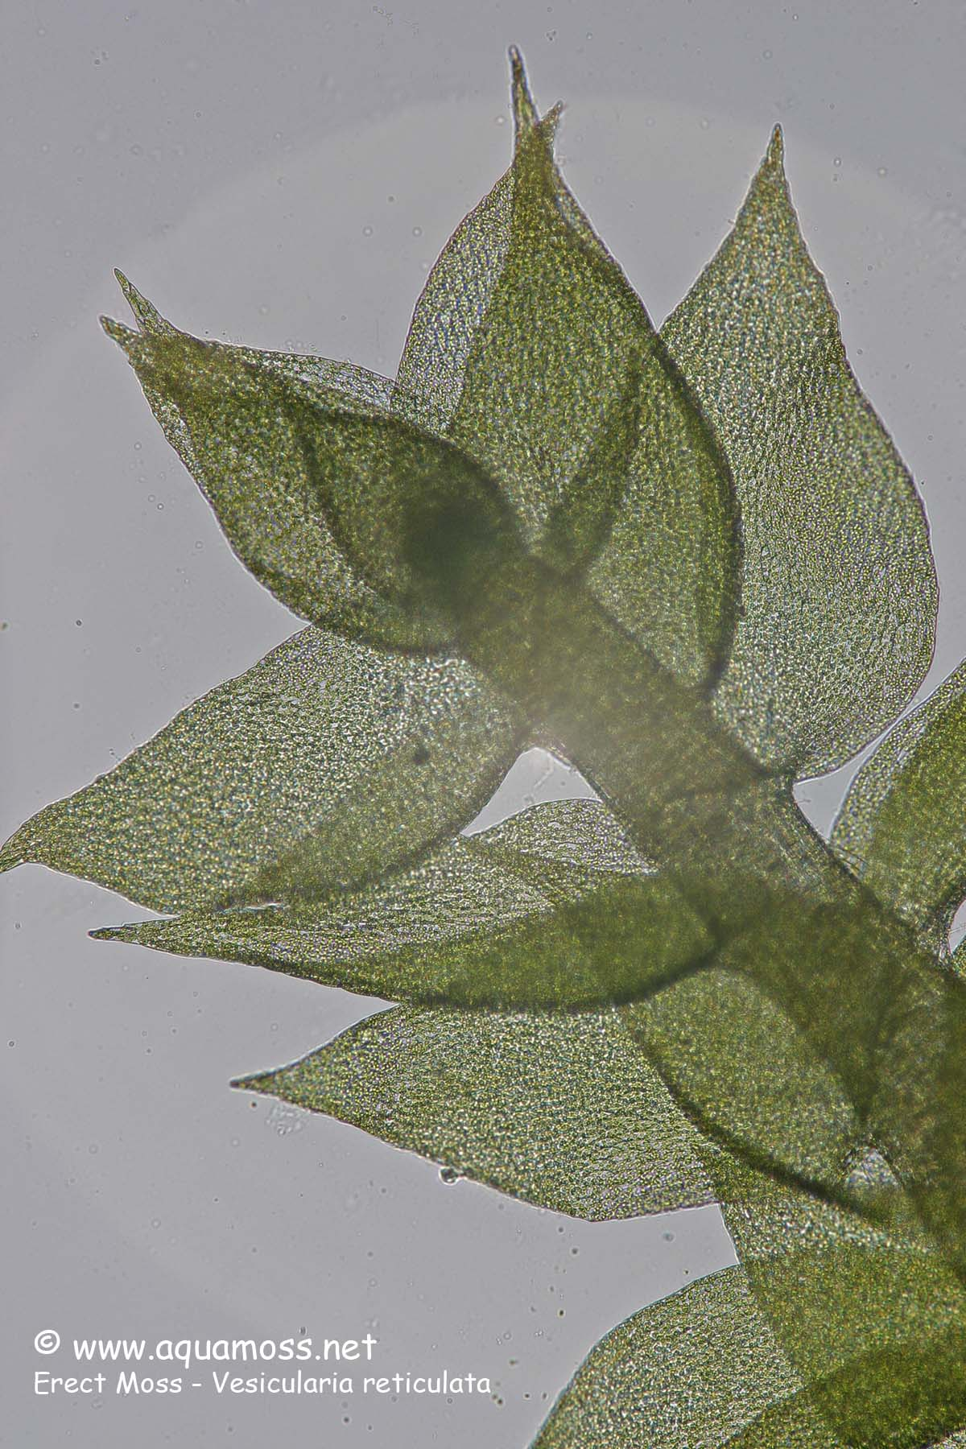
Fern
http://sciblogs.co.nz/bioblog/tag/plant-responses-to-the-environment/page/2/

