Protista Lab Pictures
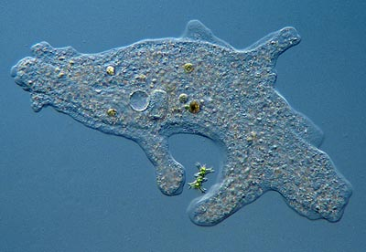
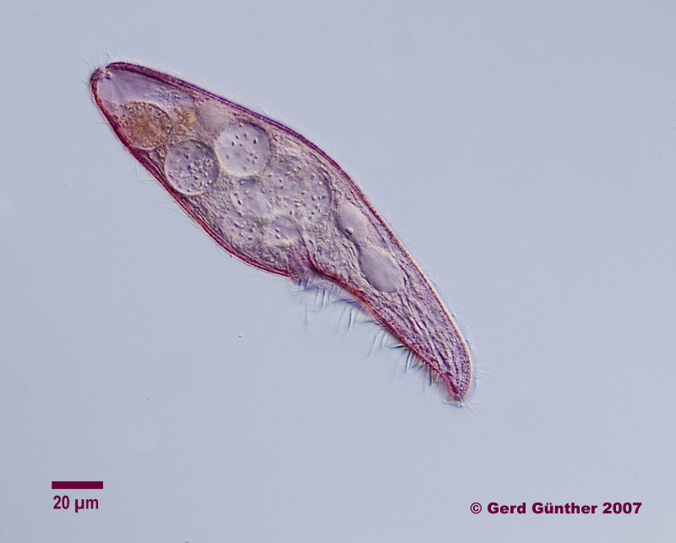
Protist #5 Protist #3

Protist #1 Protist #5
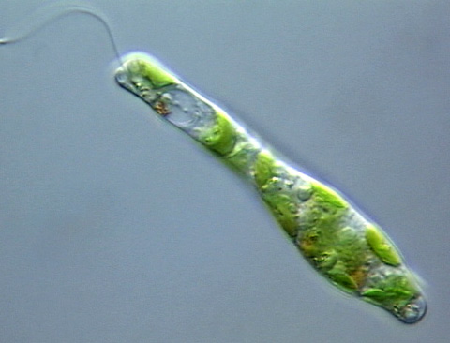
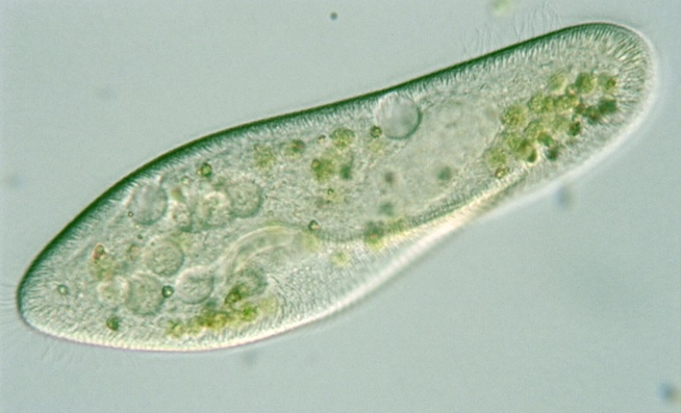

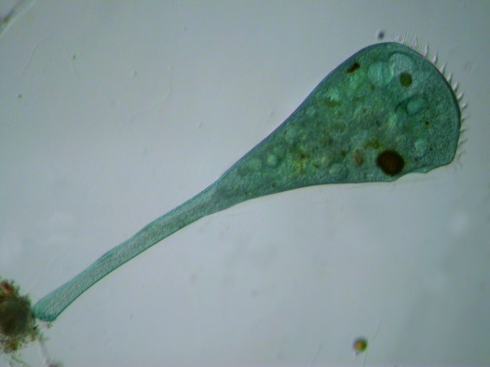
Protist #2

Movement Patterns of Protists

Protist 5
http://www.youtube.com/watch?v=H1iMCKnWDKg

Protist 3
http://www.youtube.com/watch?v=7pR7TNzJ_pA

Protist 1
http://www.youtube.com/watch?v=Lyrs79CBwfo

Protist 5
http://www.youtube.com/watch?v=oQCAY902ZAk

Protist 2
http://www.youtube.com/watch?v=beufpi64c0g

