Types of Evidence Name: ______________________
Match the correct type of evidence with the examples.

- Biological

- Chemical

- Physical

- Other

A. B. 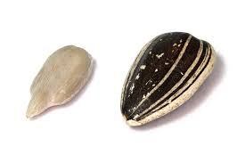C. 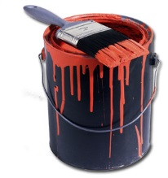D. 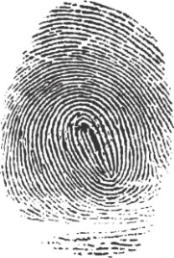E. C. F. 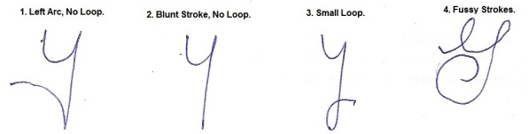G.

- Define circumstantial evidence. What does it prove?

- Give two examples of circumstantial evidence.

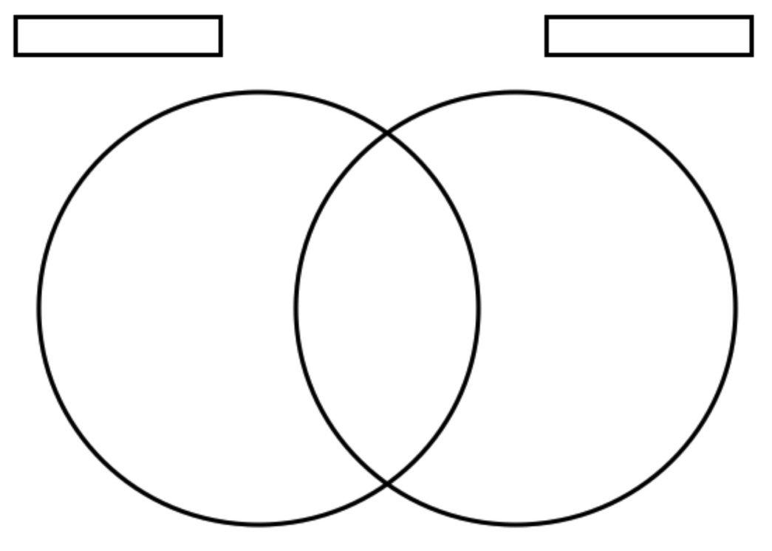
- Compare and contrast direct and indirect evidence.

Complete the following table.
Type of Evidence | Description | How is it used | Example
Trace Evidence

Material Evidence
Prima Facie Evidence
Probative Evidence
Exculpatory

Determine which picture below is which type of evidence above.
