Cell STructure and function
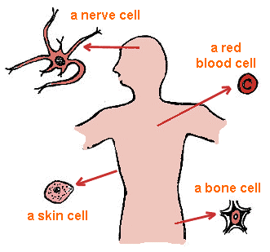
READ: Chapter 4 & 5

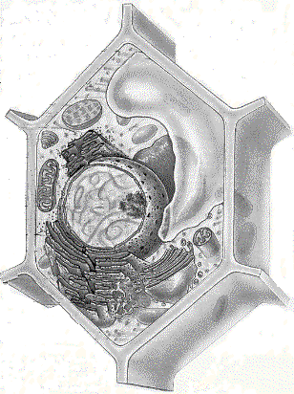SUMMATIVE:
Cell Project Organelle Quiz
Chapter Test Cell Project

FORMATIVE:
Chapter Packet Cell Presentation
Microscopes Looking at Cells of Kingdoms

Please use the following numbered scale to indicate your confidence in your knowledge of topics in CELLS.

4 | I understand the material so well I can teach it to others
3 | I feel confident I fully understand the material
2 | I get the idea, but I feel there is more to learn
1 | This is a totally new concept for me

 | PRE DATE: | POST DATE:
I am able to compare and contrast structural components and their functions in prokaryotes, eukaryotes (plant and animal) and viruses.
I am able to explain the structure and function of the cell membrane, nucleus and cytoplasmic structures.

I am able to summarize the flow of materials through the endo-membrane system.

I am able to differentiate between passive and active transport with regards to concentration gradient and particle size.

I am able to explain the Cell theory

I am able to identify the differences between cells with and without nuclei

I am able to describe the mechanisms for materials to move in and out of cells
I am able to relate the organelles with their functions
Name: __________________
CELLS OF THE FIVE KINGDOMS
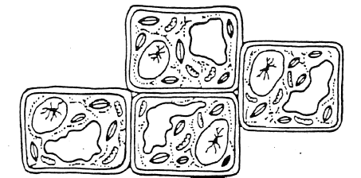
- Prokaryotic or Eukaryotic (circle one)
Which kingdom?
Explain.

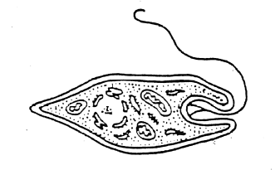
- Prokaryotic or Eukaryotic (circle one)
Which kingdom?
Explain.

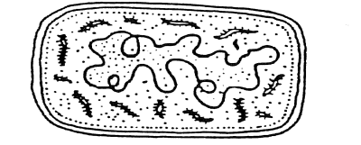
- Prokaryotic or Eukaryotic (circle one)
Which kingdom?
Explain.

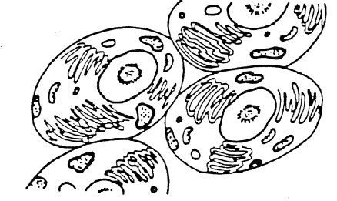
- Prokaryotic or Eukaryotic (circle one)
Which kingdom?
Explain.

COMPARE THE FOLLOWING CELLS TO EACHOTHER
Lable each of the organelles. State whethere the cells are prokaryotic or eukaryotic. State the kingdom and an explanation.
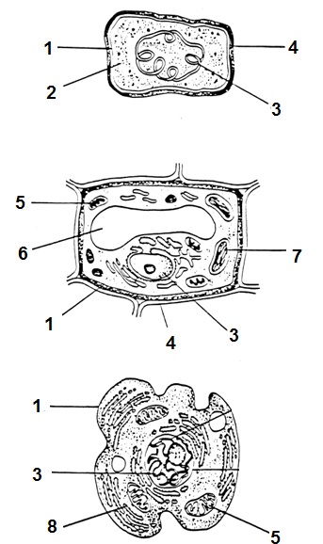
CELL A

CELL B

CELL C

ANIMAL CELLS
Label the organelles in the diagram below of a typical animal cell. Describe the function/purpose of each organelle in the cell.
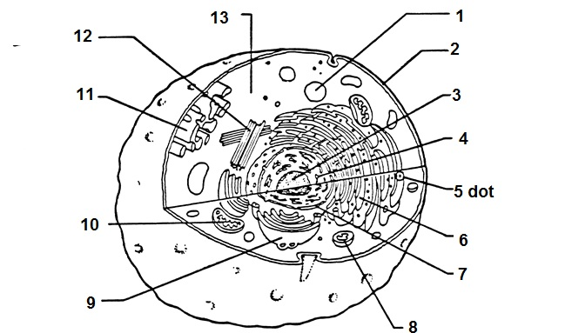

- Vacuole _______________________________________________________________
- Lysosome_______________________________________________________________
- Ribosome_______________________________________________________________
- Golgi complex ___________________________________________________________
- Cytoplasm_______________________________________________________________
- Nucleus_______________________________________________________________
- Cell membrane __________________________________________________________
- Mitochondria____________________________________________________________
- Endoplasmic reticulum_____________________________________________________
- Centriole_______________________________________________________________

Cell Fill-in Name: _________________________________
- That all cells arise from pre-existing cells is part of what is known as the _______________________.
- The functional and structural unit of all living things is the _______________________.
- Sub cellular structures found inside the cell are known as_______________________.
- Regulations of the movement of materials into and out of the cell are controlled by the _______________________.
- The “boss” of the cell, this structure contains genetic information encoded in chromosomes. It is the _______________________.
- The power housel f the cell that is the site of cellular respiration is the _______________________.
- Intracellular transport may be accomplished through membranous channels known as the _______________________.
- The organelle which contains chlorophyll and is the site of photosynthesis is the _______________________.
- A nonliving structure composed of cellulose which surround and supports plant cells is the _______________________.
- _______________________ and _______________________ are located in the cytoplasm of the cell and contain their own genetic information and are capable of reproducing .
- Exceptions to the cell theory include structure which can only reproduce inside a host cell called_______________________.
- A particular type of vacuole found in some organisms that helps maintain proper water balance is called the _______________________.
- A structure which contains digestive enzymes is the _______________________.
- A cylindrical structure important during cell division in some cells is the _______________________.
- The fluid-like environment of the cell in which other organelles between the nucleus and the cell membrane are suspended is called the _______________________.

Infering Relationships
Draw the relationship between the mitochondria and the chloroplast. Answer the following in your diagram:

 | Mitochondria | Chloroplast
What reactions occur in each?

What are the reactants of each?
What are the products of each?

What is the relationship of DNA and ribosomes? What does DNA do? What do ribosomes do? How are they connected?

What is the relationship between the cell membrane and food vacuoles? What does each do and how do they work together?
MAKING CONNECTIONS
- Describe how a digestive enzyme, like intestinal protease, is made in a cell and how it gets to where it is needed, say in a food vacuole. Which type of cells would it be made in? Be sure that all organelles are used in your description.

- How is a cell membrane related to a food vacuole?

- How do a food vacuole and a lysosome interact?

- What organelle does a Golgi body make and why is it important?

- How does a cell rid of undigested waste after it consumes another cell for food?

- Describe how and where carbon dioxide is created in a cell and how the cell rids of toxin.

- Describe the steps of breathing and explain how oxygen gets from the air into a cell where it is needed.

