Name: ______________________
CLADOGRAM PRACTICE
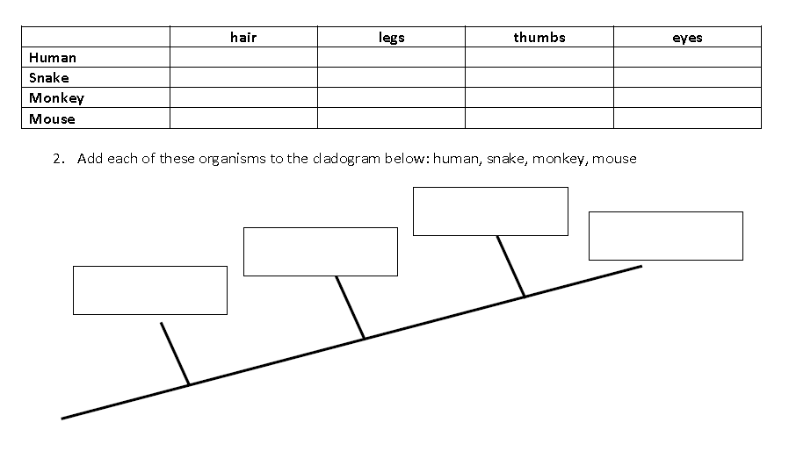
Complete the tables then create a cladogram for each.

CLADOGRAM EXTRA CREDIT
Name of Animal | Appendages |  |  |  |  | Body covering |  |  |  | Temp Regulation |  | Breathing Mech
 | Fins | Wings | Forelegs | Hindlegs | Horns | Smooth Skin | Scales | Feathers | Hair | Ectotherm | Endotherm | Gills | Lungs
Domed  Tortoise |  |  | X | X |  |  | X |  |  | X |  |  | X
Dodo |  | X |  |  |  |  |  | X |  |  | X |  | X
Utah Lake  sculpin | X |  |  |  |  |  | X |  |  | X |  | X
Texas Red  Wolf |  |  | X | X |  |  |  |  | X |  | X |  | X
Passenger  Pigeon |  | X |  |  |  |  |  | X |  |  | X |  | X
Eastern  Elk |  |  | X | X |  |  |  |  | X |  | X |  | X
Round Island  boa |  |  |  |  |  |  | X |  |  | X |  |  | X
Palestinian Painted frog |  |  | X | X |  | X |  |  |  | X |  |  | X
Orgeon Bison |  |  | X | X | X |  |  |  | X |  | X |  | X
New Zealand graling | X |  |  |  |  |  | X |  |  | X |  | X

