NAME: ____________________________
CONCENTRATION GRADIENTS
Introduction:
Charles Darwin, the famed scientist, has just returned from the ship the HMS Beagle on a trip to the Galapagos Islands. He is a natural biologist and spent his time collecting samples. One fish that he has named Dialysis tubis has been mislabeled. He doesn’t recall pond he collected the fish from. It is your task to determine the concentration of solute and water that would allow D. tubis to survive.
Four solutions have been created for you to determine the internal concentration of water and solute in D. tubis.
Hypothesis:
Predict how you will determine the concentration of solute in the unknown sample.
_______________________________________________________________________________________
_______________________________________________________________________________________

Materials:
This exercise required four 50cm strips of presoaked dialysis tubing, a potato, 10 plastic cups or beakers, string, scissors, a balance, and 2 sets of 25mL of these solutions: distilled water, an unknown, 38ppt salt, 26 ppt salt, 19ppt salt, and 8ppt salt.
Procedure:
- Obtain the six strips of presoaked dialysis tubing and create a bag out of each one by tying off one end.
- Pour 30mL of the 6 solutions into separate bags. Tie off the other end of the 5 bags.
- Determine the mass of each bag and record it in Table 1.2.
- Immerse each bag in a separate cup filled with the appropriate solution. Label the cup to indicate the ppt of salt in the solution of the cup.
- Let the setups stand for 30 minutes or overnight. Remove the bags from the solution.
- Carefully blot them dry and determine their masses.
- Record them in Table 1.2.
- Compare class data with your data.
- Follow the same protocol with the potato.
Results:
Title of Data Table: ___________________________________
Contents in cup  Ppt of salt | Initial mass (g) | Final mass (g) | Mass difference (g) | % Change in mass
A | B | C | D=C-B | E%=D/Bx100
Distilled Water ____ ppt
____ ppt
____ ppt
____ ppt
____ ppt
____ ppt
Class Average Data
Contents in cup ppt of salt | Class Average
____ ppt
____ ppt
____ ppt
____ ppt
____ ppt
____ ppt

GRAPH YOUR DATA AND THE CLASS AVERAGE: be sure to have a proper heading and label your axis correctly.

ANALYSIS:
- Why did you calculate the percent change instead of just the difference in mass?

- Why did we use distilled water?

- What happened to the unknown when it was put into the distilled water? Why did this happen?

- What happened when the unknown was placed into the blue solution? Why did this happen?

- How could you determine the concentration of D. tubis using the information you collected?

WRITE A CONCLUSION: Be sure to state what the concentration of the unknown solution is and .be sure to summarize the data, patterns to support you detailed explanation of how you
- Explain the relationship between the change in mass and the molarity of sucrose within the dialysis bags. The solute is hypertonic and water will move into the bag. As the molarity increases the water moves into the bag.
- Predict what would happen to the mass of each bag in this experiment if all the bags were placed in a 0.4M sucrose solution instead of distilled water. Explain. With the 0.2M bag, the water would move out. With the 0.4M bag, there will be no net movement of water because the solutions reach dynamic equilibrium. With the 0.6M-1M bags, the water would move into the bag.
- Why did you calculate the percent change in mass rather than simply using the change in mass? This was calculated because each group began with different initial masses and we would have different data. All the groups needed consistent data.
- A dialysis bag is filled with distilled water and then places in a sucrose solution. The bag’s initial mass is 20g and its final mass is 18g. Calculate the percent change of mass, showing your calculations. ((18-20)/20) x 100 = 10%
- The sucrose solution in the beaker would have been hypotonic to the distilled water in the bag.
Exercise 1C

Table 1.4: Potato Core: Individual Data

Contents of Beaker | Initial Mass (g) | Final Mass (g) | Difference in Mass | % Change in Mass
Distilled Water | 2.8 | 3.7 | .9 | 32.14
0.2M | 2.9 | 3.1 | .2 | 7
0.4M | 2.5 | 2.2 | .3 | 12
0.6M | 2.3 | 1.9 | .4 | 17.39
0.8M | 2.5 | 1.9 | .6 | 24
1.0M | 2.3 | 1.8 | .5 | 21.74

Table 1.5: Potato Core: Class Data

 | Group 1 | Group 2 | Total | Class Average
Distilled Water | 32.14% | 21.1% | 53.24% | 26.62%
0.2M | 7% | 6.7% | 13.7% | 6.85%
0.4M | -12% | -6.5% | -18.5% | -9.25%
0.6M | -17.39% | -15.2% | -32.59% | -16.30%
0.8M | -24% | -20% | -44% | -22%
1.0M | -21.74% | -19% | -40.74% | -20.37%

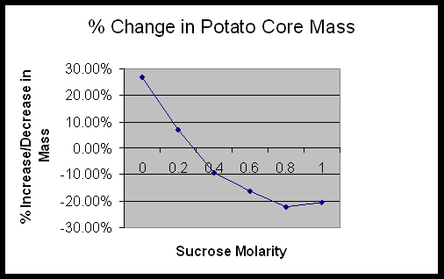
Determine the molar concentration of the potato core. 0.3M
Exercise 1D

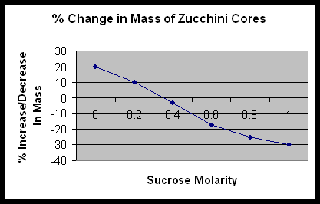

What is the molar concentration of the zucchini cores? .35M

- If a potato core is allowed to dehydrate by sitting in the open air, would the water potential of the potato cells decrease or increase? Why? It would decrease because the water would leave the cells and cause the water potential to go down.
- If a plant cell has a lower water potential than its surrounding environment and if pressure is equal to zero, is the cell hypertonic or hypotonic to its environment? Will the cell gain water or lose water? It is hypotonic and it will gain water.
- The beaker is open to the atmosphere. What is the pressure potential of the system? The pressure potential is zero.
- Where is the greatest water potential? In the dialysis bag.
- Water will diffuse out of the bag. Why? It is because the water moves from and area of high water potential to an area of lower water potential.
- What effect does adding solute have on the solute potential component of that solution? Why? It makes is more negative.
- Consider what would happen to a red blood cell placed in distilled water: a) Which would have the higher concentration of water molecules? Distilled Water b) Which would have the higher water potential? Distilled Water c) What would happen to the red blood cell? Why? It would lyce, because it would take on too much water.
Error Analysis:
Possible errors that could have affected the results of the lab include incorrectly mixing the solutions, ineffectively tying the dialysis tubing, inaccurately measuring , and inaccurately calculating.
Conclusion:
During Exercise 1A the data that was collected help determine which molecules can and can not move across a cell membrane. Obviously, because of the color change in the bag, the IKI was able to move across the membrane. It is small enough to fit through the pores in the selectively permeable membrane, along with water. Starch was too large to move across the membrane. Glucose, as the Benedict’s test proves, was able to move freely along with the water and IKI solution.
In Exercise 1B, it was proven that water moves faster across the cell membrane than sucrose. The water moved to help reach dynamic equilibrium between the 2 solutions. The sucrose molecules are too big to move across the membrane as fast as water can.
The data in Exercise 1C showed that the potatoes contained sucrose. The sucrose in the potato raised the solute potential, which lowered the water potential. The beaker of distilled water had a high water potential. Water moves down the concentration gradient, causing the potato cores to take on water.
Exercise 1D helped better understand the lab with simple algebra equations. It proved that the data that was collected was correct through mathematics.

Introduction:
All molecules have kinetic energy and are constantly in motion. This motion causes the molecules to bump into each other and move in different directions. The result is diffusion. Diffusion is the random movement of molecules from an area of high concentration to an area of low concentration. This will continue until dynamic equilibrium is reached; no net movement will occur. Osmosis is a special kind of diffusion. It is the diffusion of water through a selectively permeable membrane. A selectively permeable membrane means that the membrane will only allow certain molecules through such as water, small solutes, oxygen, carbon dioxide, and glucose, because no additional ATP is required. The membrane will not let ions, nonpolar molecules, or large molecules through because extra ATP is needed for them to travel across the membrane. Active transport is how molecules (such as ions) move against the concentration gradient. Additional ATP is required to perform this process.
Water will always travel from where there is a high concentration of water to a low concentration of water. A solute is a substance that is added to a solvent. In most real-life scenarios, water is the solvent. If a solute, like sugar or salt, the concentration of water becomes more dilute and decreases altering how the water might travel across a gradient.
Solutions can have three relationships with each other; isotonic, hypertonic, or hypotonic. When the solutions have the same concentration of solutes, they are isotonic. In an isotonic solution, there is no net change in the amount of water on each side of the membrane. If the solutions differ in their solute concentrations, the solution that has the most solute is hypertonic to the other solution. The solution with the smaller amount of solute is hypotonic to the other solution. The net movement of water will be from the hypertonic solution to the hypotonic solution. Net movement will occur until dynamic equilibrium is reached, then there will be no net movement of water.

